Credit Card Processing
How to process a Voided Transaction
(US Merchant Users Only)
To enter a voided transaction using the US Merchant credit card software go into Menu 1.2, enter the product number and the negative quantity being returned (i.e. -1).
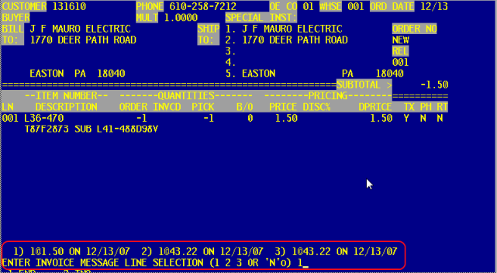
- When entering a negative quantity the system will list the dates that the product was sold. Select the one of the options listed. In example the item was purchased on 12/13/07.
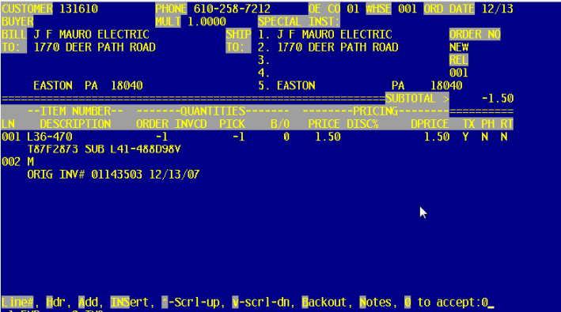
- Write down the original invoice number listed on the memo line (The number will be needed later on in this process).
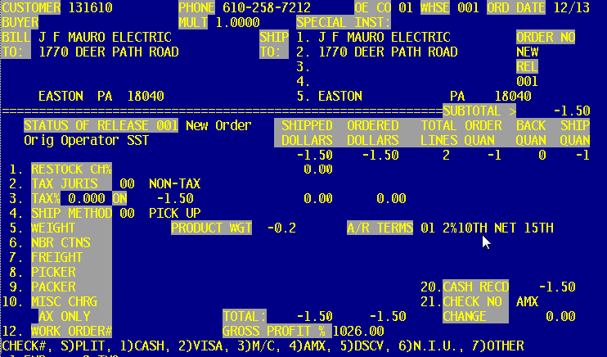
- Enter in the negative dollar amount and the card being used for the transaction.
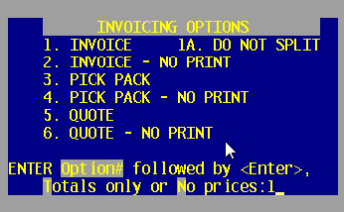
- Select Option 1 to Print Invoice or Option#2 to Invoice – No Print. After this selection the following Payment Processing screen appears.
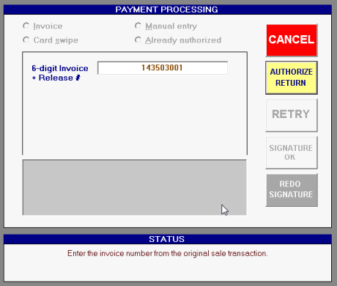
- Enter in the invoice number (as indicated on the memo line of the invoice) plus the release number (6-digits).
- Select Authorize Return.
- If the wrong invoice number is entered the following screen will appear.

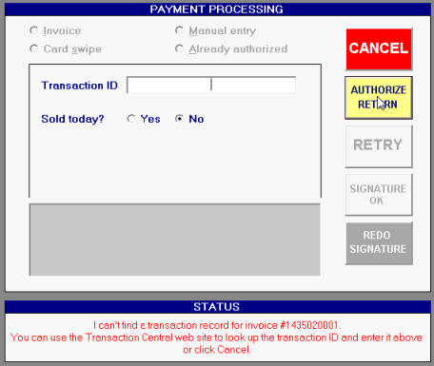
- The transaction ID is located on the TransFirst Website (https://www.oc2net.net/billing/countercheck/login.asp). After logging in select Reports, then select Transaction Detail Report.
- Sold Today? Enter Yes or No
- Select the Authorize Return button.
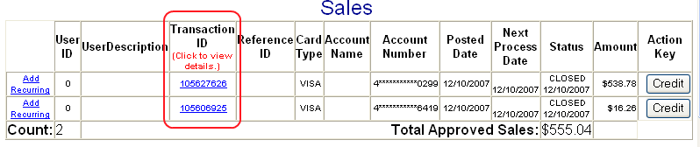
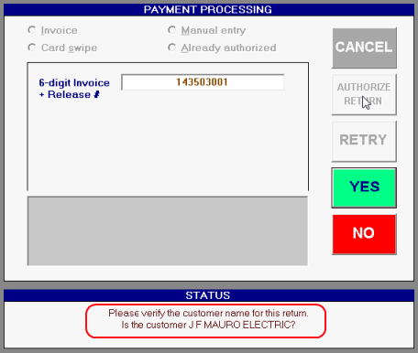
- Select the Yes or No button to verify if the correct customer appears in the Status screen.
  - Yes will take you to the next screen.
  - No will take you???
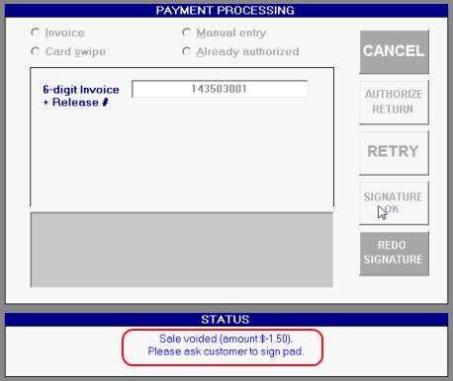
- Voided dollar amount appears in the Status screen.
- Ask the customer to sign the pad.
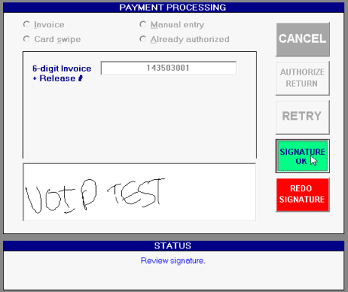
- If the signature is ok then select the Signature OK button. If the signature is not readable select the REDO Signature button and ask the customer to sign again.
Below is an example of the final invoice. The time and date stamp, plus the authorization code and transaction ID is listed above the signature.
