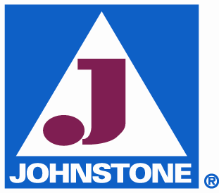

Dear Valued Customer,

Soon, you will receive your new and expanded JOHNSTONE CATALOG #196.

Our catalog is a great industry resource for our customers, with its’ detailed pictures and product information.

And, we want to help our contractor customers grow their business and improve their profitability by giving them the freedom to share this catalog with their customers.

So, this new catalog will price all products at “LIST” versus “WHOLESALE”.

If you qualify as a “Wholesale Customer”, your pricing will be automatically convert to Wholesale by our computer system.

We are committed to selling our products to qualified wholesale customers only. Please know that our catalog has a written “Wholesale Only” policy stating: “POSSESSION OF JOHNSTONE’S CATALOG DOES NOT CONSTITUTE AN OFFER TO SELL BY JOHNSTONE, OR THE RIGHT TO PURCHASE FROM US.”

To obtain your current cost on a specific product, please call one of our branches.

During the year, product prices may vary due to our monthly and seasonal specials, Spring and Fall Preseason Programs, manufacture cost changes, etc. Be assured, our wholesale customers will always receive the lowest price available to them.

Also, we want to help our wholesale customers with their special order needs. We will quickly source and ship your hard-to-find parts that are not listed in our catalog.

On behalf of all our people, who are dedicated to exceeding our customer’s expectations, thank you for choosing JOHNSTONE to be a part of your business team.

Please call me with a question or comment, at any time. My direct line is ??? ??? ????, extension ?? .

Sincerely,
Owners Name

