Order Entry
Invoice Notes Formatting Shortcuts
Instructions: Using the legend below, type any combination of the formatting shortcuts on a message line in Order Entry (Menu 1.2) to achieve the associated results. See below for an example.
Note: Make sure you type the codes at the very beginning of the line. Also, try to avoid putting two of the same shortcuts on the same line (example: #b#b).
#b | Bold
#c | Center
#u | Underline
#i | Italics
#r | Right Justified
#fb | Font Bigger
#fs | Font Smaller

Order Entry Example:
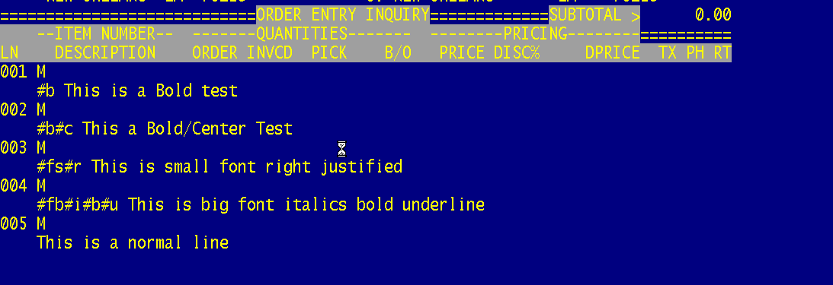
Printed Example
