How to Scan Pre-Count Inventory Using the Handheld S3 Menu
Scanning Locations and Items (S3 Menu – Option #4 Pre-counts)
Step 1: Scan or enter the Warehouse number
Step 2: Scan the Location
Step 3: Scan the Part Number
The part number, description and quantity of 1 will be displayed on the screen as well as the warehouse, warehouse location and product prompts again.
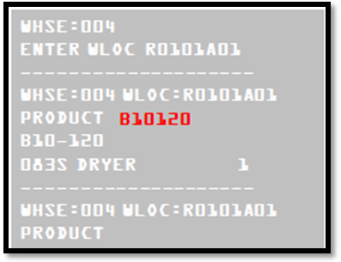
To increase the quantities, scan the item again. To manually increase the quantity of an item enter ‘.’ and the quantity (.5). To move to the next item in the same location, simply scan the next part number. When moving to the next location, scan the location at the product prompt.
Reducing the Quantity Scanned
To reduce the quantity, in the event that an incorrect quantity was entered, do the following:
Step 1: Scan the item again
Step 2: Enter the quantity to reduce, less one, with a ‘.-’ in front of it.
For example, if you want to reduce this to a total quantity of 1, you would enter ‘.-3’
