Customer Data Integration (CDI)
Customer Data Integration is an exciting NEW feature that gives you a real-time Windows interface with customer information. Customer data can be pulled and inputted into CDI just like you’ve always done in the customer files located in Menu 12.2.2. The following data is in one easy to use location: Customer Contacts, Mailing List, Online Orders, Authorized Buyers, Credit Card Information, Ship To Information, Sales, Accounts Receivable and Pricing. CDI can be accessed for viewing and editing through Menu 12.2.2.29. CDI is also available through View Maintenance in Menu 19.14.17.
Any operator that has a PROC CODE of CM setup in Menu 12.1.4 will have access to Menu 12.2.2.29.
An operator that has a PROC CODE of OE will have access to CDI in Menu 19.14.17.
**Important** - See Appendix A for CDI install instructions
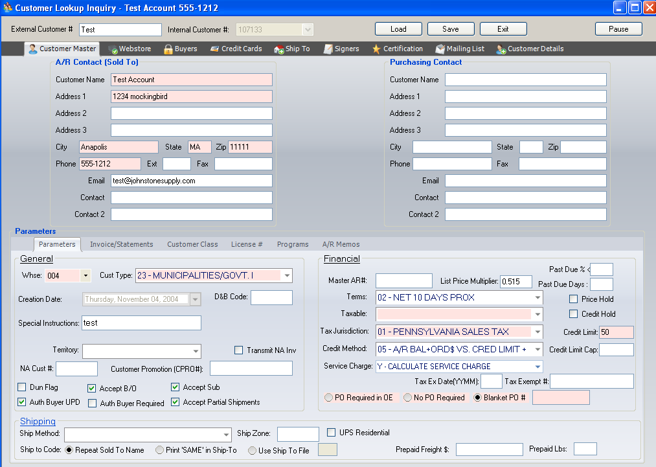
- NOTE: This documentation is designed to provide field definitions and also point out where this information is found in Customer Menu Paths (Menu 12.2.2).
Field Name | Description | Menu 12.2.2 Location
External Customer # | Customer Number | Screen 1
Internal Customer # | Internal customer number assigned by the system | Screen1
Load | After entering the customer number you can hit the <enter> key or select the Load button to bring up the customer. | New
Save | Saves changes made to the customer record. The system will prompt to save before moving to another tab, entering a new customer or exiting the program | 0 to Accept
Exit | Exit the CDI Screen
Pause | Pauses the CDI screen and allows you to return to PICK without closing CDI and the customer record
- NOTE: New customers need to be setup in Menu 12.2.2.1. Future development of CDI will allow entry of new customers.

Customer Master
AR Contact (Sold To) Information
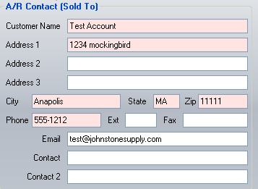
Field Name | Description | Menu 12.2.2.2 Location
Customer Name | Displays the Customer Name. | Screen 1, Field 1
Address 1 | Customer Street Address | Screen 1, Field 2
Address 2 | Customer PO Box if applicable | Screen 1, Field 3
Address 3 | Optional Address Line; ‘?’ displays Y*** to force entry of Ship-To Address in Order Entry | Screen 1, Field 4
City, State & Zip | Displays customer the location of the customers City, State & Zip | Screen 1, Field 5, 6, & 7
Phone | Customers main phone number | Screen 1, Field 9
Ext. | Phone Extension | New
Fax | Customers main fax number | Screen 1, Field 11
Email | AR Contacts Email address | Screen 1, Field 17
Contact | Accounts Receivable contact name that prints out on A/R aging report | Screen 1, Field 8
Contact 2 | Accounts Receivable contact name | Screen 1, Field 10

Purchasing Contact Information
The Purchasing Contact information box is available to track if any of the information is different from the AR Contact information.
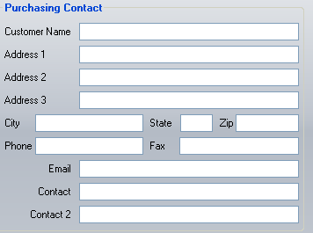
Field Name | Description | Menu 12.2.2.2 Location
Customer Name | Displays the Customer Name | Screen 1, Field 19
Address 1 | Purchasing Street Address | Screen 1, Field 20
Address 2 | Purchasing PO Box if applicable | Screen 1, Field 21
Address 3 | Optional Address Line | Screen 1, Field 22
City/State/Zip | Purchasing location of City, State & Zip code | Screen 1, Field 23, 24, & 25
Phone Number | Main phone number for Purchasing Contact | Screen 1, Field 27
Fax | Main fax number of Purchasing Contact | Screen 1, Field 29
Email | Email address for Purchasing Contact | Screen 1, Field 18
Contact | Purchasing contact name | Screen 1, Field 26
Contact 2 | Additional Purchasing contact name | Screen 1, Field 28

Customer Master – Parameters
General Information
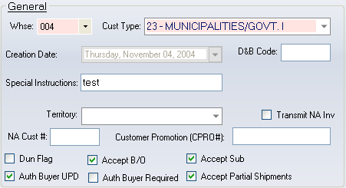
Field Name | Description | Menu 12.2.2.2 Location
Warehouse | Master warehouse number from where purchases originate | Screen 2, Field 1
Customer Type | List Customer type for reports | Screen 2, Field 3
Creation Date | Date the customer master record was created. | Screen 1, Field 12
D & B Code | Credit rating by Dunn and Bradstreet. This business classification listing is informational only and does not display anywhere else in the system. | Screen 2, Field 9
Special Instructions | Special instructions that are highlighted in Order Entry and viewed only by counter staff (not printed on invoices or pick tickets). | Screen 2, Field 6
Territory | Lists Customer Territories as setup in Menu 12.2.12 | Screen 2, Field 5
Transmit NA Invoice | Mark box to transmit National Account invoice | Screen 2, Field 35
NA Customer # | National Account Customer Number | Screen 2, Field 33
Customer Promotion (CPRO#) | Enter the Honeywell customer promotion number. | Screen 2, Field 34
VIP Reporting | Goodman VIP Reporting?? | Screen 1, Field 33
Dunning Flag | Mark box if dunning letters should be generated for this customer. | Screen 2, Field 8
Accept B/O | Determines whether a customer accepts backorders or only complete orders. | Screen 2, Field 30
Accept Sub | Determines whether a customer accepts substitute products or only “name brand” products. | Screen 2, Field 32
Authorized Buyer UPD | Allows update of authorized buyers for this customer in Order Entry (Menu 1.2) | Screen 1, Field 30
Authorized Buyer Required | Requires authorized buyers for the customer in Order Entry (Menu 1.2) | Screen 1, Field 32
Accept Partial Shipments | Determines whether a customer accepts partial shipments | Screen 2, Field 31

Financial
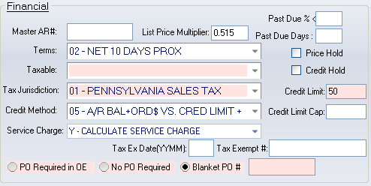
Field Name | Description | Menu 12.2.2.2 Location
Master AR# | Master Accounts Receivable account number for billing ALL customer purchases. Management companies often use this with several sites requesting products. Sales history resides in this account, but billing goes through the master account, the master account also will receive the statements. If a master account were setup for this account, then this one would be called a “satellite account.” | Screen 2, Field 2
List Price Multiplier | Multiplier setup for this customer | Screen 2, Field 37
Past Due % | Amount past due is less ten what %, to not fail the credit check | Screen 2, Field 15
Past Due Days | Number of days past due in order to fail credit check | Screen 2, Field 16
Terms Codes | Determines how each ticket will age unless the Terms Code is changed in Order Entry (Menu 1.2). Different tickets for the same customer may have different Terms | Screen 2, Field 23
Price Hold | Mark this box to bypass price hold on branch customers unless price or cost is zero. If this box is left blank then a prompt will appear for the price hold. | Screen 2, Field 10
Taxable | Select how you want the customer taxed | Screen 2, Field 24
Credit Hold | Mark box to place customer on credit hold. Regardless of credit status, a customer on credit hold will flag and require authorization in Order Entry. | Screen 2, Field 29
Tax Jurisdiction | List customer jurisdiction codes setup in Menu 12.2.10 | Screen 2, Field 25
Tax Expiration Date | List the year and month the tax jurisdiction expires (YYMM) | Screen 2, Field 36
Credit Method | Displays available credit methods | Screen 2, Field 27
Credit Limit | Enter the credit limit in whole dollars only | Screen 2, Field 28
Service Charge | Service Charge Flag, select the appropriate option for the customer | Screen 2, Field 13
Tax Exempt | Enter the tax exempt number for use when a customer is flagged exempt | Screen 2, Field 26
PO Required in Order Entry | Mark box if this customer requires a PO number to be entered in Order Entry (Menu 1.2) | Screen 2, Field 11
No PO Required | Mark this box if a PO is not required in Order Entry | Screen 2, Field 11
Blanket PO# | Enter the PO number to be placed on all Order Entry orders | Screen 2, Field 11

Shipping
Field Name | Description | Menu 12.2.2.2 Location
Ship Method | Default code for customers preferred shipping method. | Screen 2, Field 21
Ship Zone | Shipping Zone | Screen 2, Field 22
UPS Residential | Mark box for residential | Screen 1, Field 15
Ship to Code | List Ship To code options. If the Ship to File is selected it pulls from the Ship To setup in Menu 12.2.2.4. | Screen 2, Field 20
Prepaid Freight | Dollar amount of qualify for prepaid freight | Screen 1, Field 13
Prepaid Lbs | Pounds to qualify for prepaid freight | Screen 1, Field 14

Customer Master – Invoice/Statements
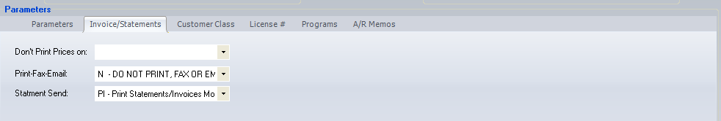

Field Name | Description | Menu 12.2.2.2 Location
Don’t Print Prices On | Option to not print prices in Picks, Invoices or Both | Screen 1, Field 16
Print-Fax-Email | Select the delivery method of the customer’s invoices. If the Statement option is left blank then the statements will send using the same method a setup for the invoices. | Screen 1, Field 31
Statement Send | Select the delivery method f the customer’s statements during month-end. | Screen 1, Field 34

Customer Master – Customer Class
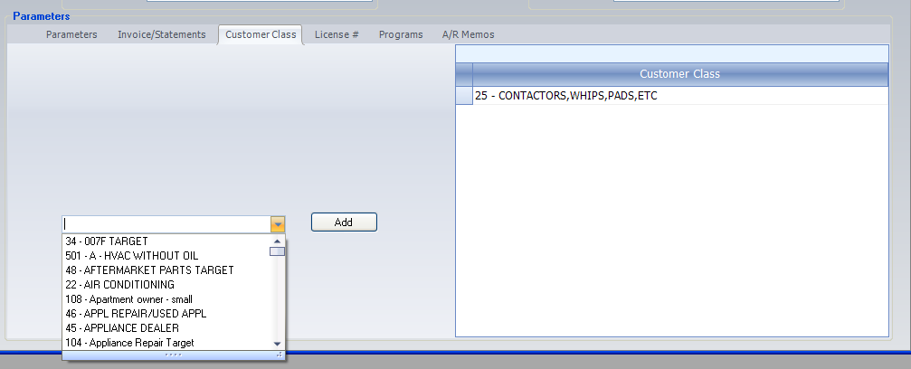
The Customer Class tab allows users to select from the customer class options setup in Menu 12.2.8 (Customer Class Maintenance) that should be applied to this customer. Select the customer class from the drop down list and then select the <Add> button. This applies the customer class to this customer as seen on the Customer Class list on the right-hand side of the window. (This functionality is the same as Menu 12.2.2.2, Screen 2, Field 4)

Customer Master – License Number
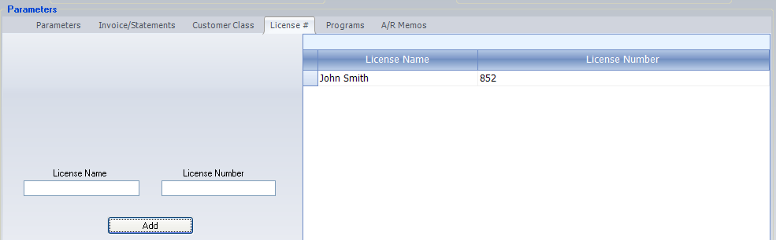
The License Number tab allows for the entry of the customers License Name and Number. Type in the License and License Number information and select the <Add> button to make it part of the customers record. To delete a license name and number, right click on the row and select the <Delete Row>. (This functionality is the same as Menu 12.2.2.2, Screen 2, Field 14)

Customer Master - Programs
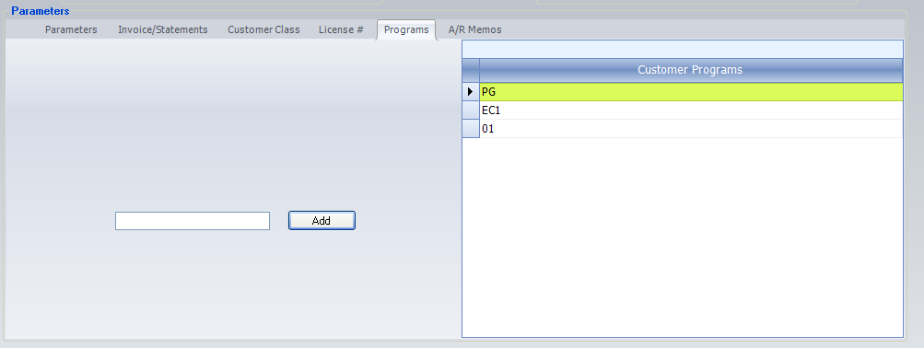
Each line represents a program/contract for this customer. Customers may have multiple programs that are setup in Menu 5.3 – Contract Prices. To enter a Program, type in the program name and select the <Add> button. To delete the Program from the list, right-click on the program name and select the <Delete Row> option.

Customer Master – Memos
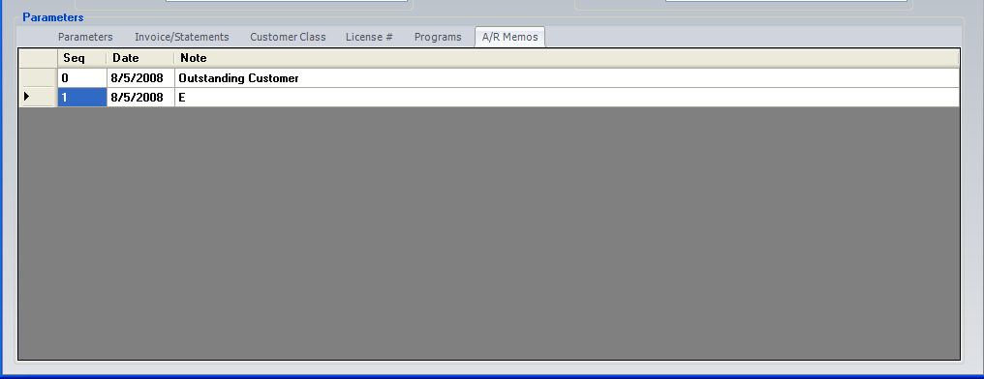
This screen represents the AR Memos entered in Menu 4.1.9. The Memos can only be viewed. To Add, Delete or change a Memo you’ll need to go to Menu 4.1.9. The Memos tab is not viewable for users who have access to CDI through View Maintenance in Menu 19.14.17.

Saving Changes
If changes are made on a screen the system will prompt you with the following window before you can exit the program or move to another window. To Save changes, check the box under the Save column. This window shows you the original value, the changed value and the save status.
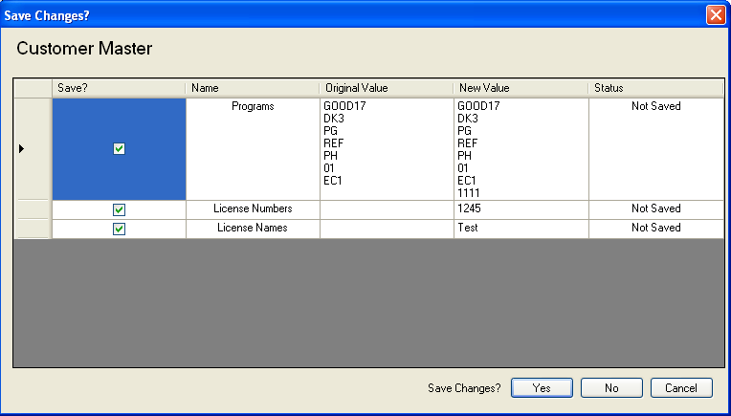
Selecting ‘Yes’ will Save the changes.
Selecting ‘No’ will not save the changes.
Selecting ‘Cancel’ will cancel the Save Changes screen and take you back to the prior window.

Webstore
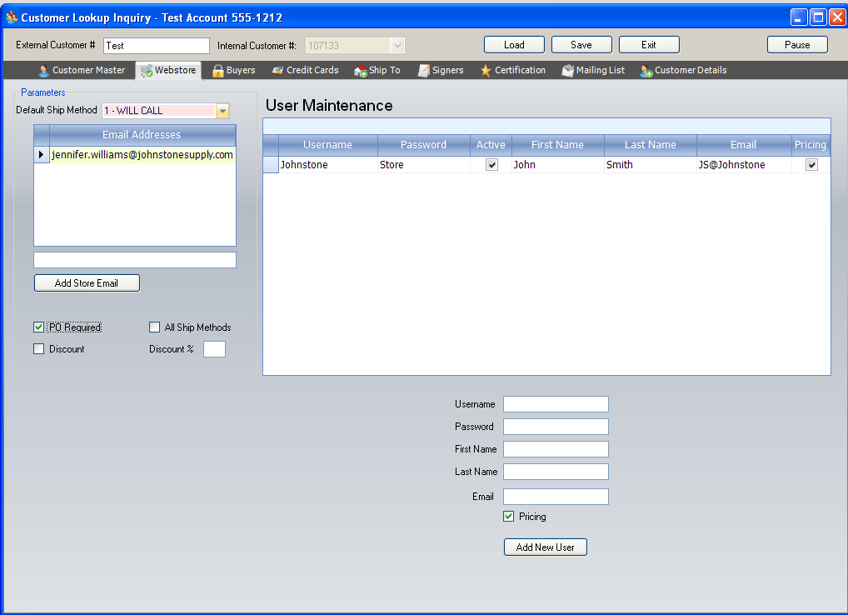
In order for customers to purchase online, their customer account must be activated for online ordering. This is done the CDI Webstore window or in Menu 35.20.4 and 35.20.5.
Field Name | Description | Menu 35.20 Location
Ship Method | Lists the customers default ship method. | Menu 35.20.4, Field 3
Store Email Addresses | Enter the email addresses for this customer that you want copied on all orders placed by any users listed in the User Maintenance list. | Menu 35.20.4, Field 4, 5, 6, & 7
PO Required | Marking this box will require the customer to enter a PO# on the checkout screen before submitting an order. | Menu 35.20.4, Field 1
All Ship Methods | Mark this box to allow the customer to choose from all the ship methods as seen in Menu 35.20.3. If this box is not marked, ship methods are restricted to 1) Will Call, 2) UPS, & 3) Best Way. | Menu 35.20.4, Field 3
Discount | Leave this box unmarked to turn OFF online discounts by customer. The discount is not related to any special pricing the customer may have, but to the special on-line discount that can be setup in Menu 35.20.2, Field 3 for customers ordering online. | Menu 35.20.4, Field 8
Discount % | Enter the online ordering discount the customer will receive. This is in addition to the customer’s specific pricing. | Menu 35.20.4, Field 9
- Use these options to setup individual users to login to Webstore.
Field Name | Description | Menu 35.20 Location
Username | The individual username must be unique. The username is not case sensitive. | Menu 35.20.5
Password | This field, in combination with the username make up the login information. The password must be a combination of at least 6 numbers and/or letters. This field is not case sensitive. | Menu 35.20.5, Field 2
First Name | First name of the person tied to the login. | Menu 35.20.5, Field 4
Last Name | Last name of the person tied to the login. | Menu 35.20.5, Field 5
Email | Enter the email address associated with this login. Order confirmations are sent to this address. | Menu 35.20.5, Field 6
Pricing | Mark this box to display specific pricing for this customer. | Menu 35.20.5, Field 7

Buyers
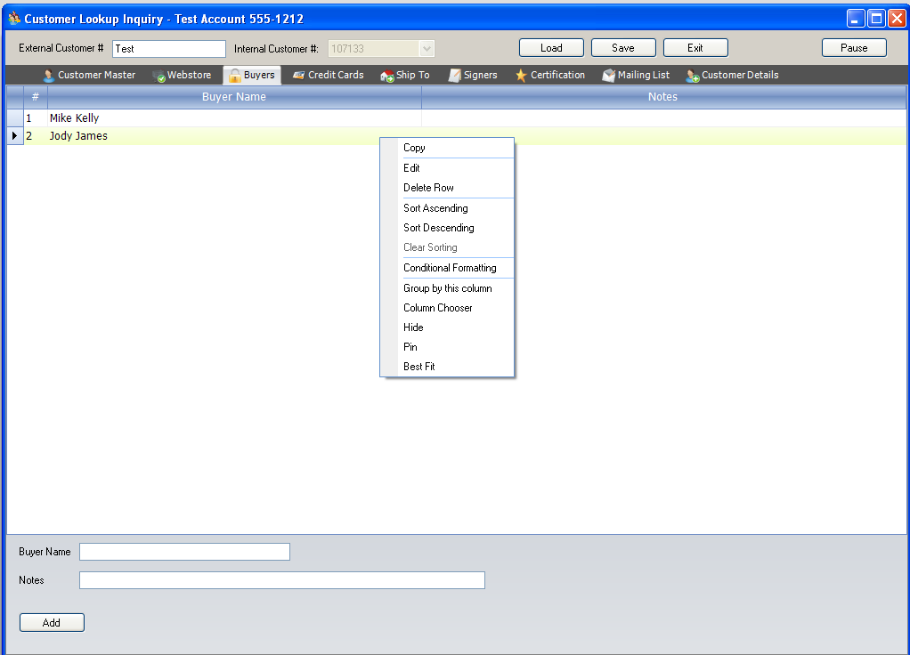
Build a list of authorized buyers, the only persons allowed to purchase on this account. All entries in this screen display in the Authorized Buyer screen of the Order Entry Header screen (Menu 1.2). This list can be maintained in Order Entry.
To Add a buyer enter the buyers name and any notes tied the individual buyer. To Edit or Delete a buyer, right-click on the row where the buyers name is located (see above screenshot for an example).

Credit Cards
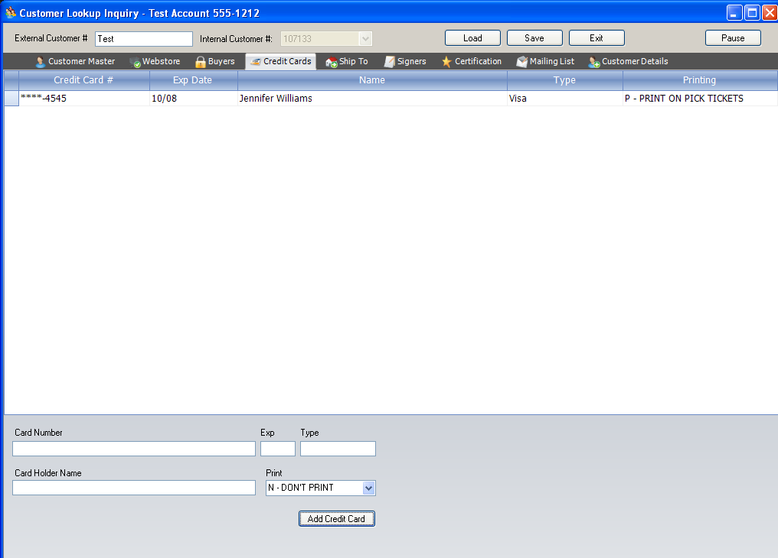
Use this window to capture credit card information for customers who always use a credit card and want their card on file.
Field Name | Description | Menu 12.2.2.8 Location
Card Number | Enter the customer’s credit card number. | Menu 12.2.2.8
Exp. | Enter the credit card Expiration Date. | Menu 12.2.2.8
Type | Enter the type of credit card (i.e. AMX, M/C, DSCV, & VISA) | Menu 12.2.2.8
Card Holder Name | Enter the card holders name as it appears on the credit card. | Menu 12.2.2.8
Print | Choice of printing the credit card (last 4-digits) on either Pick Tickets, Invoices, Both or Don’t Print | Menu 12.2.2.8

To Edit or Delete card information, right-click on the row where the card information is located.

Ship To
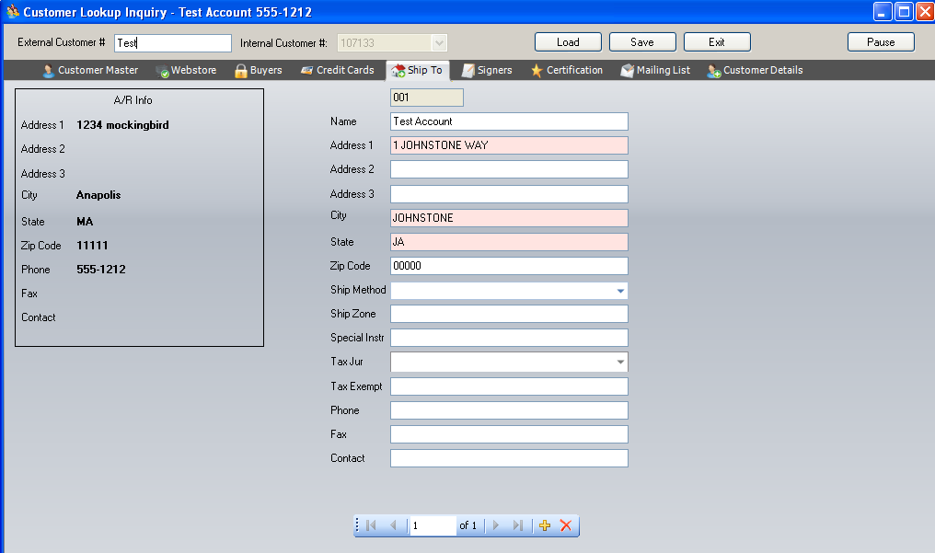
Enter the Ship To information for a customer. The customer may have multiple Ship To records. To enter a NEW ship-to number select the option. To EDIT an existing Ship-To number enter the identification number (i.e. 001) or use the forward and backward arrows to find the record. To DELETE a Ship-To record select the option.
Field Name | Description | Menu 12.2.2.4 Location
Name | Name of the addressee | Menu 12.2.2.4, Field 1
Address 1 | Street Address | Menu 12.2.2.4, Field 2
Address 2 | PO Box (if applicable) | Menu 12.2.2.4, Field 3
Address 3 | Optional Address Field | Menu 12.2.2.4, Field 4
City, State, & Zip | City, State & Zip | Menu 12.2.2.4, Fields 5, 6, 7
Ship Method | Select a Ship Method | Menu 12.2.2.4, Field 8
Ship Zone | Zone for Delivery | Menu 12.2.2.4, Field 9
Special Instructions | Shipping Special Instructions | Menu 12.2.2.4, Field 10
Tax Jurisdiction | Tax jurisdiction used for this ship method | Menu 12.2.2.4, Field 11
Tax Exempt | Tax Exempt Number | Menu 12.2.2.4, Field 12
Phone | Phone Number | Menu 12.2.2.4, Field 13
Fax | Fax Number | Menu 12.2.2.4, Field 14
Contact | Contact Person | Menu 12.2.2.4, Field 15

Signers
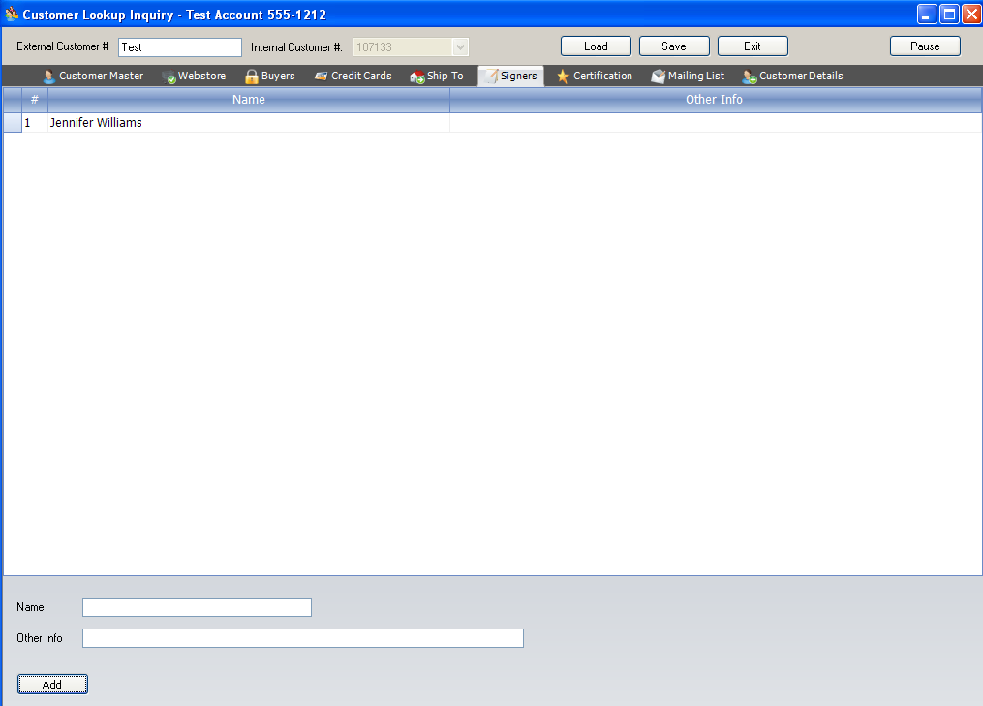
Build a list of authorized signers, these people are often considered “runners” and are authorized to pick-up ordered products. All authorized buyers are considered authorized signers.
To Add a signer enter the signers name and any notes tied the individual signer. To Edit or Delete an authorized signer, right-click on the row where the signers name is located.

Certification
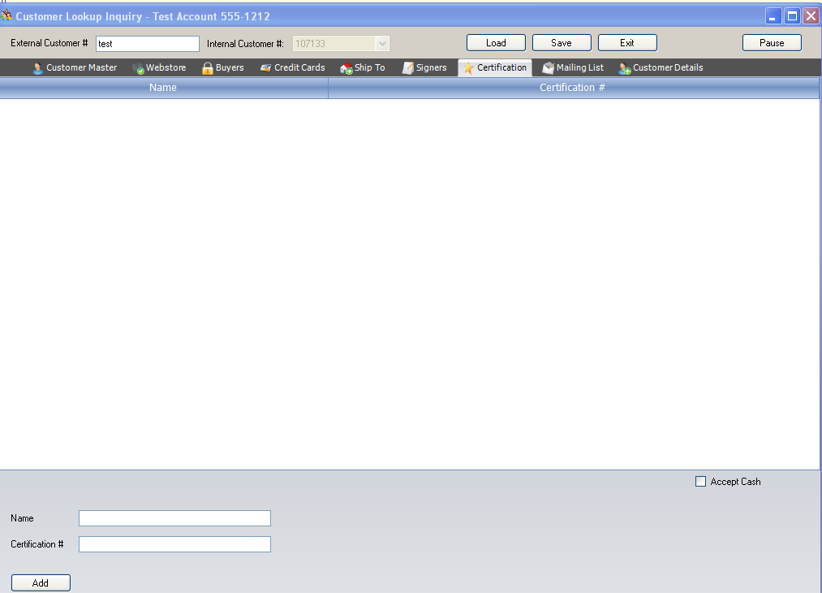
This menu contains the certification number required for hazardous products as seen in Menu 12.2.2.7. The EPA requires customers to have authorized personnel to handle hazardous products. These individuals and their EPA certification numbers must print on tickets.
Enter the customer’s name and their corresponding certificate number.
Accept Cash – Allows the customer to pay with cash so a ticket does not appear on a statement when buying hazardous products.

Mailing List
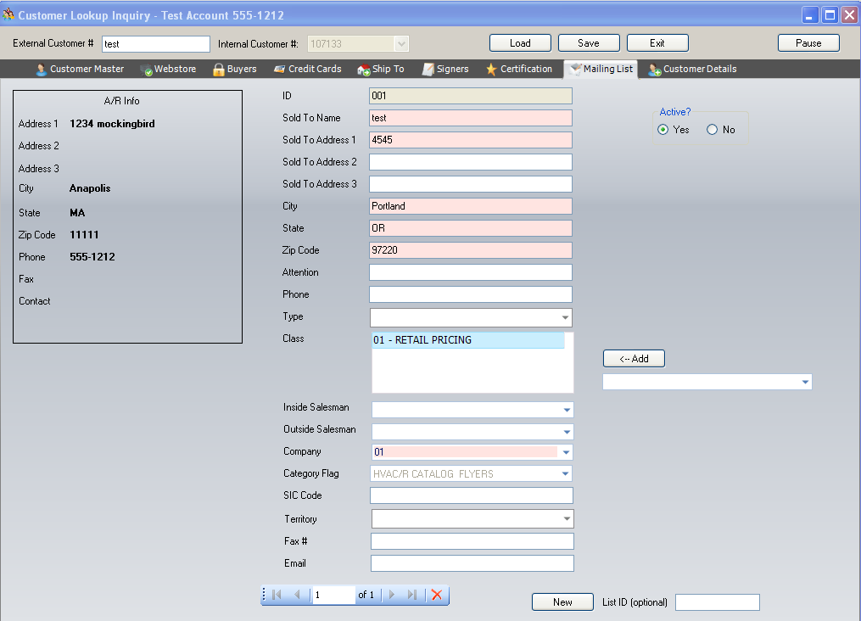
Enter the Mailing List information for a customer. To enter a NEW Mailing List click the New button. To EDIT an existing Mailing List number enter the identification number (i.e. 001) or use the forward and backward arrows to find the record. To DELETE a Ship-To record select the option.
If the customer is active check Yes so the record transmits to Corporate.
Field Name | Description | Menu 12.2.2.5 Location
ID | Mailer ID Number | Menu 12.2.2.5 Mailer #
Sold To Name | Name on the Label | Menu 12.2.2.5, Field 1
Sold to Address 1 | Catalog mailing or street address | Menu 12.2.2.5, Field 2
Sold to Address 2 | PO Box on label | Menu 12.2.2.5, Field 3
Sold to Address 3 | Optional second address on label | Menu 12.2.2.5, Field 4
City, State, Zip | City, State, Zip | Menu 12.2.2.5, Fields 5, 6, 7
Attention | Accounts Receivable Contact Name | Menu 12.2.2.5, Field 8
Phone | Phone Number | Menu 12.2.2.5, Field 9
Type | Customer Type | Menu 12.2.2.5, Field 10
Class | Label Class Maintenance screen represents the customer class. Click the Add button to see Class options. | Menu 12.2.2.5, Field 11
Inside Salesman | Inside Salesman | Menu 12.2.2.5, Field 13
Outside Salesman | Outside Salesman | Menu 12.2.2.5, Field 14
Company | Company number for this mailer item | Menu 12.2.2.5, Field 15
Category Flag | Displays catalog mailing options | Menu 12.2.2.5, Field 16
SIC Code | Standard Industry Code | Menu 12.2.2.5, Field 17
Territory | Territory Number | Menu 12.2.2.5, Field 18
Fax Number | Fax Number | Menu 12.2.2.5, Field 19
Email | Email Address | Menu 12.2.2.5, Field 20

Customer Details
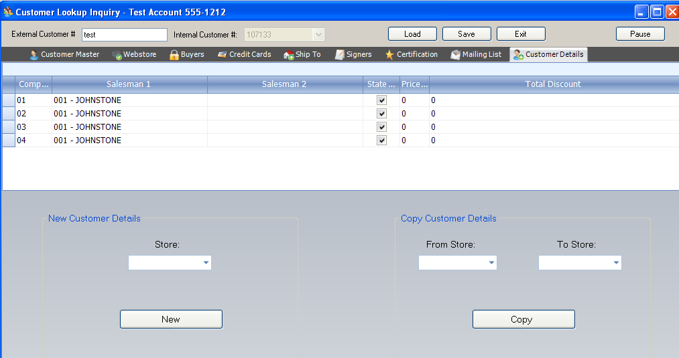
Field Name | Description | Menu 12.2.2.3 Location
Company | Company Number | Menu 12.2.2.3
Salesman 1 | Salesman Number | Menu 12.2.2.3, Field 1
Salesman 2 | Salesman Number | Menu 12.2.2.3, Field 16
Statement | Check if Customer should receive a statement | Menu 12.2.2.3, Field 2
Price | Enter Customer Price Pointer | Menu 12.2.2.3, Field 4
Total Discount | Discount Percent on Total Invoice | Menu 12.2.2.3, Field 8
New Customer Details | Creates a new detail record for a customer
Copy Customer Details | Copy one stores customer detail record to another store. | Replaces the ALL feature in Menu 12.2.2.3 where one customer record could be setup for all companies.

Appendix A

Customer Data Integration
Install Instructions

When you open CDI in Menu 12.2.2.29 you may be asked
Has CDI been installed on this computer (<enter>/N)
<enter> = Y - they have already run the install on this computer
N = quick install program, prompts are self-explanatory.
Install Steps
- The system may ask if CDI is installed, if it does Select ‘N’ and run the quick install program. In most cases your PC will detect CDI and automatically run the quick install program.
- CDI runs on Accuterm version 5.3C. If you are on a lower version the system will prompt you to upgrade Accuterm. To upgrade, follow the wizard steps. During the upgrade an exe file will be placed on your desktop. If you cannot find the exe file select this link to run instead http://www.asent.com/downloads/atw2k253c.exe
- Each PC must be running .NET 3.5. To check your .NET version go to Windows Start > Control Panel > Add or Remove Programs. Under the Currently Installed Programs list look for the Microsoft .NET version. If you do not have Microsoft .NET Framework 3.5 loaded run the download listed on this link. http://www.microsoft.com/downloads/details.aspx?FamilyId=333325FD-AE52-4E35-B531-508D977D32A6&displaylang=en
- When steps 1 and 2 are complete go back in Menu 12.2.2.29 and select <Enter> and CDI will load.

Congratulations…You’ve now successfully installed CDI!

