Creating Bar Code Labels for your Warehouse Locations

Version: Office Professional Edition 2003

First make a copy of your Warehouse Location spreadsheet. This copy should have one column for the Warehouse location and a second column for the type (either Home or Random)

Example: ** must have astericks on either side of location (ex *S0100A00*)
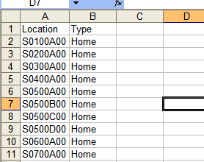
Save this file and remember where you save it and what you name it. (Recommend naming it ‘Warehouse Location Labels’ and saving it in My Documents.

Next, Open Microsoft Word and select Tools>Letters and mailings>Mail Merge

The Mail Merge wizard should come up on the right.

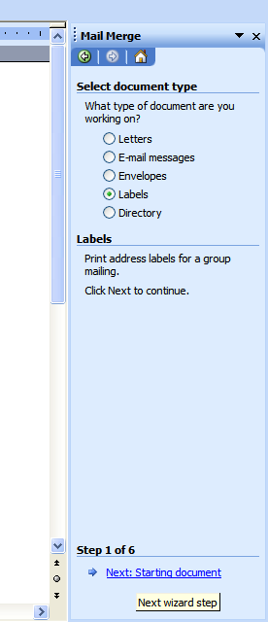
Select Labels as your document time, and then click Next: Starting Document.

In Step 2, select Label Options, then select Maco/Wilson Jones Standard
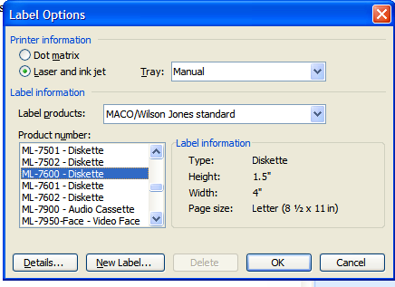
Then select ML-7600 - Diskette for the Product Number.
When you press OK, you will see label outlines on your Word Document.

Click Next: Select Recipients

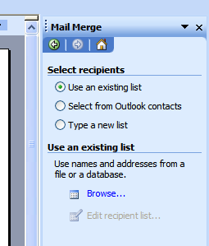
Under Select recipients, select Use an existing List, then under Use an existing list, select Browse

The Open dialog box will automatically open to My Data Sources, Select you’re My Documents folder instead, then select your Warehouse Locations Label file and click Open.

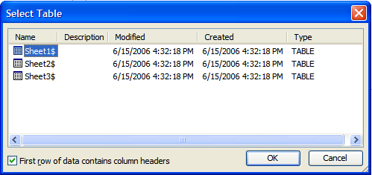
In the Select Table dialog box, make sure Sheet1$ is selected, then click OK.

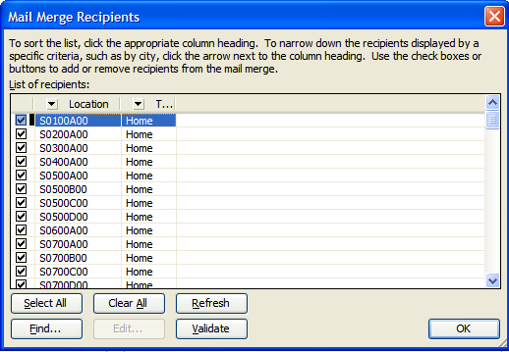When the Mail Merge Recipients window comes up, make sure all records are selected (should be by default) and lick OK

Click Next: Arrange your labels

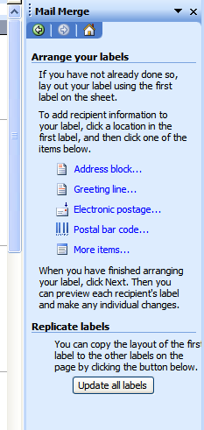
With your cursor in the first label box then in the Arrange your labels section of the wizard, select More items…
The Insert Merge Field dialog box will appear and the two fields from your spreadsheet will be shown.
Highlight each one separately and click Insert. When you’re done, click Close.
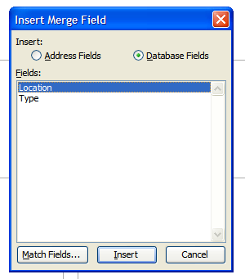

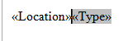

Next, place your cursor between <<Location>> and <<Type>> and Press <enter> so that Type moves to the second line. Now click the Update all labels button.

Then click Next: Preview your labels so you see the actual locations and types in all of the labels.

You now need to format the labels using the following settings

- Center the labels (Select the entire table and click the Center icon on the formatting toolbar
- Highlight the first location and change the font to Wasp 39 LC.
- While the first location is still highlighted, change the font size to 36.
- Highlight the first location Type (Home or Random) and change the font size to 24
- Use the format painter* on the standard toolbar to copy and paste these formats to the rest of the labels.
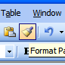
*Instructions for using the format painter. Highlight the Location, then double-click the format painter icon (Pictured). Then single-click on each of the other locations on the sheet.
Once all locations have been formatted, press <esc> to cancel the format painter tool. Repeat these steps for the Type.
Click Next: Complete the merge and then select Edit individual labels….

Selecting Edit individual labels will create a new file with all of the labels in it that can be saved separately from the mail merge file and can be emailed to other people. You don’t even have to save the mail merge file if you don’t want to, but it is a good idea just in case you need to use it again down the road. The mail merge file will only be good on the same computer that created it that has the data source (the Excel file).

When the Merge to New Document dialog box comes up, make sure All is selected and then click OK.

Save both files and then you can print your labels from the new document.

