What is a Vendor Return?: Very similar to the warranty process, a vendor return is a set of procedures for returning items to a vendor.
- If you received in too many of an item and find out later some or all need to go back.
- If you order something for a customer, it comes in, and they decide they don’t need/want it anymore.
- Return to vendor items damaged upon shipment to you.

Why Use it:
- Defined process tailored to track non-warranty returns to your vendors.
- Product is removed from inventory and tracked separately from warranty items.
- Proper audit trail is generated.
- Easy adaptation if already using the existing warranty system.

How to Use it:
There are a couple options for getting a vendor return started. The first thing to do is get the item(s) into the vendor returns file using one of the two available methods (order entry or vendor returns creation screen). Once the item(s) is in the vendor returns file, pool vendor return items together onto claims, adjust if needed, submit to vendor and upon receipt of replacement or credit, update the return claim.

Vendor returns menu 15.15 through 15.23. The Vendor Returns menu works just like the warranty menu. Similar to warranty, GL account options are available for Returns Clearing (Menu 12.1.7, #21), Returns AR (Menu 12.1.7 #20) and Returns Discrepancies (Menu 12.1.7). These accounts will be updated as part of the end of month process. EOM reports exist for the Unclaimed Vendor Returns (01-154) which should balance to the GL account in menu 12.1.7, field #21 and Open Vendor Returns Report (1-155) which should balance to the GL account in Menu 12.1.7, field #20. Two new parameters are available on Menu 35.7, fields #8 and #9 control whether the GL is updated for the warranty and vendor returns menu. Only those users using the warranty/returns module in its entirety should have these parameters set to Y.

Vendor Returns Basic Flow:
- Enter Vendor Returns Item(s) into the system
  - Order Entry Credit Memo, M-1.2, using return code 100 Vendor Returns
  - Create/Maintain Vendor Return Item(s), M-15.21
- Create the Vendor Returns Claim
  - M-5.15 Unclaimed Vendor Returns Report
  - M-15.16 Create Vendor Return Claim
- File claim with vendor and return items
  - M-15.18 Vendor Return Adjustment (if needed)
  - M-15.19 Vendor Return Transaction Report.
- Track open and pending Vendor Return Items (claimed and unclaimed)
  - M-15.15 Unclaimed Vendor Returns Report
  - M-15.17 Open Vendor Returns –Inq/Rpt
  - M-15.20 Aged Vendor Returns Receivable Report
- Update Vendor Return with Receiving or with Credit
  - M-15.22 Update Vendor Returns with Receiving
  - M-15.23 Update Vendor Returns with Vendor Credit
Vendor Returns Menu Breakdown

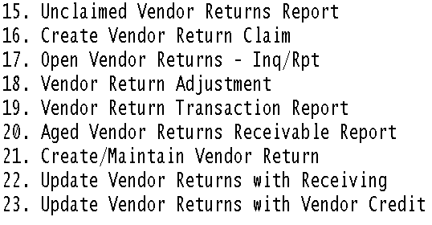

M-15.15 Unclaimed Vendor Returns Report

The unclaimed vendor returns report lists all parts that have been brought into vendor returns through the two entry methods (M-1.2 reason code 100 or M-15.21) but have not yet been turned into claims.

This report can be run by vendor, in Detail or Summary as well as run by company.

Sample ‘D’etail report:
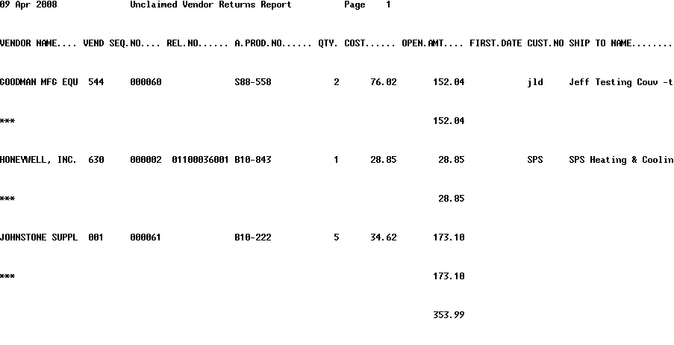

Sample ‘S’ummary report:
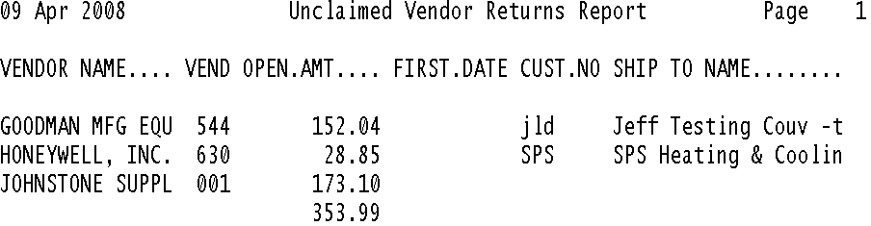

M-15.16 Create Vendor Return Claim
Menu 15.16 -Create Vendor return Claim Program allows you to create a vendor return claim with a vendor by assembling outstanding vendor return items*. This program also allows maintenance (addition or deletion) on existing claims.
*An outstanding vendor return item would be any item in the vendor return file not yet on a claim (Entered through M-1.2 with vendor return reason code 006 or via M-15.9 Create/Maintain Vendor return Items)

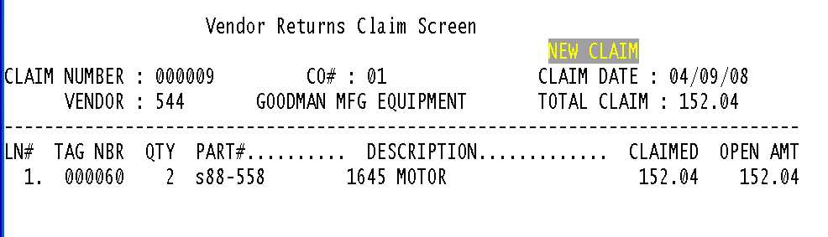
Follow these steps to create a vendor return claim:
- Proceed to M-15.16
- Enter operator code
- Enter company number or <CR> (enter) to combine unclaimed items for all companies into a single claim for specified vendor.
- Enter an existing claim number or if using pre-numbered vendor return forms enter that number _OR_ enter 'NEW' for a system assigned claim number. If the system doesn't recognize the claim number as one already on file, you will be prompted "Is this a new claim (Y/<CR>). If a new claim answer with 'Y'.
- If the claim number entered is an existing claim, the information will display. If the claim entered is new the next prompt will be 'C'OMBINE CLAIMS FROM ALL STORES OR <CR> FOR JUST COMPANY 01 (C,<CR>) Enter for the company input in step 3 or 'C' to combine vendor return items into this claim for all companies.
- If the claim is new, the next prompt is the vendor number field. Input vendor number for the selected vendor return items.
- Once the vendor number is entered the system searches throughout the vendor return file for any unclaimed items for the input vendor and displays them each on a line, returning the following prompt line. This prompt provides a multitude of options for addressing the line detail of the current claim
LN#;'P'RIOR;'DELETE';'BO'BACKOUT;'ADD';'H'OLD;'HP'RINT;'F'INALIZE;'UNF'INALIZE;'CD'CONTACT DATE: - ENTER OPTION

LN# -After entering line number, enter 'CHANGE' to make changes to that line or 'Y***' to delete the line (only from this claim and NOT the vendor return file).
ENTER -displays the next page of vendor return items on this claim (if any).
Prior -displays the previous screen of vendor return items on this claim (if any).
DELETE -deletes the current claim if it has NOT been finalized. It does not delete the line items from the vendor return (just the current claim only).
BO -BACKOUT -Backs out the current claim session without any changes.
ADD -Adds items to the claim for this SAME vendor. If the vendor number needs to be changed on a vendor return item, change it through M-15.9.
Hold -Files the claim without finalizing it. Also, there will be NO printed copy of the claim.
HP -Hold & Print -Files the claim without finalizing it AND prints a copy for review. Check the claim to verify accuracy prior to finalizing.
Finalize -Finalizes the claim and prints a claim form for the vendor. This process updates each vendor return item and includes the claim number and date for tracking and aging reports.
UNFinalize -After a claim has been finalized this option Unfinalizes the claim if no item on the claim has been updated through either of the two vendor return receiving programs (M-15.10 and 15.11). Will have to confirm with 'Y***' or to keep the claim on file answer 'N'o.
CD Contact Date -Records a contact date for this claim for follow-up with vendor.
Finalize the New Claim

What to do: Prepares and Prints the vendor return document for the vendor. Involves making a few decisions about the claim/products and providing select information necessary for the transaction.

Product Disposition -After selecting 'F' to finalize a claim will need to determine the product disposition. The options are listed below (options 1 - 5)
- Keep at Store
- Return to Vendor
- Return to Portland Distribution Center (PDC)
- Return to Memphis Distribution Center (MDC)
- Field Scrap

Return Goods Authorization# -If returning product to vendor will need to enter an RGA# (will recieve the RGA# from vendor), Who provided the RGA# (EX: RGA# Given by).
- Exchange
- Replacement
- Repair
- Credit
- Vendor Option (Credit/Repair/Replacement)
Purchase Method -Product information where product originated.
- Distribution Center
- Drop Shipment
- Vendor
- Not Specified
Ship Method/Ship Via -Ship method for claim.
- UPS
- Truck
- Other
Freight Payment Method -Payment method arranged for return.
- Prepaid
- Collect
- Deduct
- 3rd Party Billing
Misc Freight Fields -The following fields may contain info provided by you.
  - Weight in Pounds
  - Number of Cartons
  - Number of Pallets
  - Enter Freight Charges
Finish the Claim: After reviewing the final claim screen for accurate information enter '0' to continue and print out your claim. Right after the printer select screen, there will be an option for number of copies-print up to 125 copies of the vendor return claim.

M-15.17 Open Vendor Returns - Inq/Rpt
The Open Vendor REturns report is a list of all outstanding vendor return claims. The output details the vendor assigned to the vendor return item, the date of return, the invoice or release number of the return, the extended cost of the return, and the claim number and date of the filing.

Sample Open Vendor Returns Report
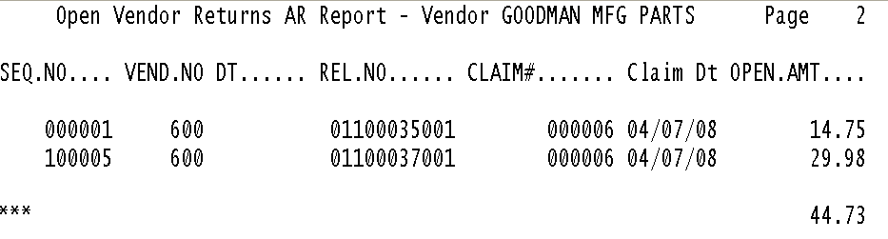

M-5.18. Vendor Return Adjustment
Menu 15.18 –Vendor Return Adjustment Program allows you to make changes to a Vendor Return item even if it has been claimed (M-15.16 Finalized). This program provides the ability to assign the claim to a specific general ledger account or change the accounting period affected by the claim. Any change (amount, gl#, reference, etc) constitutes an adjustment.

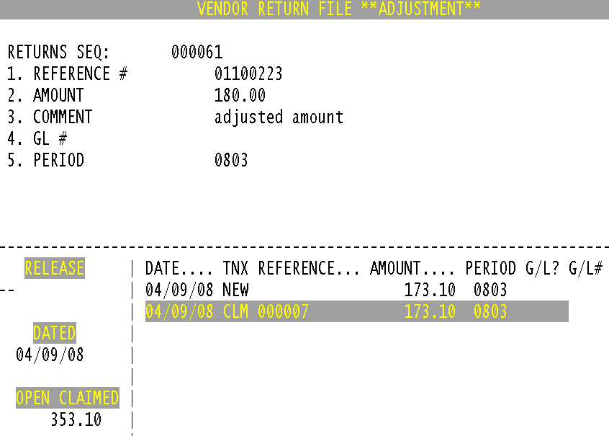

Follow these steps for Vendor Return Adjustments:
- Proceed to M-15.18
- Enter operator code
- Vendor Return Sequence -Enter the Vendor Returns sequence number to adjust. Enter a vendor return item number (found on an existing claim in the TAG NBR column) or this number can be arbitrarily assigned by the operator. If an existing vendor return item is entered, the current audit displays on the screen. At this point you can edit Reference#, Amount, Comment, GL#, Period.
***Cannot change the existing lines displayed in the body of the vendor return adjustment screen_only add to it by making adjustments to lines 1 through 5.

- Accept the Vendor Return Adjustment -After adjusting the appropriate fields (Reference#, Amount, Comment, GL#, Period) '0' to accept.
- Review Adjustment -To verify the adjustment go back into M-15.6, put in the reference number as entered in step 3 and the adjustment will show as an 'ADJ' transaction in the body of the Vendor Return adjustment screen.

M-15.19. Vendor Return Transaction Report
This report details all transactions that have occurred on a vendor return item (claimed or not), including the original invoice and any adjustments.

M-15.20 Aged Vendor Returns Receivable Report
This report provides an aged listing of finalized vendor return claims to help track vendor returns performance. Based on the claim date, the open amount of each open claim is listed in its appropriate 30-day aging bucket.

This report can also be used to view Aged Vendor Returns Receivables for "all" of your stores.
- Select the printer number to print the report
- Enter vendor number(s), seperate multiples with ';' <CR> for All
- Choose (S)ummary or (D)etail Report
- To combine all stores into one report type 'C' and return.

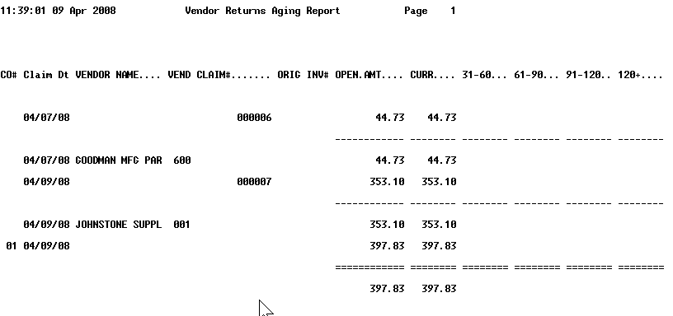

M-15.21 Create/Maintain Vendor Returns
Besides Order Entry, this is the only other menu for creating a vendor return claim item.

Sample M-1.2 Entering Item into Vendor Returns file
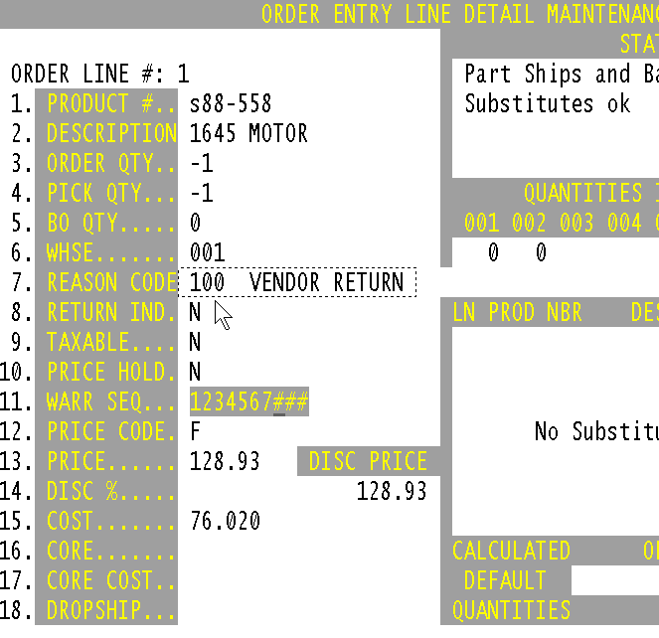

Screen Shot of M-15.21
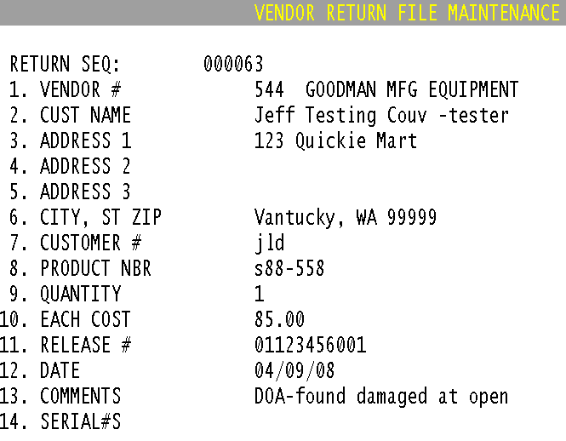

Use this program to create a vendor return item only if you cannot use the normal Order Entry process. Since Order Entry also accepts unique vendor return sequence numbers, there are few reasons to use this program. However, an exception to this would be an item that appears damaged when its box is opened to show the customer: DOA, damaged in shipment but not evident until the box is opened.

- Enter your operator initials.
- Enter your company number.
- Enter the vendor return sequence number which is either arbitrarily assigned or, in most cases, is from preprinted vendor return tags.
- If the vendor return sequence number already exists, the information from the vendor return claim will display.
- If the number entered is new, the prompt will display
Not On File, Is This A New Item (Y/CR)? enter "Y" and then enter the needed vendor return information.
- Serial Numbers - When field 14 is selected the Serial Number Maintenance Screen will display. Several serial numbers may be entered in to this screen.
Note: The cursor "stops", required fields, and defaults can be entered from the vendor return sequence fields, just as in all maintenance programs.
- Select a line to change the informational field of the vendor return item, but not any of the amounts.
- If the item has been claimed, the program displays a warning, enter 'y****' to make any changes. "Change tag#' is the sequence number.
- '0' to accept and return to previous screen.
- '0' to accept again will prompt for -DO YOU WANT TO REMOVE THIS ITEM FROM INVENTORY (Y/<CR>)? 'Y' removes the item from inventory, while Enter does not affect inventory.

M-5.22 Update Vendor Returns with Receiving
Use this program to receive vendor replacements into stock and to update inventory.

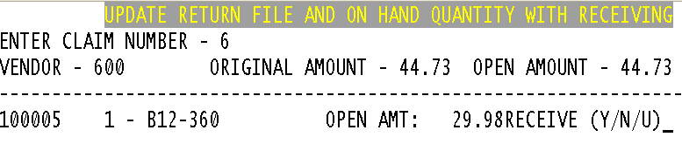
- Enter your operator code
- Enter the claim number (not the vendor returns sequence number).
- At the prompt 'IS THIS THE CORRECT CLAIM (Y/N)? enter 'y' to pull up the claim only, or 'n' to scroll to the next claim in sequence.
- At the prompt 'RECEIVE (Y/N/U)? enter;
  - 'Y' to update the claim only
  - 'N' to update nothing
  - 'U' to update the claim and quantity on hand.
- Enter next claim number or 'end'

M-5.23 Update Vendor Returns with Vendor Credit
If a vendor sends a credit for the vendor return claim, this program allows you to update your vendor returns general ledger files. For disputed items, you can claim credit for all or part of the claim.
Vendor credits are set up in Menu 13.1.1, Accounts Payable Voucher Input.
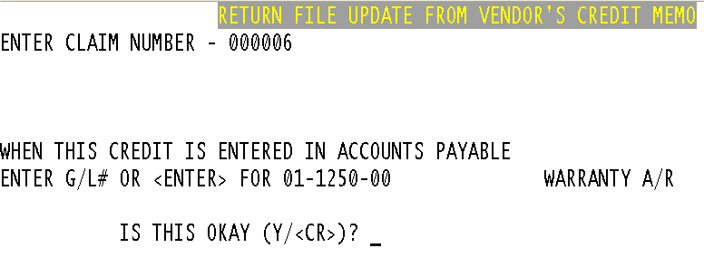

- Enter the claim number for which the credit was received. The following prompt appears: WHEN THIS CREIDT IS ENTERED IN ACCOUNTS PAYABLE WHAT G/L NUMBER WILL BE USED - ##-####-##
- Enter the general ledger number entered on the credit, usually the inventory general ledger number. At the next prompt IS THIS OKAY (Y/<CR>)? answer 'y' if correct. Enter 'n' to make changes to the general ledger number.
- Confirm the vendor and original amount are correct on the next screen Vendor Returns File Update From Vendor's Credit Memo. If correct answer 'y' at the next prompt IS THIS THE CORRECT CLAIM (Y/N)?
- IS THIS CLAIM COMPLETE AND READY FOR CLOSING (Y***/N)? If part of the claim is in dispute, answer 'n' and update individual lines of the claim. If claim is complete type 'y***' and proceed.
- The total amount cleared will display and the following prompt IF THIS IS NOT THE SAME AS THE CREIDT YOU RECEIVED, DO YOU WISH TO APPLY THE DIFFERENCE TO A DIFFERENT G/L # (<CR>/N). If you Enter <CR>, type in the amount of credit received from the vendor, then type the general ledger number to apply to. Enter 'y' to accept the Vendor return general ledger number and the amount of the credit received.
- Enter the next claim number or 'end'.

