Data Services
U2008.2 Upgrade Documentation
Winter 2008/2009
COUNTER/SALES

General Updates
Description: Automatically rolling product, customer and vendor number that are entered in lowercase to uppercase.
Menu Path: General Programming
How to Use it: All Product, Customer and Vendor numbers that were entered in lowercase will be transferred automatically to uppercase on a weekly basis. This is an auto process done by the system.

Menu 1 – Order Entry & Invoicing
Description: Re-run credit check on customer orders initially approved for sale.
Menu Path: Menu 1.2 and Menu 35.1, screen 3, field 13. REQUIRE credit authorization on every access
Why Use it: Setting this parameter ensures that regardless of origination of the order the customers credit is always checked. Credit will be checked when the order is accessed and re-checked with filed away.
How to Use it: Go to Menu 35.1, screen 3, field 13 and set field to ‘Y’

Description: Add options for Date and Part Number ranges to the serial number report.
Menu Path: Menu 12.3.30 Serial Number Report
Why Use it: The Serial Number Report (m 12.3.30) has been updated, now it is selectable by specific product#, customer#, warehouse, or serial# as well as date range. The new version of this serial number report provides greater flexibility and selection criteria to tailor your report for the most commonly requested needs.
How to Use it:
- Menu 12.3.30 Serial Number Report
- Select printer
- Select reporting options to select by serial#, customer# or product#...see screen shot: 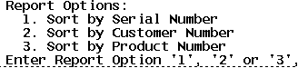
- Depending on reporting option selected, input serial#, customer# or product# and continue on to the date range.
- Input beginning and ending date range. 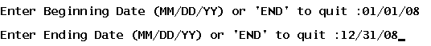
- Input AOC vendor number or <ENTER> for all.
- Input Warehouse or <ENTER> for all.
- See Sample of serial# report run by customer.
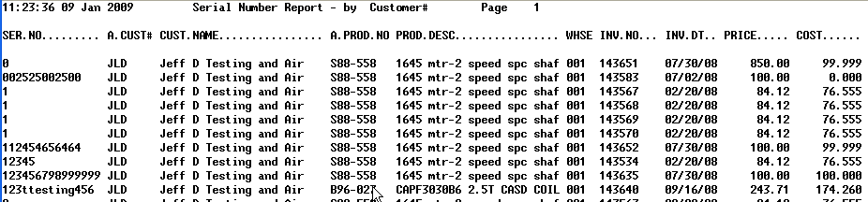

Menu 19 – Inquiries
Description: Update and expanded information on the Direct Cost option in stock status.
Menu Path: 19.6 Stock Status, ‘D’irect Option
Why use it: This updated option in stock status will display a new window of costs when selecting the ‘D‘ option. The Direct Cost window will show all the costs related to a product including Corp‘s Large Quantity Cost.
How to use it: Go to Stock Status (menu 19.6), input the item, and select the ‘D’irect Option to display the direct, branch, average and warehouse cost for the item.
The WHSE field will display costs for the product that are specific to your stores (this affects those stores that have branches in other states).
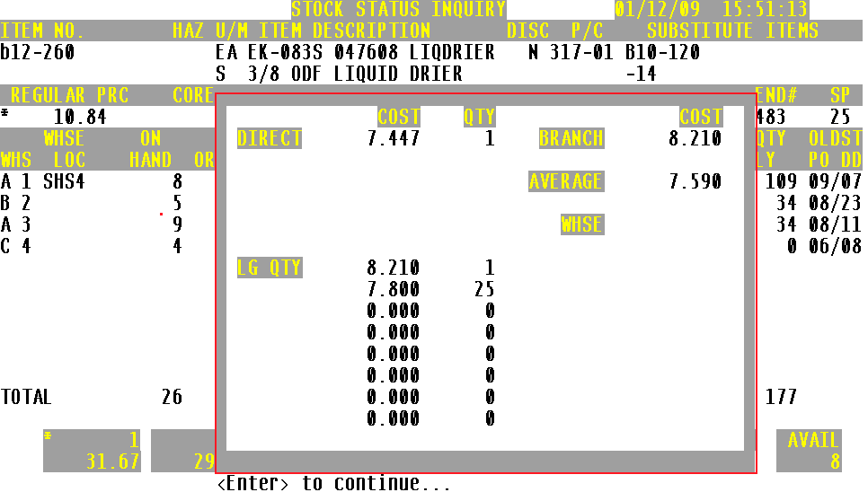
Menu 35 – Parameter
Description: Parameter driven notification of standard ‘P’ack quantities in order entry.
Menu Path: To Setup Menu 35.1, screen 3, field 12 for prompt in Menu 1.2
Why Use it: One goal is to eliminate the potential for over/dead stock before it even gets into your warehouse. One way identified how over/dead stock gets into our warehouses is by customer orders that don’t match purchasing pack quantities. Many of these scenarios can be prevented with a little information that is already available in the ‘P’ack quantities, notifying counter staff of the pack requirements in order entry.
For example, you must purchase a product in a pack of 12 from the DC. You have 12 on hand. Your customer orders 20. Since you have less than 20 on hand, you will now be in a position to order more from the DC to fill this backorder, minimum order of 12. Once you fill the backorder of 8, you will have 4 on hand, less than the normal standard pack. With the added notification, your counter staff will now see the pack requirements and have the opportunity to up-sell to the higher amount.
How to Use it:
The following conditions must be met:
- The parameter needs to be set in Menu 35.1, screen 3, field 12 to ‘Y’ (see screen shot 1).
- Product detail record, Menu 12.3.2.3, field 15 must have a pack quantity with a ‘P’ (see screen shot 2). EX: 12P
- Quantity Ordered Requirement Notification: in order entry Menu 1.2, the customer attempts to order a quantity of a product that is <<MORE>> than what is on-hand (creating a customer B/O scenario –kicking off the purchasing process). IF the customer orders less than what is currently on-hand that is OK, but if they order more -counter staff will be notified of the Pack quantity requirement and prompted for ‘Y***’ to continue (see screen shot 3) or increase the order to meet the purchasing pack requirement..
Screen Shot 1: Setup the Parameter Menu 35.1, screen 3, field 12.
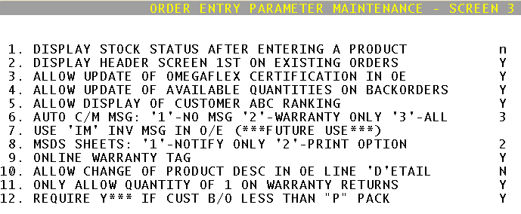
Screen Shot 2: Standard Pack Flags

Screen Shot 3: Order Entry Quantity Requirement
