Data Services
U2008.2 Upgrade Documentation
Winter 2008/2009
ACCOUNTS PAYABLE/ACCOUNTS RECEIVABLE

General Updates
Description: Automatically rolling product, customer and vendor number that are entered in lowercase to uppercase.
Menu Path: General Programming
How to Use it: All Product, Customer and Vendor numbers that were entered in lowercase will be transferred automatically to uppercase on a weekly basis. This is an auto process done by the system.

Description: Users now have the option to include a flyer with the faxed or emailed monthly statements.
Menu Path: Custom Program
Why use it: Stores now have the ability to attach/include a monthly flyer with their customer statements that are emailed or faxed. Flyers can be sent monthly or on demand, the flyers must be formatted as a pdf. If you do not have the ability to create a pdf, a free site is www.cutepdf.com. How to use it: Users have the option to have this program loaded onto their system. If you are interested in receiving this upgrade, log a job online with Database Support http://dst.myjohnstone.com/Login.asp.

Description: Spring Pre-Season Pricing
Menu Path: General Programming Update
How to Use it: The Spring Pre-Season pricing program (SPS2009) has been loaded with an expiration date of 07/31/09. To setup customers on this program, go to Menu 12.2.2.2, Screen 2, Field 7 and add SPS2009 to the list of programs.

Menu 1 – Order Entry & Invoicing
Description: Re-run credit check on customer orders initially approved for sale.
Menu Path: Menu 1.2 and Menu 35.1, screen 3, field 13. REQUIRE credit authorization on every access
Why Use it: Setting this parameter ensures that regardless of origination of the order the customers credit is always checked. Credit will be checked when the order is accessed and re-checked with filed away.
How to Use it: Go to Menu 35.1, screen 3, field 13 and set field to ‘Y’

Menu 4 – Accounts Receivable
Job Description: Option to enter invoice number for payment application
Menu Path: Menu 4.1.1 Cash Receipts Entry
Why Use it: When posting AR checks in 4.1.1, instead of scrolling through screens of invoices to find the right invoices to apply payment to, entering a single invoice will now pull up a specific invoice. Enter the six-digit invoice number, the company number does not need to be input at the following prompt;
Job Description: Swap locations of Pd TD$ and Pay$ fields
Menu Path: Menu 4.1.9 Credit Manager Inquiry
How to Use it: The “Payd TD$” and “Pay$” fields in 4.1.9 have been switched. Now the “Pay$” field will display the amount of the last check posted on the date reflected in the field immediately above it. Also, ‘Pd TD$’ has been updated to ‘PYTD$’, Paid Year To-Date.

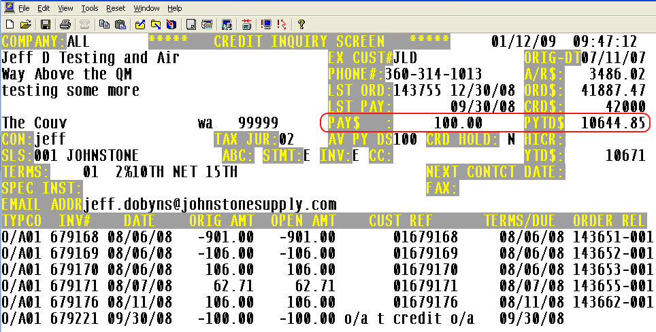

Job Description: Display statement invoice delivery method in the Credit Manager Header screen.
Menu Path: Menu 4.1.9 Credit Manager Inquiry
Why Use it: To view the Statement and Invoice delivery method for a specific customer.
How to Use it: Go to Menu 4.1.9 and enter the desired customer number. The statement and Invoice delivery method displayed below is pulling from Menu 12.2.2.2 field 31 (Invoice) and field 34 (Statement). For a complete list of delivery methods view the documentation on this link http://dst.sitemax.com/InvStmtSendOptions.asp or enter a ‘?’In field 31 or Field 34.
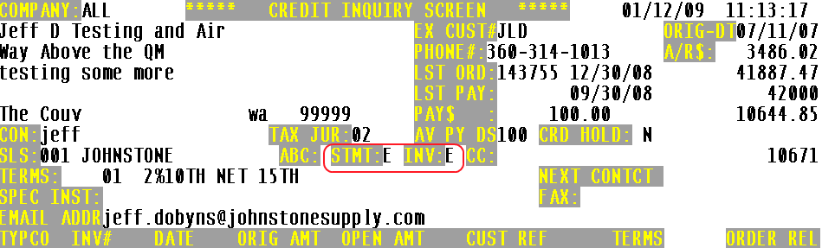

Description: Generate a FT (File Transfer) Service Charge report before Service Charges are updated
Menu Path: Menu 4.3.6.11 Laser Service Charge Calc & Invoices
How to Use it: A printer select prompt has been added to Menu 4.3.6.11, use the ‘FT’ option to review the service charge listing before the update of service charges to the AR file.
Menu 12 – File Maintenance
Description: New GL Control for 'Inbound Freight'
Menu Path: Menu 12.1.7, field 23 Inbound Freight - General Ledger Control Maintenance
How to Use it: The addition of a freight field in 12.1.7, field #23 has been added to use as inbound freight when auto-posting Corp invoices in 13.20.3. If this field is blank, the system will default to the GL account listed in field #3. FRT G/L NO (Freight G/L Number)

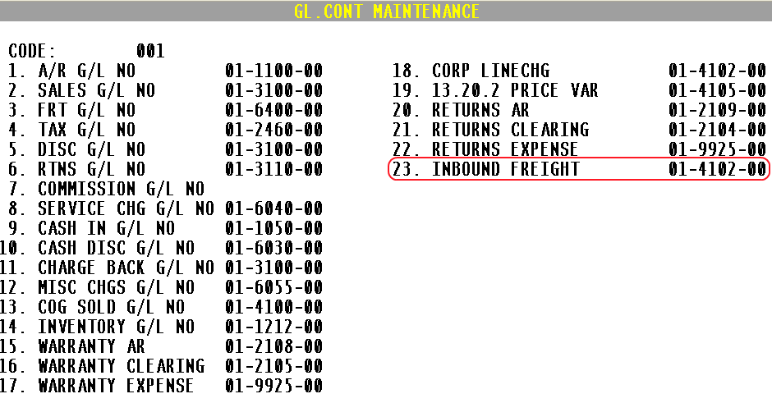
Menu 13 – Accounts Payable
Description: Display vendor notes in Payables Inquiry
Menu Path: Menu 13.5 Vendor Payables Inquiry
Why Use it: Using the NOTES feature of the system, it is now possible to add notes to a vendor so that you can view these notes in Menu 13.5.
How to Use it: If a vendor has notes you’ll see ***NOTES*** indicated in the upper right-hand side of the screen. To View the notes enter ‘NOTES’.
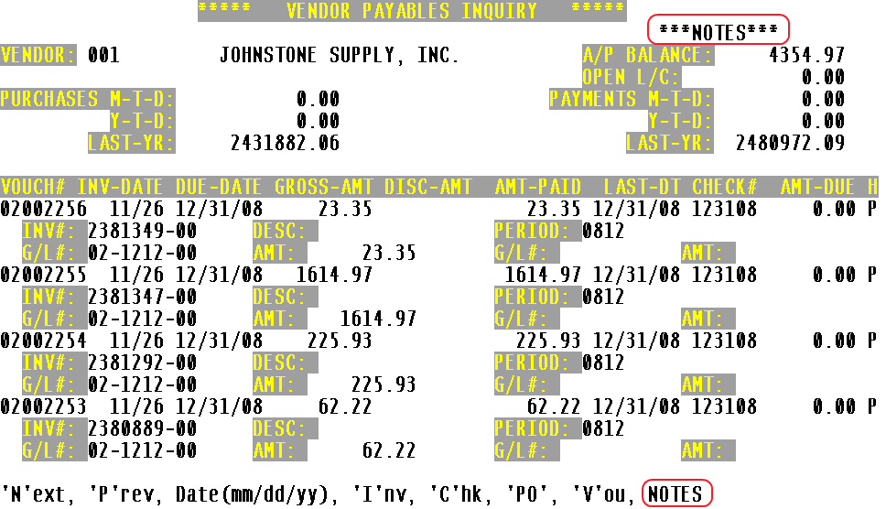
Notes are entered in the system by typing NOTES at the Main Menu.
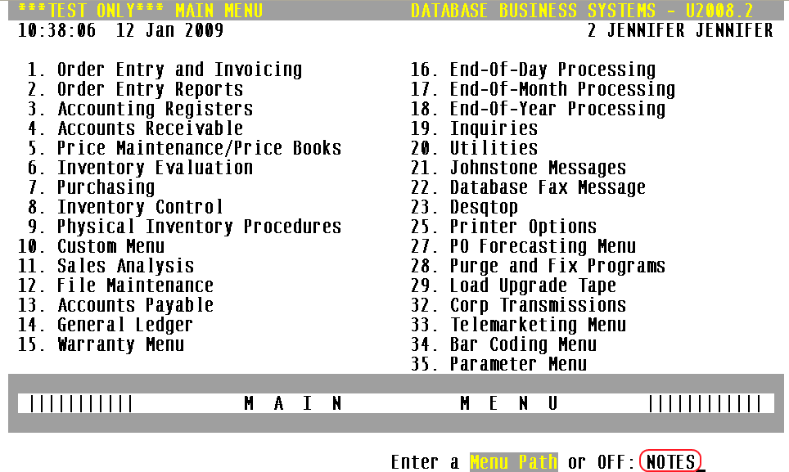
Description: Access to have Inquiry menu while in 13.20.2
Menu Path: Menu 13.20.2 Purchase Order Receipts Update to A/P
Users can get to the inquiry menu from within 13.20.2, using the “INQ” option at the bottom of the screen. This is a useful tool in researching purchase orders while vouchering.
