Data Services
U2008.2 Upgrade Documentation
Winter 2008/2009

General Updates
Description: Automatically rolling product, customer and vendor number that are entered in lowercase to uppercase.
Menu Path: General Programming
How to Use it: All Product, Customer and Vendor numbers that were entered in lowercase will be transferred automatically to uppercase on a weekly basis. This is an auto process done by the system.

Description: Users now have the option to include a flyer with the faxed or emailed monthly statements.
Menu Path: Custom Program
Why use it: Stores now have the ability to attach/include a monthly flyer with their customer statements that are emailed or faxed. Flyers can be sent monthly or on demand, the flyers must be formatted as a pdf. If you do not have the ability to create a pdf, a free site is www.cutepdf.com. How to use it: Users have the option to have this program loaded onto their system. If you are interested in receiving this upgrade, log a job online with Database Support http://dst.myjohnstone.com/Login.asp.

Description: Spring Pre-Season Pricing
Menu Path: General Programming Update
How to Use it: The Spring Pre-Season pricing program (SPS2009) has been loaded with an expiration date of 07/31/09. To setup customers on this program, go to Menu 12.2.2.2, Screen 2, Field 7 and add SPS2009 to the list of programs.

Menu 1 – Order Entry & Invoicing
Description: Re-run credit check on customer orders initially approved for sale.
Menu Path: Menu 1.2 and Menu 35.1, screen 3, field 13. REQUIRE credit authorization on every access
Why Use it: Setting this parameter ensures that regardless of origination of the order the customers credit is always checked. Credit will be checked when the order is accessed and re-checked with filed away.
How to Use it: Go to Menu 35.1, screen 3, field 13 and set field to ‘Y’

Menu 4 – Accounts Receivable
Job Description: Option to enter invoice number for payment application
Menu Path: Menu 4.1.1 Cash Receipts Entry
Why Use it: When posting AR checks in 4.1.1, instead of scrolling through screens of invoices to find the right invoices to apply payment to, entering a single invoice will now pull up a specific invoice. Enter the six-digit invoice number, the company number does not need to be input at the following prompt;
Job Description: Swap locations of Pd TD$ and Pay$ fields
Menu Path: Menu 4.1.9 Credit Manager Inquiry
How to Use it: The “Payd TD$” and “Pay$” fields in 4.1.9 have been switched. Now the “Pay$” field will display the amount of the last check posted on the date reflected in the field immediately above it. Also, ‘Pd TD$’ has been updated to ‘PYTD$’, Paid Year To-Date.
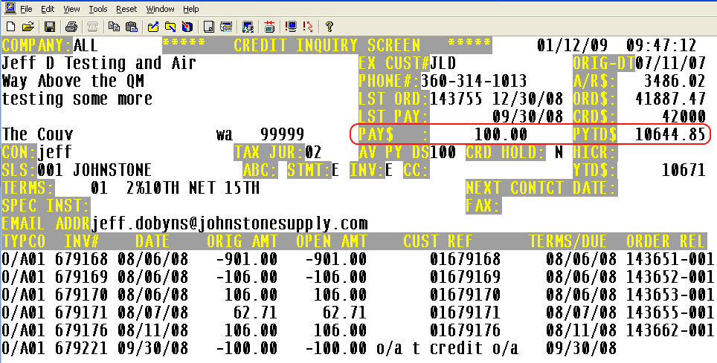

Job Description: Display statement invoice delivery method in the Credit Manager Header screen.
Menu Path: Menu 4.1.9 Credit Manager Inquiry
Why Use it: To view the Statement and Invoice delivery method for a specific customer.
How to Use it: Go to Menu 4.1.9 and enter the desired customer number. The statement and Invoice delivery method displayed below is pulling from Menu 12.2.2.2 field 31 (Invoice) and field 34 (Statement). For a complete list of delivery methods view the documentation on this link http://dst.sitemax.com/InvStmtSendOptions.asp or enter a ‘?’in field 31 or Field 34.
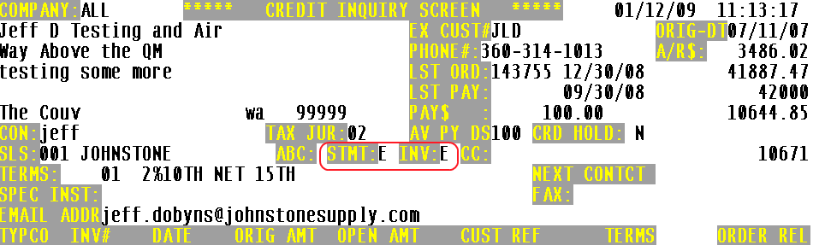

Job Description: Generate a FT (File Transfer) Service Charge report before Service Charges are updated
Menu Path: Menu 4.3.6.11 Laser Service Charge Calc & Invoices
How to Use it: A printer select prompt has been added to m-4.3.6.11, use the ‘FT’ option to review the service charge listing before the update of service charges to the AR file.

Menu 5 – Pricing
Description: Addition of columns to sales reports.
Menu Path: Menu 5.21 List of Programs and Menu 11.4.11 Company Totals Inquiry (EOD/EOM)
Why Use it: Additional critical info has been added to these reports/Inquiries. By adding these fields we have helped streamline your sales monitoring by incorporating more pertinent fields into specific reports.
How to Use it: We have modified Menu 5.21 and Menu 11.4.11
- Menu 11.4.11 we have added columns to this inquiry that reports the number of invoices, the invoice average value in the current year, the invoice average value in the previous year, the invoice average value 2 years ago.
  - The new columns display in the first three columns of the inquiry.
  - Depending on which year option selected, will determine which historical data will display.
    - Select 1) This YEAR –the system will display current year values and last year.
    - Select 2) LAST YEAR –the system will display last year invoice values and 2-years ago.
    - Select 3) 2YR AGO –the system will display invoice values from 2 years ago and 3 years ago (as the data is built).
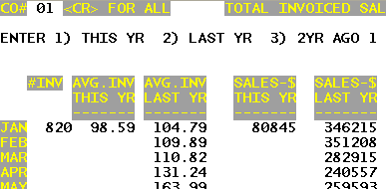

- Menu 5.21 –We have added some sales columns to this report to make it more useful in monitoring activity and effectiveness of your programs. This will list sales for a program. The sales values in this report are MTD -Month-To-Date, YTD -Year-To-Date and LY-Last Year. 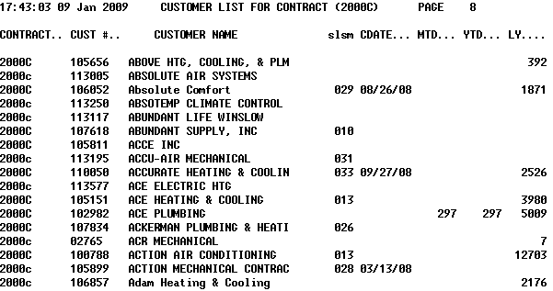

Menu 6 - Inventory Evaluation
Description: The Menu-6.8 Stock Out report has been changed to only show those parts that have had a stock out in the review days selected. In addition, a column has been added for LAST.DATE – this is the most recent out of stock date.
Menu Path: 6.8 Stock-out Report or from the Inventory Class Menu 27.20.3.7 Stock-out Report
Why use it: Review monthly stock outs by ABC code and associated lead times/safety stock.
How to use it: Menu 6.8 Stock-out Report
Important – When running this report keep the following cautions in mind:

1) The Lost sales appearing on the report are NOT necessarily lost sale dollars. This report assumes that sales were lost while you were out of stock. Realizing that this is not true every time, this report considers those.

2) The ABC ranking seen on this report will pull from Menu 6.30 only if you have Menu 35.11, Field 13 (Use new ABC in ROP/EOQ calculations) is set to ‘Y’ and the ROP is set to auto-calculate. If 35.11, Field 13 is NOT set to Y then the ABC ranking displayed on this report will pull from the old cost pool program http://dst.sitemax.com/ABC_Sales_Ranking.asp.

The selection for running this report is; warehouse number and number of days to review, DST recommends NOT going beyond 180 days, 90 days is recommended number of days to review.

Stock-out report on "A" & "B" Items
Enter Warehouse (3N)? 001
Enter number of days to review?14

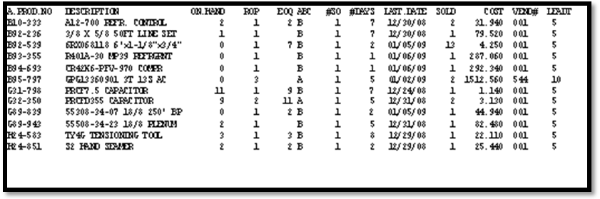
Job Description: Enhancements to "List of Inventory Problems" report

Menu Path: Menu 6.21 Possible Inventory Problems & Menu 16.5 (01-151) EOD Report

Why Use it:
- Purpose: Identifies recent inventory issues that could lead to “dead inventory” if not addressed immediately. Identifies all transactions that happened the previous day, including credits, adjustments and cancelled items.

- Process:
  - 1) Look at Cost of the item
  - 2) Evaluate if the item can be transferred to another branch
  - 3) Return to Vendor

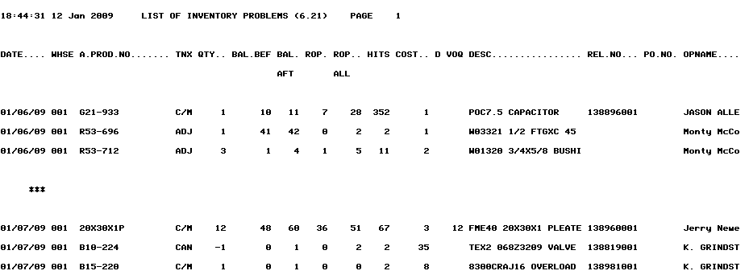

How to Use it: Possible Inventory Problems report is designed to identify transactions where the inventory has increased for an item that meets one of the following criteria:
- Product is Discontinued or a "T"empory Item (NS)
- ROP is zero
- The On Hand (BAL AFT) has taken the inventory level from below the ROP factor to over the ROP factor
  - See ROP factor in Menu-27.1.21, field 16. Inventory Problem report - ROP factor
  - If the ROP factor field is blank, the default is 2.0 (2 times the ROP)
- POR - purchase order receiving will be added to the report, if one of the above 3 criteria is met AND the receiving quantity is greater than the ordered quantity
The difference between Menu 6.21 and the EOD report is that Menu 6.21 is selectable by beginning and ending dates. Also, today's cancelled orders that result in a possible inventory problem will be on the report "real-time".

Menu 7 – Purchasing
Description: Allow PPM messages in PO's that do not show on faxed and emailed copies
Menu Path: Menu 7.1 and Menu 7.30 Fax/Email PO thru Linux Server
Why Use it: Sometimes it’s necessary to add message lines to purchase orders for internal informational or reference purposes that don’t need to display on the final document that the vendor receives. For example, these could be message lines specific to a customer order or delivery information for the receiving department.
How to Use it: When creating the PO, enter the message line like you normally do using ‘M’ for message and simply preface the text of the message with PPM. Any message line with leading PPMwill not print on the PO.
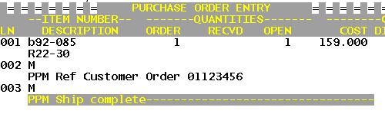

Menu 9 – Physical Inventory
Description: Run the Items Not Scanned report before running the 9.20.5 Freeze Inventory
Menu Path: Menu 9.20.7 Items Not Scanned Report
Why Use it: The Items Not Scanned report m-9.20.7, can now be run prior to freezing inventory in menu 9.20.5. This change allows users to scan in locations missed while still in the pre-count phase.

Menu 12 – File Maintenance
Description: New GL Control for 'Inbound Freight'
Menu Path: Menu 12.1.7, field 23 Inbound Freight - General Ledger Control Maintenance
How to Use it: The addition of a freight field in 12.1.7, field #23 has been added to use as inbound freight when auto-posting Corp invoices in 13.20.3. If this field is blank, the system will default to the GL account listed in field #3. FRT G/L NO (Freight G/L Number)
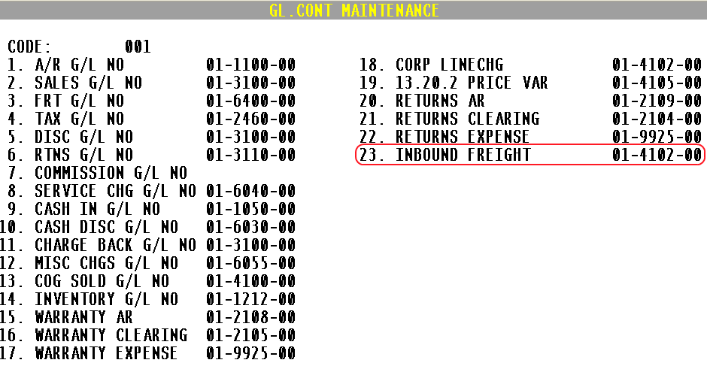
Description: Add minimum number of months to expire to the Minimum ROP field.
Menu Path: Menu 12.3.2.3 Product Detail Maintenance
Why Use it: A prompt has been added to m-12.3.2.3 Field 6 Min ROP. The system will now prompt for the # of months to maintain the Minimum ROP after the ROP number is changed. Use menu 27.1.10 Minimum & Frozen ROPs, Days Supply to review the ROP information. Please note: This prompt has not been added to 27.5. Maintain Forecast.
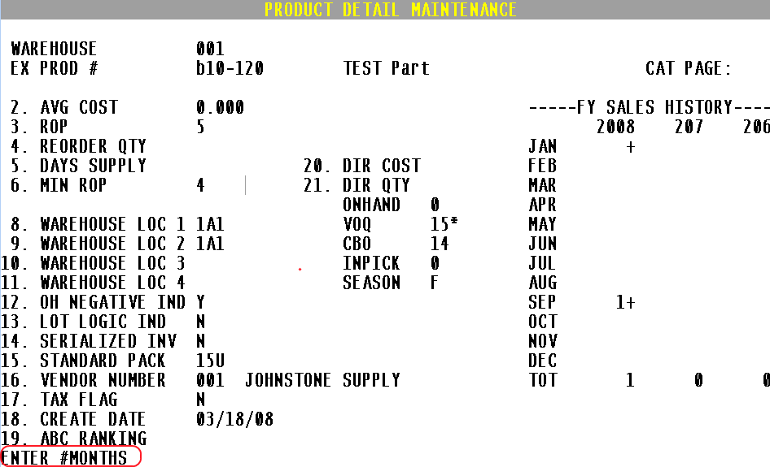
How to Use it: After the Min ROP is entered in field 6, the system will prompt for the number of months to hold the minimum ROP. The system will reset the MIN ROP to the number calculated in the forecast if this field is not maintained and the time expires.
To maintain the ROP, read the online documentation in Menu 27.20.3.32. Minimum & Frozen ROPs - Days Supply. Reviewing the minimum ROP’s should be part of a monthly review process
The MIN ROP will be set to the number entered in Field 6, indefinitely, if nothing is entered in the #Months field.
Description: Add options for Date and Part Number ranges to the serial number report.
Menu Path: Menu 12.3.30 Serial Number Report
Why Use it: The Serial Number Report (m 12.3.30) has been updated, now it is selectable by specific product#, customer#, warehouse, or serial# as well as date range. The new version of this serial number report provides greater flexibility and selection criteria to tailor your report for the most commonly requested needs.
How to Use it:
- Menu 12.3.30 Serial Number Report
- Select printer
- Select reporting options to select by serial#, customer# or product#...see screen shot: 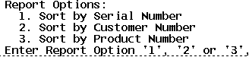
- Depending on reporting option selected, input serial#, customer# or product# and continue on to the date range.
- Input beginning and ending date range. 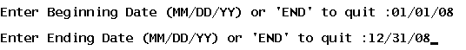
- Input AOC vendor number or <ENTER> for all.
- Input Warehouse or <ENTER> for all.
- See Sample of serial# report run by customer.
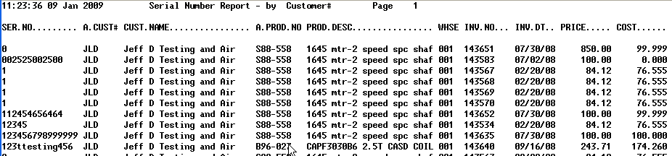

Menu 13 – Accounts Payable
Description: Display vendor notes in Payables Inquiry
Menu Path: Menu 13.5 Vendor Payables Inquiry
Why Use it: Using the NOTES feature of the system, it is now possible to add notes to a vendor so that you can view these notes in m- 13.5.
How to Use it: If a vendor has notes you’ll see ***NOTES*** indicated in the upper right-hand side of the screen. To View the notes enter ‘NOTES’.
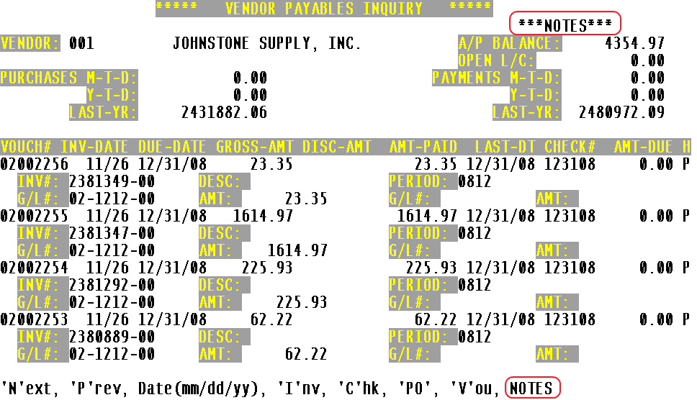
Notes are entered in the system by typing NOTES at the Main Menu.
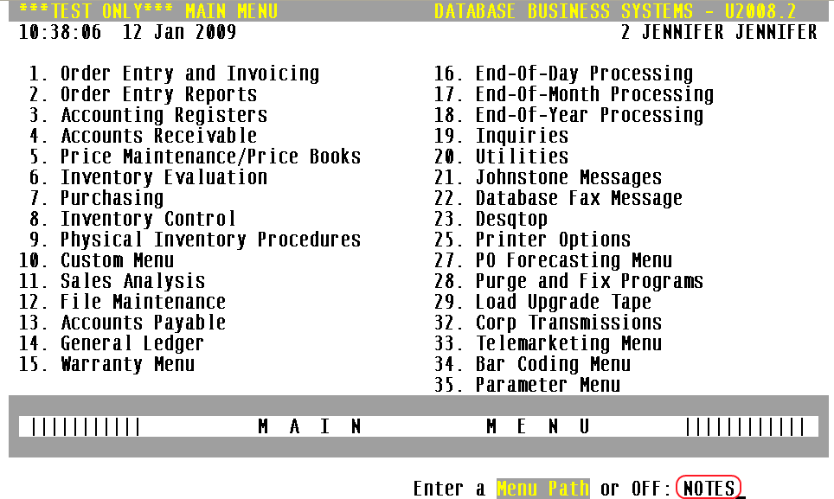
Description: Access to have Inquiry menu while in 13.20.2
Menu Path: Menu 13.20.2 Purchase Order Receipts Update to A/P
Users can get to the inquiry menu from within 13.20.2, using the “INQ” option at the bottom of the screen. This is a useful tool in researching purchase orders while vouchering.
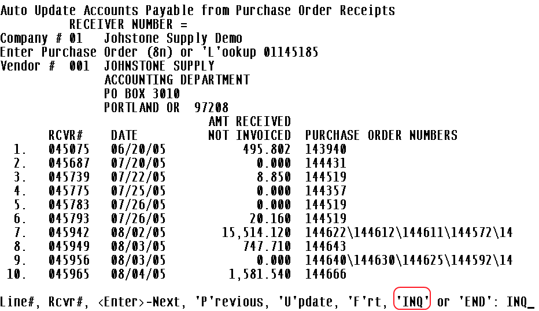

Menu 19 – Inquiries
Description: Update and expanded information on the Direct Cost option in stock status.
Menu Path: 19.6 Stock Status, ‘D’irect Option
Why use it: This updated option in stock status will display a new window of costs when selecting the ‘D‘ option. The Direct Cost window will show all the costs related to a product including Corp‘s Large Quantity Cost.
How to use it: Go to Stock Status (menu 19.6), input the item, and select the ‘D’irect Option to display the direct, branch, average and warehouse cost for the item.
The WHSE field will display costs for the product that are specific to your stores (this affects those stores that have branches in other states).
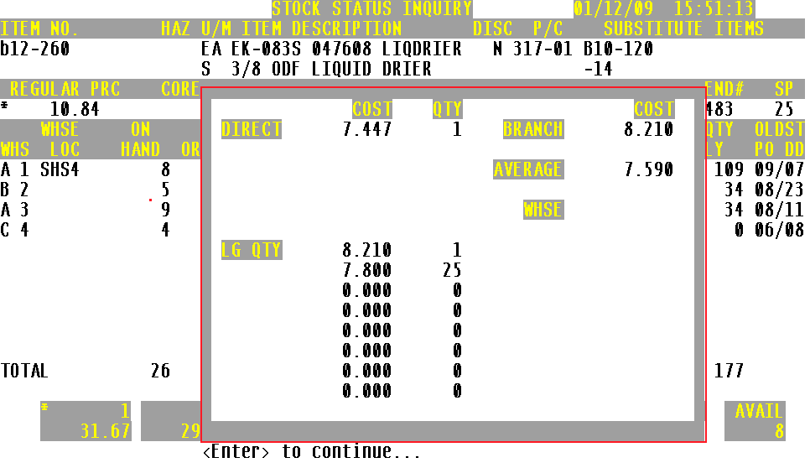

Menu 27 – PO Forecasting
Description: Display 'F'orward and 'B'ackward season code flags in PO Forecast Maintenance
Menu Path: Menu 27.5 – PO Forecast Maintenance
How to Use it: The PO Forecast Maintenance screen now displays the ‘F’orward and ‘B’ackward season code flags.
F = Seasonal item that will use a forward usage method
B = indicates a non-seasonal item and will use backward usage method
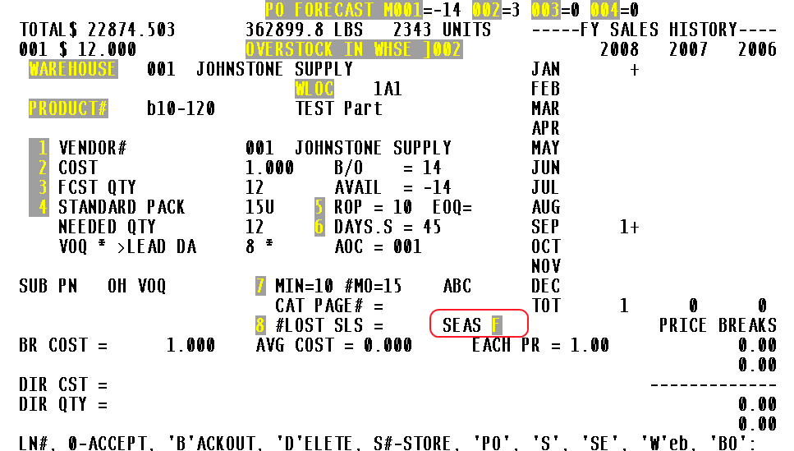

Description: Add the option to view customers’ backorders directly from the Forecast Maintenance Menu. Eliminate having to go to Stock Status (S) and then to the Backorder (BO).
Menu Path: Menu 27.5 Maintain Forecast
Why use it: To view customers’ backorders directly from the Forecast Screen
How to use it: From the prompt, select ‘BO’. If there are backorders for this item, Open Orders by Item will display listing all orders with this item on backorder. The user can select a customer’s order and go directly to the Order Entry process.
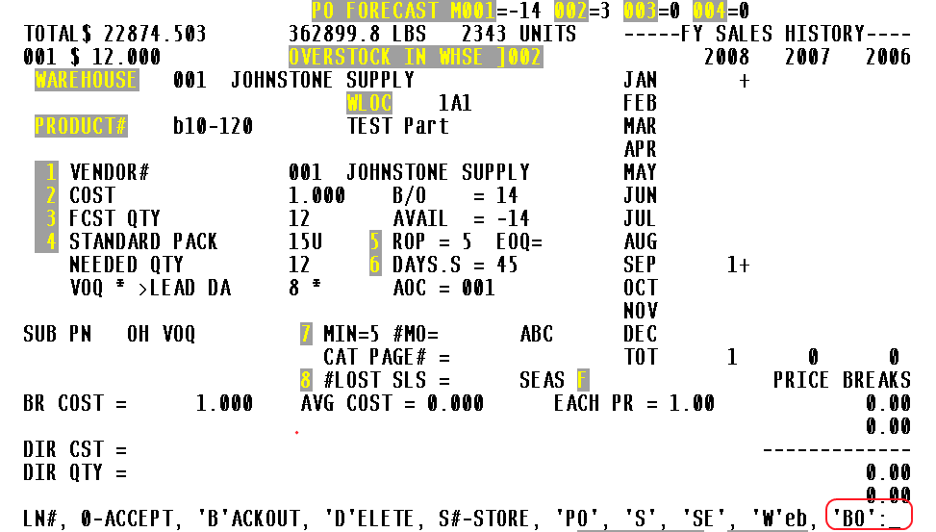

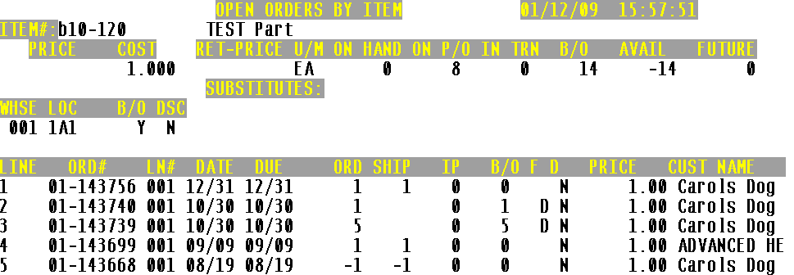

Menu 35 – Parameter
Description: Parameter driven notification of standard ‘P’ack quantities in order entry.
Menu Path: To Setup Menu 35.1, screen 3, field 12 for prompt in Menu 1.2
Why Use it: One goal is to eliminate the potential for over/dead stock before it even gets into your warehouse. One way identified how over/dead stock gets into our warehouses is by customer orders that don’t match purchasing pack quantities. Many of these scenarios can be prevented with a little information that is already available in the ‘P’ack quantities, notifying counter staff of the pack requirements in order entry.
For example, you must purchase a product in a pack of 12 from the DC. You have 12 on hand. Your customer orders 20. Since you have less than 20 on hand, you will now be in a position to order more from the DC to fill this backorder, minimum order of 12. Once you fill the backorder of 8, you will have 4 on hand, less than the normal standard pack. With the added notification, your counter staff will now see the pack requirements and have the opportunity to up-sell to the higher amount.
How to Use it:
The following conditions must be met:
- The parameter needs to be set in Menu 35.1, screen 3, field 12 to ‘Y’ (see screen shot 1).
- Product detail record, Menu 12.3.2.3, field 15 must have a pack quantity with a ‘P’ (see screen shot 2). EX: 12P
- Quantity Ordered Requirement Notification: in order entry Menu 1.2, the customer attempts to order a quantity of a product that is <<MORE>> than what is on-hand (creating a customer B/O scenario –kicking off the purchasing process). IF the customer orders less than what is currently on-hand that is OK, but if they order more -counter staff will be notified of the Pack quantity requirement and prompted for ‘Y***’ to continue (see screen shot 3) or increase the order to meet the purchasing pack requirement..
Screen Shot 1: Setup the Parameter Menu 35.1, screen 3, field 12.
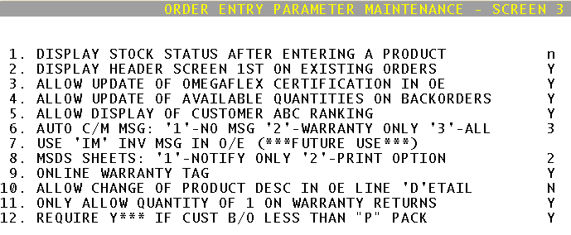
Screen Shot 2: Standard Pack Flags
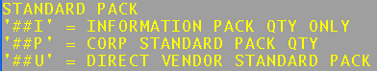
Screen Shot 3: Order Entry Quantity Requirement
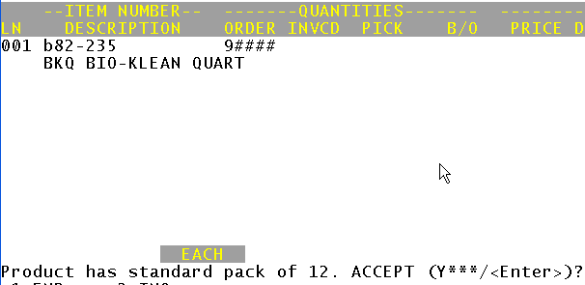

Description: New parameter to keep the EOQ pure
Menu Path: Menu 35.11 – Inventory Parameters
Why Use it: To keep the EOQ number pure and not be over-inflated by the standard pack.
How to Use it: Menu 35.11.15 – Round up EOQ for non ‘P’ standard packs. If this parameter is blank or set to “Y”, the system rounds up the EOQ that is calculated to the nearest standard pack. Entering an ‘N’ in this parameter will keep the EOQ pure. For example, if the EOQ is calculated to 13 and the standard pack is 5; then if this parameter is set to “N”, then the EOQ will stay at 13 and the normal forecasting calculation will deal with the standard pack requirement. If this parameter is left blank, the EOQ will be rounded up to 15, which could result in over-stocking, once the forecast calculation also uses the standard pack.

EOD
Description: An additional field, Pre-paid freight dollars (PPD), has been added to the Forecast Totals by Vendor Report.
Menu Path: Menu 27.24 Forecast Totals by Vendor, Menu 27.20.1.9 Forecast Totals by Vendor, EOD report ##-123.
Why use it: This report determines if orders need to be placed with a vendor by looking at the current forecast vs. the minimum needed. This report includes vendor #, vendor name, standard pack quantity, extended cost and weight, and information on pre-paid freight dollars (PPD$). Information on the PPD$ is pulled from Menu 12.4.1.2, Field 12. FRT TERMS.

How to use it: This report can be set up as part of the EOD, go to Menu 16.5, report xref# 01-123 (02-123, 03-123…). This report can also be printed on demand using either menu 27.24 Forecast Totals by Vendor or from the Inventory Class Menu, 27.20.1.9 Forecast Totals by Vendor.

