U2007.2 Upgrade Documentation
Fall 2007
Menu 1 - Order Entry & Reports
Description: Laser pick tickets using HTML
Menu Path: Multiple changes to Menu 1 (Order Entry & Invoicing)

Why use it: Menu 1 has been renumbered to make way for new features. We have added the display of PDF quote to Menu 1.30 and the email and fax of HTML pick packs thru the Linux server to Menu 1.35 and 1.36.

How to use it: The changes made to Menu 1 are shown in the screen shot below. We have moved the OLD Menu 1 to Menu 1.40 for review and comparison to the new menu.
***If you want to make the HTML pick tickets the default form for pick tickets, please run a pick ticket normally and then email yourself that same pick ticket to compare the two documents as most current pick tickets forms have some degree of customization. If there are issues between the two, please fax us or email us a copy of each for consideration on the new HTML pick pack forms. Some changes will not be possible on the new form.
- Menu 1.30 Display PDF Quotes works like M-1.29 but for quotes. Enter quote number. Must be connected to your local network.
- Menu 1.35 Email Pick/Pack thru Linux Server –Put in the 11 digit release number, confirm to show pricing (Y/N), enter operator code and confirm email address for delivery confirmation or enter a new one, and finally confirm or enter an email address for the pick ticket recipient. See below for sample HTML Pick Ticket
- Menu-1.36 Fax Pick/Pack thru Linux Server – Enter the 11 digit release number, confirm pricing (Y/N), confirm the fax# or enter a new one, enter the Attention line, enter any special messages and when you file that away, the fax is delivered.

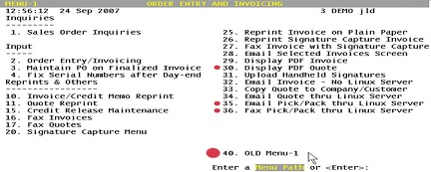

NEW Menu 1 VS. OLD Menu 1
New Menu 1 | Old Menu 1
Menu 1.25 Reprint Invoice on Plain Paper  Menu 1.26 Reprint Sig Capture Inv  Menu 1.27 Fax Inv with Sig Cap  Menu 1.28 Email Selected Inv  Menu 1.29Display PDF Invoice  Menu 1.30 Display Quote PDF  Menu 1.31 Upload Handheld Signatures  Menu 1.32 Email Invoice –No Linux Server  Menu 1.33 Copy Quote to Company/Customer  Menu 1.34 Email Quote thru Linux Server  Menu 1.35 Email Pick/Pack thru Linux Server  Menu 1.36 Fax Pick/Pack thru Linux Server  Menu 1.40 OLD Menu-1 | Old Menu 1.30  Old Menu 1.31  Old Menu 1.32  Old Menu 1.33  Old Menu 1.34  NEW TO MENU 1  Old Menu 1.35 Upload Handheld Signatures  Menu 1.36 Email Invoice –No Linux Server  Menu 1.37 Copy Quote to Company/Customer  Menu 1.38 Email Quote thru Linux Server  NEW TO MENU 1  NEW TO MENU 1  NEW TO MENU 1

Sample HTML/PDF Pick Pack
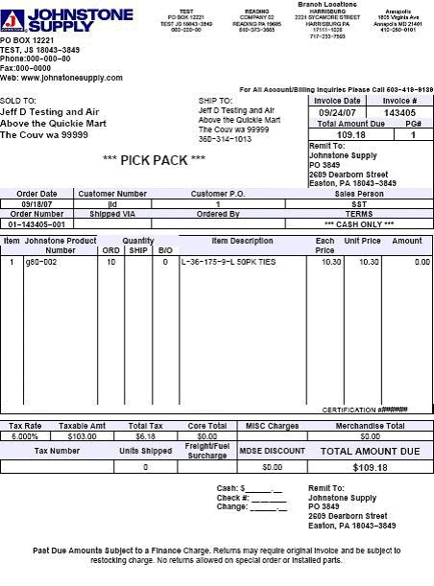

Description: Display original operator on totals screen on new orders
Menu Path: Menu 1.2 (Order Entry/Invoicing)

Why use it: Provide easy reference to know who has started the order.

How to use it: Often times in Order Entry staff will walk away to track down some information or a product. Previously, there was no way to know who had started the order. The information in Menu 1.2 on the Order entry Total Screen in the 'STATUS OF RELEASE’ area will display that it’s a new order, but also who has started the order.

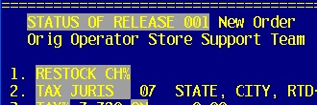

Description: Include original quote number as a message line when converting to an order
Menu Path: Menu 1.2 (Order Entry/Invoicing)
Why Use it: Better reference to tie the original quote to the newly created invoice.

How to use it: In Order Entry just like normal, convert the quote to an order and it will automatically appear. See sample:

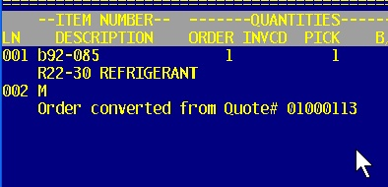

Description: Parameter to lock product desc in OE line detail screen from being changed
Menu Path: Menu 1.2 (Order Entry/Invoicing), Menu 35.1 (Order Entry Parameter Maintenance) Screen 3, Field 10 set to ‘N’
Why Use it: Prevent operators from changing product description information in Order Entry to keep consistency and integrity of product data on the invoices.

How to use it: Set Menu 35.1, Screen 3, Field 10 to 'N' - ALLOW CHANGE OF PRODUCT DESC IN OE LINE 'D'ETAIL. When operator is in order entry line detail and try to change field 2 they will get the following message:
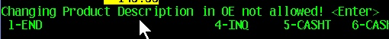

Description: Fix number of copies parameter prompt in Order Entry
Menu Path: Menu 1.2 (Order Entry/Invoicing) and Menu 35.12 (Signature Capture Company Parameters)
Why Use it: Previously this parameter could be set but Order Entry didn’t prompt for number of copies, now it does.

How to use it: Go to menu 35.12, Screen 2, Field 10. Prompt for number of copies in OE and set this to ‘Y’. In Order Entry, after selecting the invoice option, you will be prompted for number of invoices-hit <ENTER> for a default of 1 copy.

Description: Add PO#, Job Name and Product Description to quote lookup
Menu Path: Menu 1.2 (Order Entry/Invoicing) ‘QL’ option
Why Use it: Additional information makes it easier to track down existing quotes.

How to use it: Access Menu 1.2, use the QL to lookup a quote. PO#, Job Name and Product Description have been added to quote lookup.

Description: Display the FDC inventory in the ORDER detail screen
Menu Path: Menu 1.2 (Order Entry/Invoicing) Line Detail Maintenance Screen
Why Use It: Quick access to DC product availability info. No longer need to go to ‘W’eb stock status to view the same information.

How to use it: This request is available on a request by request basis. Fill out a support job and we will load this code. http://dst.myjohnstone.com/Login.asp

In order entry, Menu 1.2, put in a product, the list of DC's are located in the Order Entry Line Detail Maintenance screen, in the ‘QUANTITIES IN OTHER WAREHOUSES’ location.

See below:
FDC = Florida Distribution Center
PDC = Portland Distribution Center
MDC = Memphis Distribution Center
ADC = Allentown Distribution Center

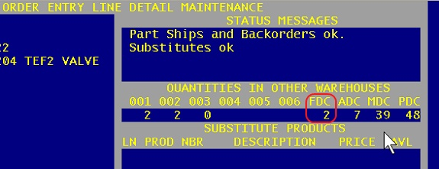

Description: Prompt to verify customer information is correct before faxing/emailing invoices/quotes
Menu Path: Menu 1.17 (Fax Quotes), 1.27 (Fax Invoice with Signature Capture) & Menu 1.34 (Email Quote thru Linux Server)

Why Use it: Confirm the right document is selected and set to go to the right customer. Catch a potential mistake prior to it happening.

How to use it: Enter menu path for what you are trying to send, and then when prompted if the correct customer is selected, press <ENTER> to confirm and move along or enter ‘N’ to end out and put in the invoice, release, quote number again.

Description: Update quote audit trail to include when a quote was emailed
Menu Path: Menu 1.34 (Email Quote thru Linux Server), Menu 2.28 (Quote Audit), Menu 19.5 (Detailed Invoice/Release Inquiry) –AUD option
Why Use it: Provides and improved audit trail for quote activity.
How to use it: When emailing a quote using Menu 1.34 it will record who the quote was emailed to. Menu 2.28, enter the quote number, see sample Quote audit. Also, access detailed quote inquiry via Menu 19.5 and select the AUD option from the total screen.

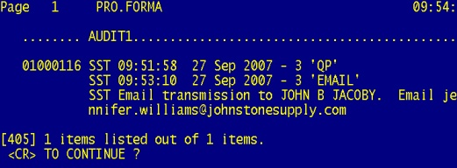

Menu 2 - Order Entry Reports

Description: Sort Sum Finalized Invoices report by operator finalizing ticket
Menu Path: Menu 2.10 (Sum Today's Sales), Menu 35.10 (EOD Update Parameter Maintenance), Field 14 and 12
Why Use it: To show Menu 2.10 sorted by finalizing operator.

How to use it: In order to use this new sort option, you need to update the parameter in Menu 35.10. The new parameter for this is Field 14, but is only used if Field 12 is set to be using the new Menu 2.10 Sum Today’s Sales. To use this new sort option, go into Menu 35.10, Field 12 and set to ‘Y and then set Field 14 to ‘Y’ If the parameter in Field 14 is set to ‘N’ this report will sort by original operator on the ticket.

Menu 4 - Accounts Receivable

Description: Display customer/invoice information with confirmation prior to fax/email
Menu Path: Menu 4.1.9 (Accounts Receivable Inquiry)
Why Use it: To catch a potential mistake prior to sending something to a customer.

How to use it: When using Menu 4.1.9, Invoice ‘F’ax or ‘E’mail option after entering an invoice or string of invoices a recap of the invoice customer# and AR amount is displayed giving a chance to confirm that this is the right information that is about to go out. Options are ‘Y’ to send or END to reenter the invoices.

Description: Add cover page to manually faxed statements
Menu Path: Menu 4.3.6.5 (Fax EOM Statement for Selected Customer or Month)
Why use it: Ability to add a cover page to the manually faxed statements.
How to use it: Menu path 4.3.6.5. Fax EOM Statement for selected customer & month will have the statement cover page. Enter company number, Enter Customer, enter Month, Fax Number and Attention. At the prompt ‘Do you want to Enter Special Messages? (Y/<CR>): enter ‘Y’ to put your special messages on the cover page of the faxed statement. When complete press the <ESC> to get the next options.



- ‘S’ave option saves your special message and sends the fax.
- ‘A’bort option disregards the special message and sends the fax.
- ‘C’lear option clears out your special message so you can enter it again.
- Spe’L’l option runs the special message through the spell check.

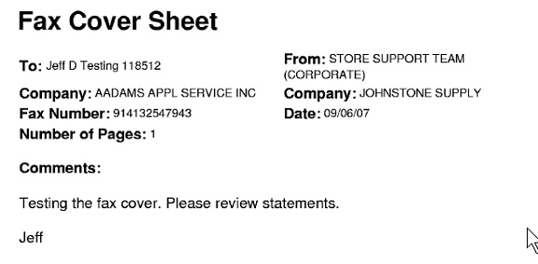

Description: New option to display PDF invoices
Menu Path: Menu 4.3.6.6 (Reprint/Display EOM Statement for Selected Customer & Month)
Why Use it: No longer need to print out a customer statement to view it.

How to use it: Go into Menu 4.3.6.6 Reprint/Display EOM Statement for selected customer & month and select Option 1. Display EOM Statement, then input the customer# and the month the statement is from. The statement will then display in the PDF viewer.

Menu 7 - Purchasing

Description: Add the PO# reference to the PO fax cover sheet
Menu Path: Menu 7.30 (Fax/Email PO thru Linux Server)
Why use it: Additional reference to tie the PO and the cover sheet together on a fax transmission.

How to use it: Fax the PO via Menu 7.30, the PO# will be on the cover sheet.

Description: Option to fax/email PO’s with no costs
Menu Path: Menu 7.30 (Fax/Email PO thru Linux Server)
Why use it: Use the system to send PO’s without costs instead of printing a PO, blocking the prices and then manually faxing.

How to use it: Go to Menu 7.30 Fax/Email PO thru Linux server and look for this prompt: Do you want to include costs? (<CR>/N): ?N Answer ‘N’ to send PO without costs. See sample:

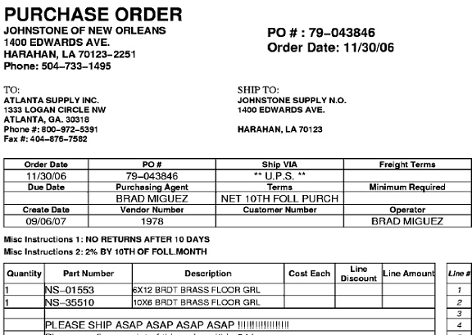

Menu 11 - Sales Analysis

Description: Display current month inventory values
Menu Path: Menu 11.4.10 (Inquiry by Company - from Sales Files)

Why Use it: Quick snapshot of inventory value on total invoiced sales inquiry.

How to use it: Run Menu 11.4.10 like normal, inventory value added to far right-hand column. The inventory value is the summary of all products (catalog and non-catalog) on-hand quantity times average cost.

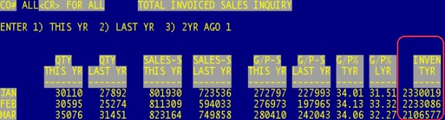

Menu 12 - File Maintenance

Description: Additional email added to Customer Master Maintenance for accounts receivable and purchasing
Menu Path: Menu 12.2.2.2, Field 18 (Customer Master Maintenance)
Why use it: Currently this field is being used for data collection only. Eventually will be used for reporting and distribution of emailed documents.
How to use it: Go into Customer Master Maintenance Menu 12.2.2.2, select Field 18. EMAIL PUR. And enter the email address.
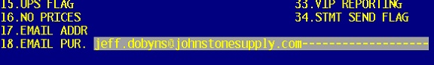

Description: Enhancement to serial# maintenance for message/reference entry
Menu Path: Menu 12.3.10 (Serial Maintenance), Menu 19.8 (Serial Number Inquiry)
Why use it: Allows you to enter a message or reference associated with a specific serial record and have that reference display in the serial# inquiry.

How to use it: Go to Menu 12.3.10 (Serial Maintenance) and edit Field 8 - MSG/REF# of the serial # record.
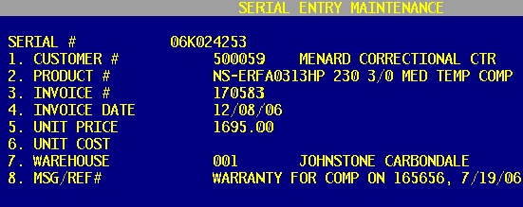

Go to Menu 19.8 (Serial Number Inquiry) and pull up the serial number and the MSG/REF# displays.
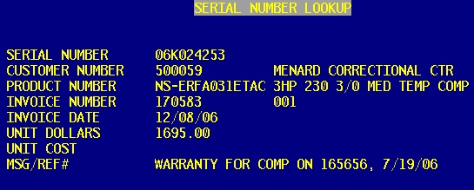

Description: Additional characters added to maintainable vendor web address
Menu Path: Menu 12.4.1.2 (Vendor Master Maintenance), Field 10

Why Use it: Room added for web addresses allows this important information to print correctly on PO’s.

How to use it: Access vendor in Menu 12.4.1.2, maintain address in Field 10 up to 35 characters. It prints on PO’s as Miscellaneous Instructions 1 and 2.

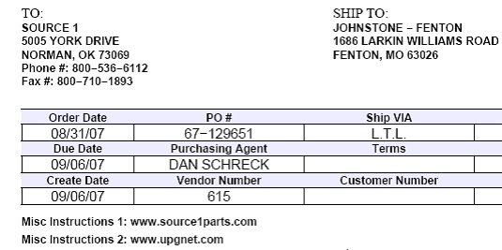

Description: Vendor change program created
Menu Path: Menu 12.4.1.9 (Change Vendor Number)
Why Use it: Program to replace the merge.vends program and streamline the process for changing a vendor number.

How to use it: Go to Menu 12.4.1.9 Change Vendor Number, input the OLD vendor number first and then enter in the NEW vendor number you are changing it to. After that, the program changes the related vendor files from OLD vendor to NEW vendor (checking vendors, products, vouchers, etc).

Menu 19 - Inquiries

Description: Add PO#, Job Name and Product Description to quote lookup inquiries.
Menu Path: Menu 19.1A (Quote Lookup Inquiries), Option 2
Why Use it: More information makes it easier to track down existing quotes.

How to use it: Access Menu 19.1A, Option 2 customer quote Listing, ‘D’etailed listing…and the new fields are added into the detailed reports.

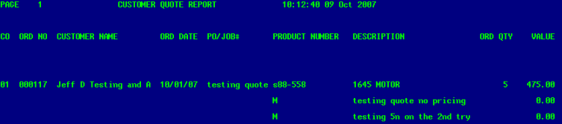

Description: Option to display Order Entry and Purchase Order audits from Inquiries 19.5 and 19.12
Menu Path: Menu 19.5 (Detail Invoice/Release Inquiry) and Menu 19.12 (Detail Open Purchase Order Inquiry)
Why use it: This option combines the quote, order entry and PO audit screens (Menu 2.28, Menu 2.27, Menu 7.23) into the Detail Invoice/Release Inquiry (Menu 19.5) and Detail Open Purchase Order Inquiry (Menu 19.12) so all the information you will need on a quote, invoice/release, or PO is accessible from a single menu path instead of splintered in multiple menu paths for each.

How to Use it: Menu 19.5 "How to use the ‘AUD’ option?" Pull up your quote/pick pack/invoice/release and when you get to the total screen you will see a new option of ‘AUD’it After entering the AUD option, the typical audit detail will display on your screen.

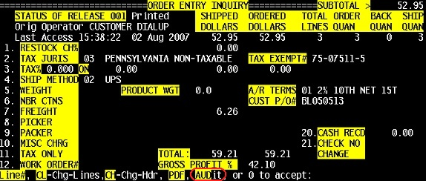

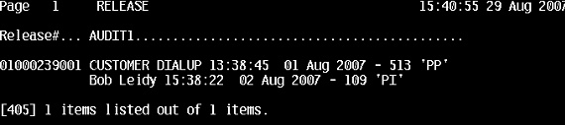

Menu 19.12 PO Audit works the same as Menu 19.5 Pull up the PO, get to the PO total screen and the AUD option will be available. The PO audit information displays.

Description: Miscellaneous menu paths adding printer select (Ft, Display, and Email) option.
Menu Path: m-13.20.9, M-4.3.20, M-12.2.39, M-14.2.2, M-7.19, M-3.11,

Why Use it: By adding the printer select program to these menu paths you can direct output to specified printers as well as enabling the options for FT, Display and email.

How to use it:
Once the printer select screen displays, enter the appropriate option…specific printer#, EM to email, D to display the report, FT to file transfer the report to your pick folder.

