U2007.1 Upgrade Documentation
Summer 2007
Menu 1 - Order Entry & Invoicing

Emailing/Faxing Quotes
This new features allows Linux users to fax and email quotes. (Note: Stores without a Linux server can still fax quotes using Menu 1.17 but they will not appear in the HTML format that Linux provides).

To use Quotes the following parameters must be setup.
- Menu 35.12, screen 2, field 11 set to ‘Y’

- Field 12 has been added, Use Purchasing Fax# for Quotes, if this field is set to ‘Y’ then the fax number used to fax quotes is what is listed in Menu 12.2.2.2 field 29. If this field is set to ‘N’ or blank then the number listed in Menu 12.2.2.2 field 11 is used to fax the quotes.
- The same concept is true for Field 2, Use Purchasing Fax# For Invoices. If this field is set to ‘Y’ then the number listed in Menu 12.2.2.2 field 29 will be used to fax invoices. However, if the field is set to ‘N’ or blank then the AR fax number will be used from Menu 12.2.2.2 field 11.
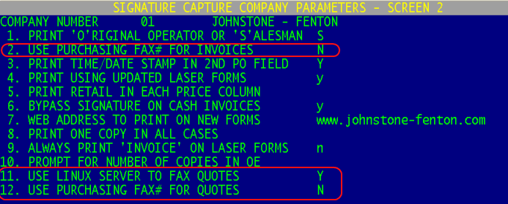

NOTE: Make sure port parameters are defined for the ports that are trying to fax/email quotes (m-35.13). If these ports do not print laser forms, you can set field 3, Order Entry Printer to “A” for All-Multi.

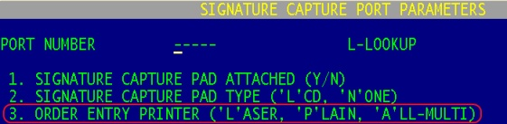

Fax Quotes Menu 1.17
Stores with a Linux server will now fax an HTML cover sheet and quote through the Linux server. System prompts are 1) Quote Number, 2) Days to Honor Quote, 3) Print Prices, 4) Enter Fax Number, and 5) Attention.

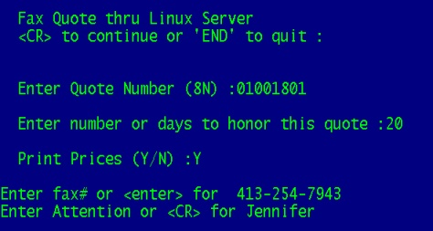

Users also have an option to enter a separate message that will print on the cover page of the quote.

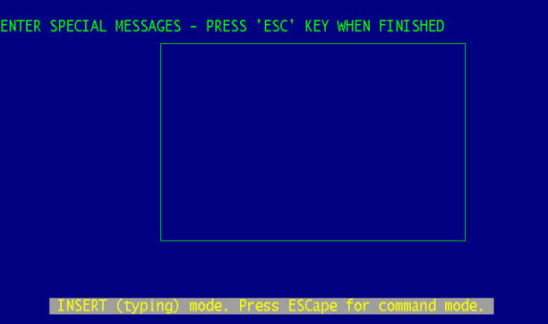
Email Quotes through Linux Server Menu-1.38
You will be prompted for the quote number, honor days, price printing, email address and operator code. The “email for confirmation” is the address that will be showing in the “from” section of the email sent to your customer. You will also be prompted for the “email recipient” which, will be pre-populated with the customer’s email address. You can accept that address or enter a different address.

Note: Stores without a Linux server do not have the ability to email Quotes.

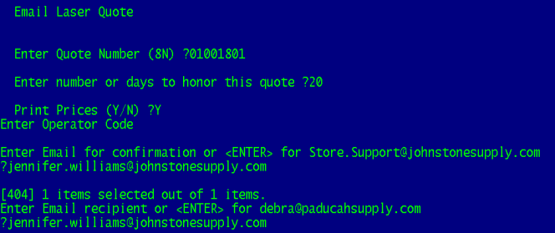
Fax Notification – Real-time notification that faxes have been sent.
After sending a fax from Menu 1.17 an email confirmation will be sent to you to confirm that the fax was delivered. The fax confirmation will be sent to the email address setup in Menu 12.1.4 field 31 for the operator logged-in to that port.

Email Notification - Real-time notification of fax/email status
Once the email quote has been sent from Menu 1.38, a confirmation will be sent to the sender or the default confirmation address.

The following is a sample of an email quote confirmation:

BATCH STARTED: Thu May 17 10:45:03 PDT 2007

EMAIL TO: jennifer.williams@mail.johnstonesupply.com
Here is the QUOTE that you requested!
QUOTE: 01001801 PO#:

BATCH COMPLETE: Thu May 17 10:45:05 PDT 2007

Menu 1.2 – Order Entry
After looking up a customer the option will appear to type PO to display only the orders tied to the PO. The system will prompt for the first portion of the PO (only the first few digits are needed to pull the open orders).

Menu 1.2 – Order Entry
All Authorized Buyers setup for a customer in Menu 12.2.2.6 now appear on the Authorized Signers list as seen in Menu 1.2 Order Entry.
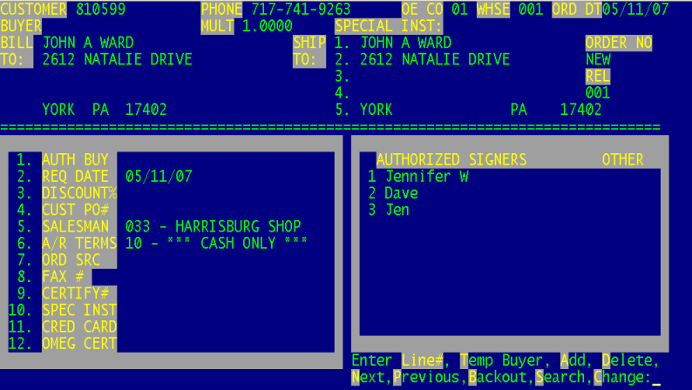

Menu 1.34 – Display PDF Invoices
Menu 1.34 takes users to the Detailed Invoice/Release Inquiry (Menu 19.5). Users can pull up an order and select PDF on the Totals page to view the invoice. Invoices will only display in the PDF format if a Linux server is being used for invoicing.

If a PDF is not found or if you are not on a Linux server then the invoice information will pull up in the normal 19.5 format (the PDF version will not appear).

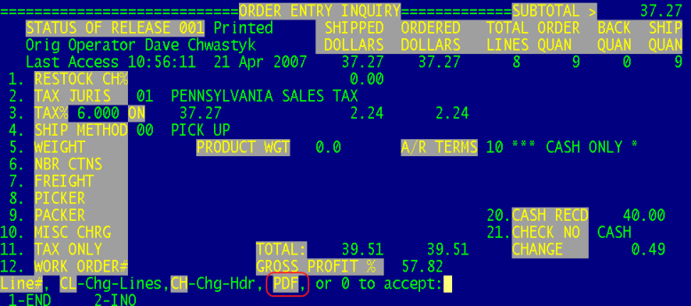

Menu 4 - Accounts Receivable

Menu 4.1.1 – Cash Receipts Entry
The customer lookup feature now displays the accounts receivable dollar amount next to the customer. The AR dollar amount is pulling from the AR$ field in Menu 4.1.9.

Menu 4.3.6.12 – Reprint Laser Service Charge Invoices
Service Charges Invoices can now be reprinted using Menu 4.3.6.12. Users will be prompted for a Service Charge Date and a Customer Number. The Service Charges Invoices print in an HTML format. See image below for a cropped screenshot of the updated service charge invoice format.

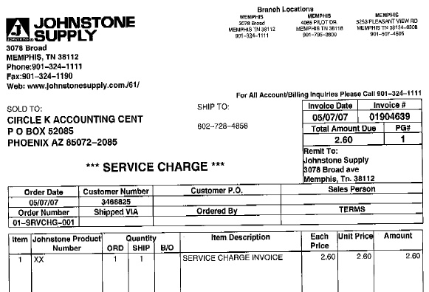

Menu 4.3.6.16 Number of Print/Fax/Email Statements from Last EOM
This feature has been added to provide you with a count of how many statements were printed, faxed and emailed during the EOM statement run. Two options are available when running this report 1) ‘S’ummary of the total number of statements printed, faxed and emailed (see image below), or 2) ‘D’etail for a list of customers that had their statements printed, faxed or emailed.
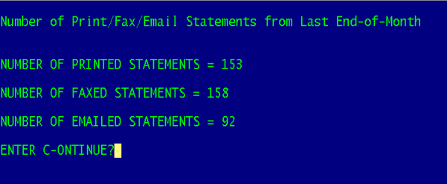

Menu 5 - Pricing

Menu 5.24 – New Pricing Matrix Listing
Selection Option #8 has been added to give users the ability to Select for Specific Programs.

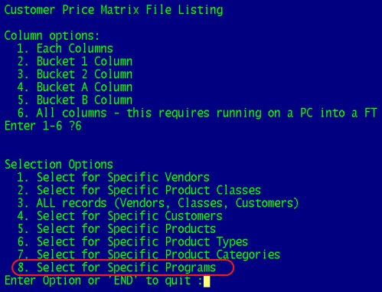

Menu 5.26 – Contract Price Listing (FT Only)
This new report gives users the ability to print a list of contract prices that includes cost information.

The prompts for the report are:

Enter Company Number or 'END' to quit

Enter Contract Number or 'END' to quit

Pricing as of 12:32:38 17 May 2007 Price Book for Contract FD07-1 Page 1

Product Description Price List Price Avg Cost Branch Cost Direct Cost Sold.12mo Source Vend# Vendor Name
------- ----------- ----- ------------- ----------- ----------- ----------- ---------- ------ ----- -----------
FD18 18" FLEX DUCT 39.70 107.85 37.170 35.000 35.000 3 PP*FD07-1 1340 TWO J SUPPLY

Menu 5.33 – New Customer Pricing Matrix
Effective Date and Expiration Date are new options on this Menu. The effective date is the date the pricing is to be begin. The Expiration date is the day pricing will end. The expiration date will print out on Menu 5.21 - Contract Prices Below Minimum GP%.
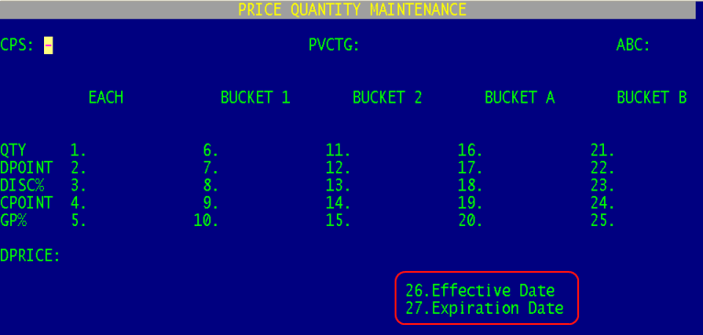

Menu 5.33 – New Customer Pricing Matrix
In the U2006.3 release Database released the following ‘S’ell Price feature.

When the "S"ell price option is selected, the system will prompt for the actual sell price that the user determines. This will then auto setup the matrix as follows. If there is a list price on this product, it will auto fill Field 2, DPOINT with a price pointer of "23" and auto fill Field 3, DISC% with the calculated discount percentage off the list price to get the desired sell price. If there is no list price on this product, it will auto fill Field 2, DPOINT with a price pointer of "0" and auto fill Field 3, DISC% with the calculated discount percentage off the each price to get the desired sell price.

In this release (U2007.1) the same ‘S’ell Price feature is now available for Bucket 1, Bucket 2, Bucket A, and Bucket B. When U2006.3 was released the ‘S’ell Price was only available for Each Price.
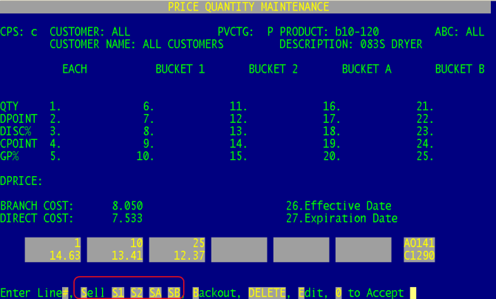

Menu 7 - Purchasing

Menu 7.1 – Purchase Order Entry
The Customer PO number now prints on dropship purchase orders.

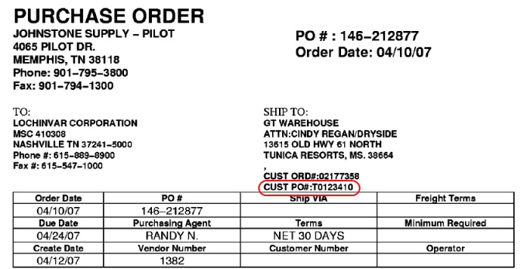

Menu 7.1 – Purchase Order Entry
A new option has been added to Menu 7.1 to “Hold, Print and Rolldown” on store transfers. This eliminates the need to use Menu 7.1A to rolldown store transfers.

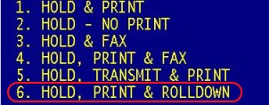

Menu 7.1A – Purchase Order Rolldown to Order Entry
Purchase Orders setup in Menu 7.1, as dropship with the customer number in the Ship To will rolldown directly to an order for the customer. This added features saves users from manually entering the ticket in Menu 1.2 – Order Entry.
- Menu 7.1 Header screen -In the PO header screen, change the ‘S’hip-to using the ‘C’ustomer# option.

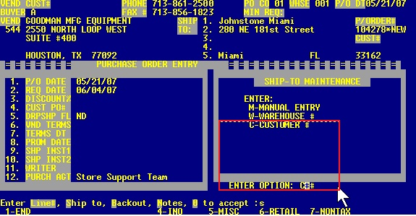

- Menu 7.1 after inputting a specific customer#. Note that the ship-to area now have the information for the specific customer# and field 5, Dropship flag is set to ‘DS’
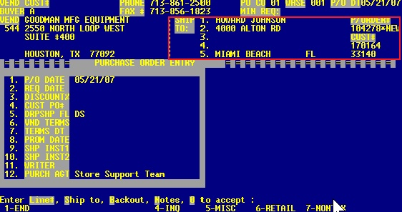
- File the PO away using option 1 or 2. Hold & Print or Hold –No Print
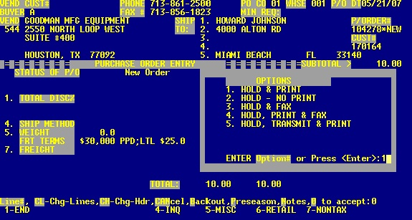

- Once the PO is created (EX: 01104278), go to Menu 7.1A Rolldown to OE and put in the PO#

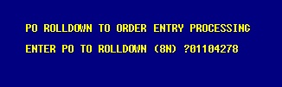

- After putting in a valid PO#, confirm that you want to roll the Dropship PO into a Dropship order:

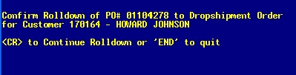

• After confirming the Rolldown, select the printer where the order will print and collect order from printer.

See confirmation of Order# created from the PO:

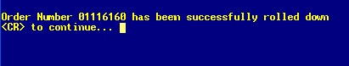

Menu 7.7 – Fax Purchase Orders
Menu 7.7 will fax purchase orders using the Linux server if Menu 35.5.9 is set to ‘Y’ (Use Linux Server to Fax Purchase Orders).

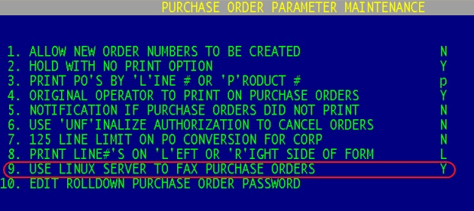

Menu 7.23 – PO Audit
When Purchase Order Rolldown to Order Entry is done through Menu 7.1 or 7.1A and audit will now be tracked in Menu 7.23 as HPTO.

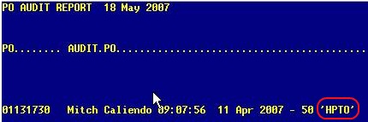

Menu 7.30 – Fax/Email Through Linux Server
The ability to email Purchase Orders using a Linux server has been added to the system. Menu 7.30 has been modified to allow faxing and emailing of purchase orders. To email a purchase order, select Option #2 - Email PO, enter in the 8-digit PO number, and then enter the recipient’s email address.

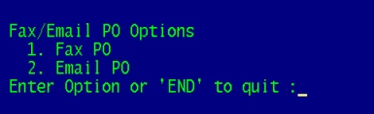

Selecting Option #2 (Email PO) will prompt for the following:
1. Enter the email address where the confirmation should be sent.
2. Option to type a message that will appear on the email or hit <enter> for the default message of “Here is the PO you requested”.
3. Enter the email address of the recipient.

Menu 8 - Inventory Control

Menu 8.3 – Non-Purchase Order Receipts Posting
Entries made in Menu 8.3 now auto update to Menu 19.7B. In the past POR entries made in Menu 8.3 did not appear in Menu 19.7B until after day-end was run.

Menu 8.4 – Inventory Adjustment Posting
The Reason Code ‘RC’ is now a required field in Menu 8.4. To view the list of reason codes type ‘?’ and <enter>.
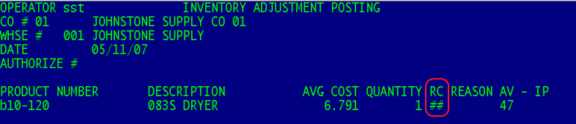

Menu 9 - Physical Inventory

Menu 9.20.22 – Products with No Warehouse Location
This report details the list of products that have no warehouse location listed in product detail (Menu 12.3.2.3). Before beginning your inventory, consider it a best practice to run this report. To tie a product to a warehouse location use Menu 34.11 Scan Warehouse Locations. If you have the Symbol handheld scanner the S3 option 1 – Scan Location can also be used to tie a product to a location.

Menu 9.20.28 – Display Old Locations
Menu 9.20.28 is a new menu path that if activated will display old warehouse location in Stock Status (Menu 19.6) during the physical inventory process. The second step in the inventory process is to run Menu 9.20.2 to clear Warehouse locations. When this menu is run it clears the warehouse locations in stock status and in Product Detail (Menu 12.3.2.3). Menu 9.20.28 allows for the old (cleared) warehouse locations to appear in Stock Status during the inventory process.

Note: If Menu 9.20.28 is set to Y during inventory you must go back into this menu and set to N when inventory is complete. Otherwise, the old warehouse locations will continue to display in Stock Status.

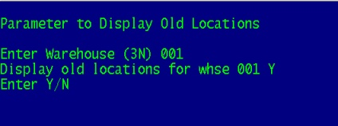

Menu 12 - File Maintenance

Menu 12.2.2.2 – Customer Master Maintenance
The List price multipliers that are setup in Customer Master Maintenance, Screen 2, Field 37 have been expanded to 4-digits after the decimal (i.e. .4500). Previously, only 3-digits were allowed.

Corp DC regional branch costs--auto updates, stock status and PO costing
Database has added the capability to receive the special regional pricing that Corp is rolling out over the next few months. In the past the special pricing has not been available in the transmissions, so your costs when transmitted to Corp come back on the acknowledgement as an adjustment.

This program will use spreadsheets provided by Corp and update your branch cost field in prod.mast (Menu 12.3.2.2 Field 16) depending on your main Corp DC warehouse. These costs will be made available in stock status and in PO's buying from another DC. To access the information in Stock Status, type ‘D’irect.

Sample of product with regional pricing: R94-221

MDC Pricing-
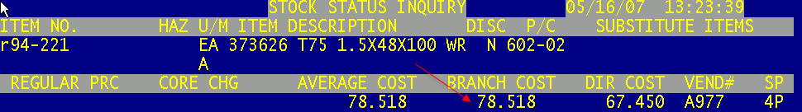

PDC Pricing-
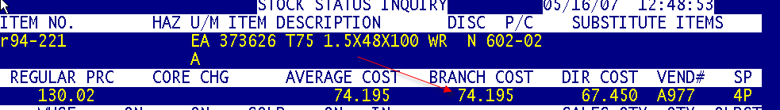

Menu 13 - Accounts Payable

Menu 13.20.3 – Auto Post Corp Invoices
Menu 13.20.3 will now prompt for “Include Credits”. Answer ‘Y’ if you want to include credit memo’s from Corp. Answer ‘N’ if you do not want Corp credit memos included.

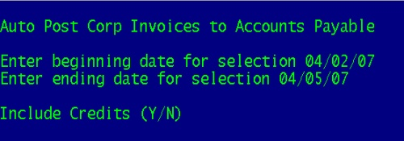

Menu 19 - Inquiries

Menu 19.7B – Inventory Transaction by Product
When viewing and item users now have further type options to select when building the inquiry.
The following options are available:
• ADJ = Adjustments
• POR = PO Receiving
• INV = Invoice
• CM = Credit Memo (Returns to Stock)
• NON = Credit Memo (Not Returned to Stock)
• PI = Physical Inventory
• DIN = Drop Ship Invoice
• DPO = Drop Ship PO
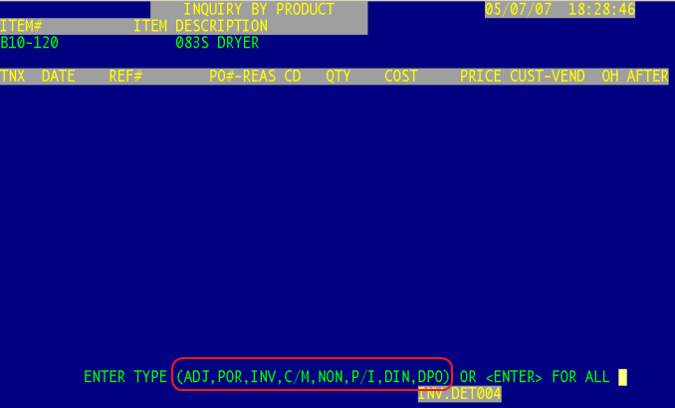

Menu 19.7B – Inventory Transaction by Product
Complete PO information can be pulled up from a POR item.

• Enter the 8-digit PO number
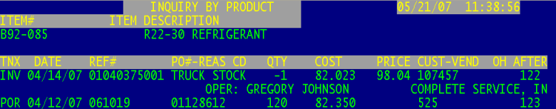

• Entering in a 8-digit PO number takes the user to Menu 19.12 to view the PO.
• Entering in a 11-digit Release number takes the user to Menu 19.5 to view the release.

Menu 19.8 – Serial Number Inquiry
The warehouse number will now display to the right of the INVOICE number.

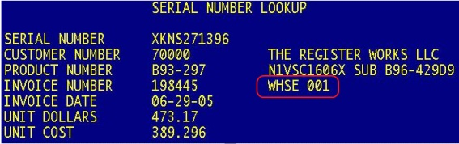

Menu 19.14.1 – View Maintenance Menu for Customer Master
Menu 19.14.1, Screen 2 Field 7 – Allows people to view customer contracts who don’t have access to Customer Master through Menu 12.2.2.2. Selecting field 7 takes the users to the Contract Maintenance Screen.

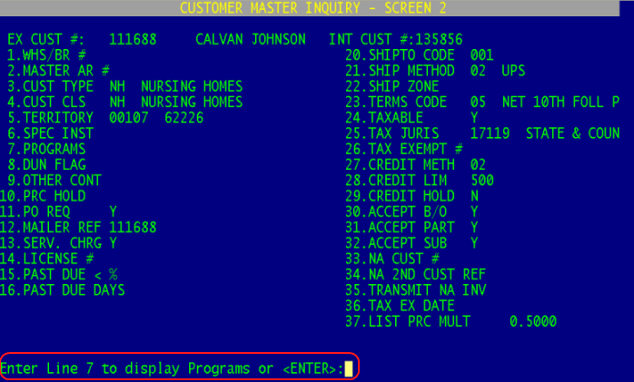

Menu 27 - PO Forecasting

Menu 27.30 – List of A Code Products – Not 001
Johnstone occasionally decides to start stocking certain items in the DC, which, were originally transmitted as “O” codes. The new Price Transmission from Corp changes the Product Master record to vendor code “A” but the Product Detail vendor is not changed to 001. Which results in the product not appearing on your DC forecast.

Use Menu 27.10 to change the Product Detail vendor to 001, one vendor at a time.

Enter A*** if you want the complete list that printed auto updated to vendor 001.

EOD Forecasting Reports
Warehouse number has been added as part of the header of EOD Forecasting reports.
• Forecast Totals by A & O Vendors (01-122)
• Forecasting Totals by Purchasing Vendor (01-123)

Menu 28 - Purge & Fix Programs

Menu 28.10 – Purge Discontinued Catalog Items
This menu path purges items that are flagged as discontinued (Menu 12.3.2.2 Field 22), have a back order quantity of zero, have zero on hand, zero on purchase order for all stores and zero in pick. A report will print out of the purged items. This report is similar to non-stock monthly purge.

A new feature has been added that provides the option to 1) Report Only or 2) Report and Update. Option #1, lists the items flagged to be discontinued. Option #2 will purge the discontinued items and list them out on a report.

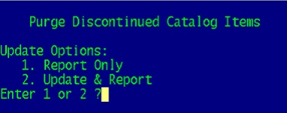

Menu 34 - Bar Coding

Menu 34.8 – Print Bar Code Labels
Users have the option to print the product number on the Bar Code label in all CAPS. If you are interested in receiving this upgrade, log a job online with Database Support http://dst.myjohnstone.com/Login.asp.

Menu 34.26 Auto Update Receiver with Qtys from Corp Packing List
This menu path has been changed to NOT include Centralized Shipments.

Menu 35 - Parameter Menu

Menu 35.19.7 – Event Notification of Cancelled Invoices & Pick Tickets
Field 11 – Include Quotes has been added. Users will now be notified if a Quote is cancelled if a ‘Y’ in inputted in field 11.
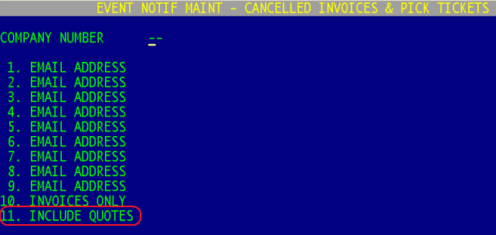

End of Month

End of Month
End of Month XREF report 01-160 has been added to list all the purged non-stock items. See Menu 28.0.1 to see when NS items are set to purge for your system. The report will be generated after your purge is set to run. To receive this report, add your email address to the report by going into Month-End, Option 5 – EOM Report XREF Maintenance.

AP EOM Reports
Accounts Payable EOM reports 01-131 through 01-141 now have the same paperless options as other EOM reports. To setup the desired output method of the report, Logoff to the ‘J’, type Month-End, and pull up the report ID in the AP EOM.XREF Maintenance (Option #5).

This same group of AP EOM reports can also be setup to be automatically archived to the Linux server. The file name of the report is stored in Field 9. The file name is what will appear on the Linux server in the EOM folder.

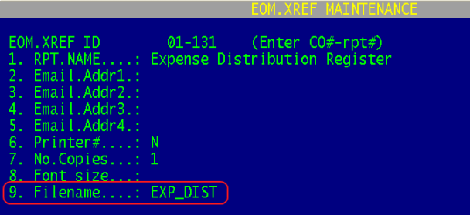
To access the reports off the Linux server, setup the following:
- Map a drive – Open up My Computer from your Desktop icon.
- Tools > Map Network Drive > Select ‘R:’ from the dropdown list.
- In the Folder field enter \\YOUR LINUX IP ADDRESS\reports
For Example - \\192.168.100.226\reports
- Reconnect at logon – Check this Box
- Select Finish

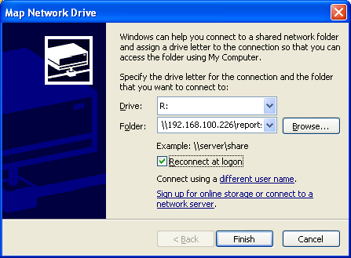

- Open the EOM folder to view the AP EOM reports
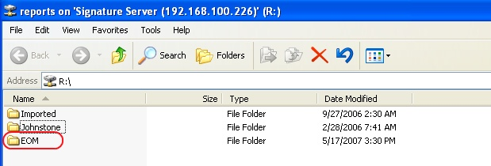
- Openthe EOM folder to view the AP EOMreports
- Each report is listed as a PDF and a TXT file. Simply double click on a report name to view the report.

