U2007.3
Upgrade Documentation
Winter 2007/2008

Menu 1 – Order Entry & Reports
Description: Fax and email a quote from order entry total screen
Menu Path: Menu 1.2 (Order Entry/Invoicing)
Why Use it: Step saver by adding the ability to create the quote, file it away and send it off to the customer from a single menu path.
How to use it: In Menu 1.2, in the total screen, when the Invoicing Options display (see screen shot below) select 5A to fax the quote or 5B to email the quote.
- If 5A is selected follow these quick steps
  - Enter # of days to display honoring quote.
  - Enter to confirm is prices should display on quote.
  - Enter fax# or enter to accept default fax# on customer file.
  - Enter Attention or enter for account default.
  - Enter special messages or enter to send the fax.
  - Then the system files the quote away and sends it to customer.
- If 5B is selected follow these quick steps:
  - Enter # of days to display for honoring the quote
  - Enter to confirm if prices should display on the quote.
  - Enter operator code
  - Confirm Email confirmation address
  - Confirm Email Recipient address –type in new address or enter to accept address on file
  - Then the system files the quote away and sends it to customer.

NOTE: Menu-35.12. Signature Capture Company Parameters, Screen 2, Field 11. USE LINUX SERVER TO FAX QUOTES - needs to be set to Y

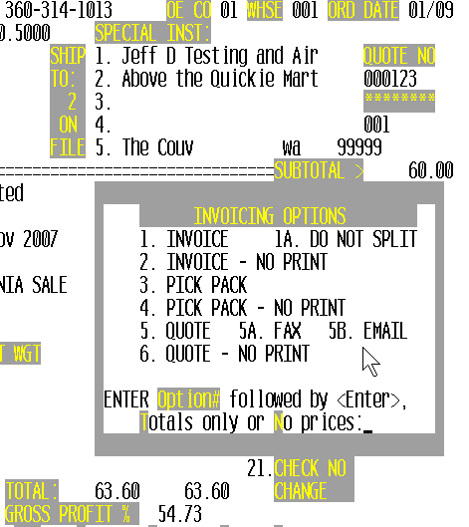

Description: Additional digits added for authorized buyer display in Order Entry to accommodate customers with larger numbers of buyers
Menu Path: Menu 1.2 (Order Entry/Invoicing)
Why Use it: As more customers add more and more buyers, this allows the authorized buyer screen display to continue to work continue to work with a current maximum of 999.
How to use it: See sample screen shot below.

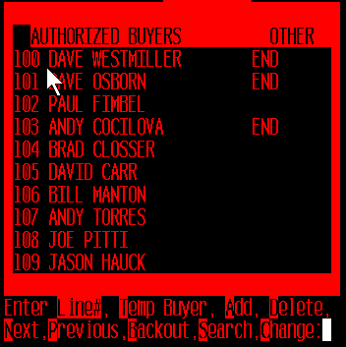

Description: Send email confirmations for quotes and picks like we do for PO’s
Menu Path: Menu 1.2 (Order Entry/Invoicing), Menu 1.34 (Email Quote thru Linux Server), & Menu 1.35 (Email Pick/Pack thru Linux Server)
Why Use it: Consistency of processes across PO’s, Invoices, picks and quotes when emailing and faxing.
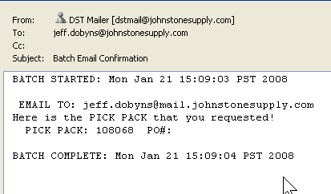

Menu 4 – Accounts Receivable
Description: Added display of email address in Accounts Receivable Inquiry
Menu Path: Menu 4.1.9 (Credit Manager Inquiry)
Why Use it: Ease of access to customer email information (from M-12.2.2.2, field 17) in the credit manager’s inquiry screen (Menu 4.1.9). Allows confirmation of the customer email address before emailing copies of the invoice.
How to use it: The email address is displayed at the bottom-left of the customer header information before the transition to customer invoice detail.

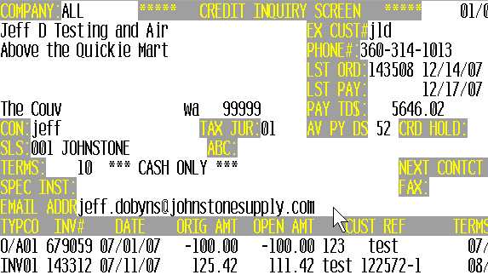

Menu 5 – Pricing
Description: EDLP - Pricing code and considerations for ‘Every Day Low Pricing’
Menu Path: Menu 1.2 (Order Entry/Invoicing) & Menu 5.3 (Contract Prices)
Why Use it: Ease of use for setting up and assigning to all your customers certain items that need to get your Every Day Low Price.
How to use it: All you need to do is setup an EDLP program in Menu 5.3 Contract Prices and the coding is in place to give that EDLP to all your customers. Then in Menu 1.2 (Order Entry/Invoicing) when a customer pulls product up, pricing will display that is coming from the EDLP program. See 2nd screen shot below.

Screen Shot from M-5.3 (setting up the EDLP)
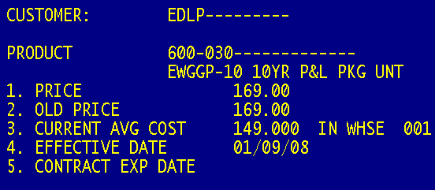
Screen Shot 2 from CPR (display of EDLP)
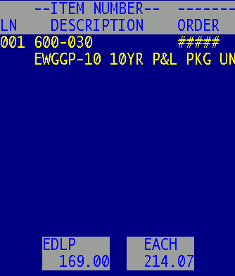

Description: New Pricing reports added to Menu 5
Menu Path: Menu 5.22 (List of Customers with PPoint) & Menu 5.27 (Customer Discounts)
Why Use it: Additional pricing reports.

Menu 5.22 – List of Customers with PPoint
This report will list the customers that have a PRICE POINT in field 4 of Menu 5.2 (Customer Detail Maintenance).
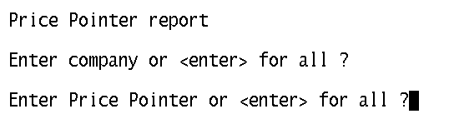
Example of Menu 5.22 Report
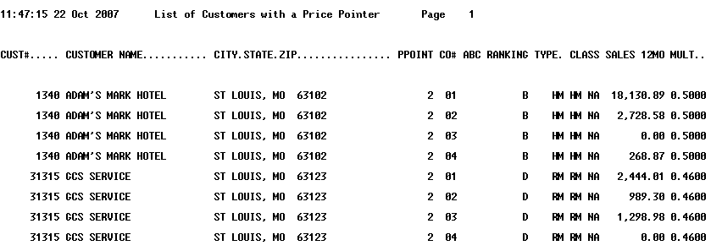
Menu 5.27 – Customer Discounts
Option 1 – Maintain Customer Discounts
This is a special pricing program to set up pricing for specific customers using broader categories: discounts or markups on product types or classes (depending on parameter in Menu 35.3.1), discounts for specific vendors, and authorize/restrict products.
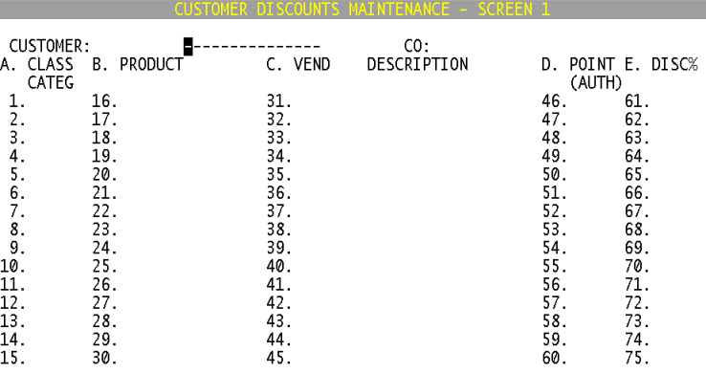
Column A is for Product Class and Category - allows only one entry per row in column A, B (product) or C (vendor), along with setting up column D (price pointer) & column E (discount/markup percentage)
Option 2 – List Customer Discounts
This report will list customer numbering, customer name, company number, class, product, vendor and customer discount; based on discounts enter in old Menu 5.27.1. To run, select the printer number to print to or FT for the file transfer.
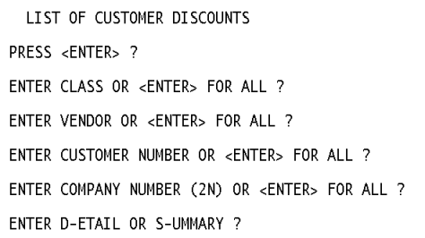
Sample Report for a Detailed List of Customer Discounts.
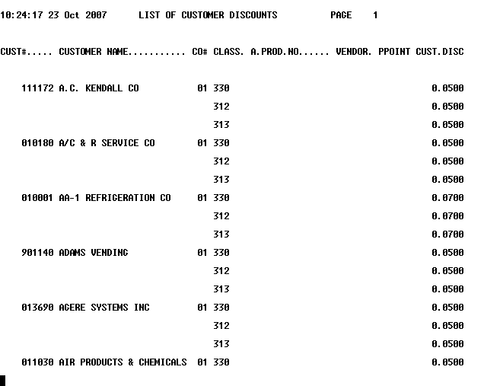

Description: Sales information added to Contract Price File report
Menu Path: Menu 5.23 (Contract Price File)
Why Use it: New option to include sales in the last 12 months, to help evaluate pricing programs to make decisions on keeping active or deleting.
How to use it: Run Menu 5.23, at the prompt to ‘Include Sold Last 12 months (Y/N)’ - enter ‘Y’.

Menu 7 – Purchasing
Description: Updated Johnstone logo on faxed Purchase Orders
Menu Path: Menu 7.1 (Purchase Order Entry & Edit) & Menu 7.30 (Fax/Email PO through Linux Server)
Why Use it: Updated HTML PO fax form adding Johnstone Logo.
How to use it: Run a fax using Menu 7.1 or 7.30. See sample PO:
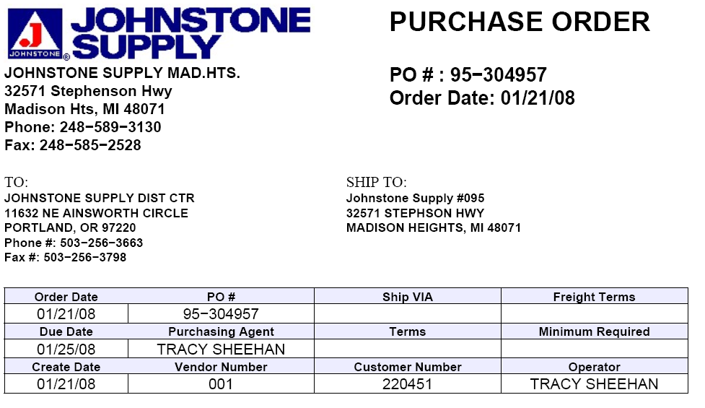

Menu 11 – Sales Analysis
Description: New sales report to show items sold and GP for a vendor
Menu Path: Menu 11.4.40 (Vendor Sales – Detail by Product)
Why Use it: The Vendor Sales report provides detailed information for vendor data from Menu 11.4.20 (Vendor Sales Inquiry).
How to use it: This new report is tied into the existing inquiry, Menu 11.4.20 (Vendor Sales Inquiry) which provides summary information, this new report provides the detailed data broken down for a vendor and time frame.

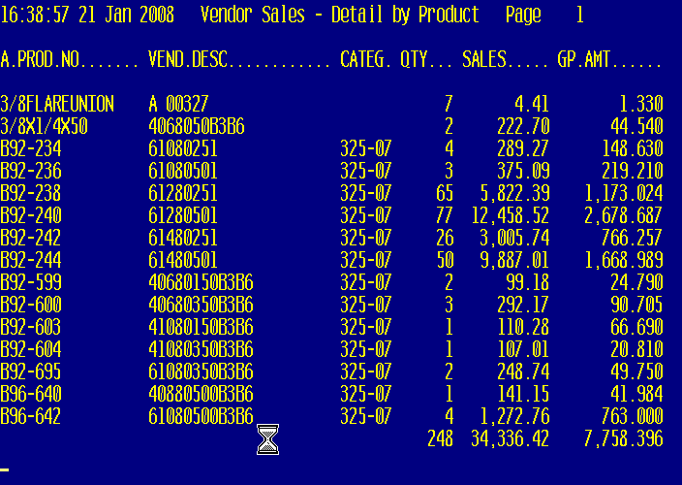

Menu 12 – File Maintenance
Description: Report to generate EOM financial information required by corporate
Menu Path: Menu 11.4.30 (Monthly Financial Information to Corp) & Menu 12.1.1 (Company Maintenance)
Why Use it: Easy to use and find, centralized data needed for corporate reporting, saves time by running a single report instead of running various reports to generate the needed data.
How to use it:
Note: As of February 2008 running Menu 11.4.30 is still a manual process to create the single report to generate the data. Future plans are for an automation of this process where the report will generate and transmit to Corp. and you will receive a confirmation of completion of the process.
- Step 1 -Set your Employee Count in Menu 12.1.1, Field 20 for all stores within your store group.
- Step 2 –Run report from Menu 11.4.30 and begin by entering fiscal month to report (YYMM)
This report provides the following data. The data will be sorted by, each store#.
- Monthly Net Sales - Total sales less freight, tax and inter-store merchandise transfers.
- Gross Profit $ - Monthly Net Sales less monthly cost of goods sold. Monthly cost of goods sold is defined as the total cost of goods sold including freight-in and excluding vendor rebates and Cooperative Patronage.
- Monthly Net Purchases - Total purchases plus incoming inter-store merchandise transfers, less outgoing inter-store merchandise transfers, returns and freight.
- Inventory $ - Net Inventory $ value as of month-end (new).
- FTE''s - The number of full time equivalent employees employed on the last day of the month.

Sample Report:
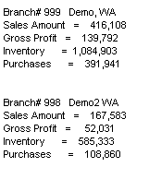
Description: Changes to customer master field 7 are added to audit tracking
Menu Path: Menu 12.7 (File Maintenance History), Menu 12.2.2.2, Screen 2, Field 7 (Customer Master – Program), & EOD Emails
Why Use it: Ability to track changes to the program field in customer master –helpful in the cases where programs have been put in place and things are being changed without proper approval.
How to use it: When anyone makes a change to Menu 12.2.2.2, Screen 2, Field 7 (Programs) an entry is written to the status log, which in turn makes the entry available in Menu 12.7 as well as in the EOD Daily Inventory Transaction Audit Report (EOD.XREF 01-114).

Description: Clean up fax and email flags in Customer Master
Menu Path: Menu 12.2.2.2, Field 11, 17, 29, 31, 34 (Customer Master Maintenance)
Why Use it: To clean up data, which cleans up the email and faxing processes providing better chances for successful transmissions.
How to use it: See below for breakdown of how this job affects the various fields.
The following explains various situations of what will happen to your invoices if a valid fax number and email address is not listed in the appropriate field?
Situation #1: A customer in (menu-12.2.2.2, screen 1), with a “F”, “FE” or “FS” in field 31- PRINT-FAX-EMAIL, does NOT have a valid fax number in field 11- FAX NUMBER or in field 29.
Resolution: Field 31 will be changed from “FE” to “E” and “F” & “FS” to NULL (blank).
Situation #2: A customer in (menu-12.2.2.2, screen 1), with a “F” or “FI” in field 34- STMT SEND FLAG, does NOT have a valid fax number in field 11- FAX NUMBER or field 29.
Resolution: Field 34 will be changed from “F” & “FI” to NULL (blank).
Situation #3: A customer in (menu-12.2.2.2, screen 1), with an “E” or “FE” in field 31- PRINT-FAX-EMAIL, does NOT have a valid email address in field 17- EMAIL ADDR.
Resolution: Field 31 will be changed from “FE” to “F” and “E” to NULL (blank).
Situation #4: A customer in (menu-12.2.2.2, screen 1), with an “E” or “EI” in field 34- STMT SEND FLAG, does NOT have a valid email address in field 17- EMAIL ADDR.
Resolution: Field 34 will be changed from “E” & “EI” to NULL (blank).

Description: Comprehensive customer data information (CDI) report
Menu Path: Menu 12.2.2.30 (List of Customer Information)
Why Use it: New customer information report. Data includes: customer master address, mailer address, webstore login information, email address, fax number, AR Balance, Sales in the last 12 months, etc…)
How to use it: Menu 12.2.2.30, FT ONLY, then select either ‘ALL’ customers or those with no activity in the last 5 years.

Description: Compares serial numbers to on-hand quantities
Menu Path: Menu 12.3.31 (Serial Numbers Still On-Hand List)
Why Use it: This new parameter is used to track serial numbers on hand. It compares to on-hand quantity for a product.
How to use it: Menu 12.3.31, answer prompt ‘SELECT ONLY ITEMS WHERE ON HAND DOES NOT MATCH NUMBER OF SER.NOS Y/N’, report selects only items where the on-hand does not match the number of serial numbers.

Description: Add option to product listing for reporting by category
Menu Path: Menu 12.3.33 (Product List – P/C, P/T, Category)
Why Use it: When setting up pricing, sometimes you need to know what products are in a certain type, class, or category…this report gives an easy option to obtain that list of products.
How to use it: After selecting the printer in Menu 12.3.33 the first prompt is to select by 1)PRODUCT CLASS, 2)PRODUCT TYPE, or 3)CATEGORY ? Input 1, 2, or 3 depending on what you want to run the listing by. Then input the class, type or category.

Description: ‘FT Only’ version of product pad
Menu Path: Menu 12.3.38 Product Pad (FT Only version)
Why Use it: There probably isn’t a better report for raw product data…and there probably isn’t a worse report for printing out a lot more pages than needed. The FT version of the product pad provides the great info and builds it on an expandable platform for easy additions of more fields.
How to use it: There will be no printer select. Answer the prompts to Menu 12.3.38 and the report will FT into your Pick folder on your C:\ drive named FT.TXT. Once the report File Transfers, open with Notepad or import easily into Excel.
Sample of FT’d product pad.
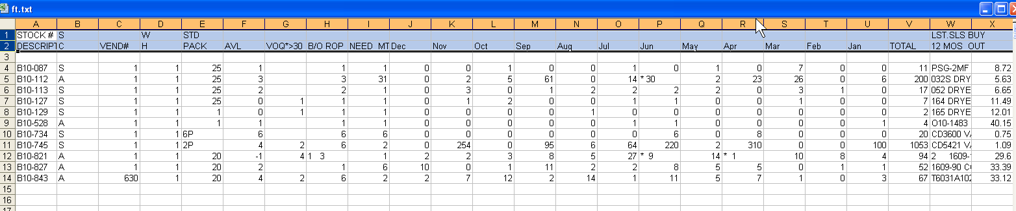

Menu 15 – Warranty
Description: Enhanced audit information for warranty transactions
Menu Path: Menu 15.10 (Update Warranty File with Receiving) & Menu 19.7b (Inventory Transaction by Product)
Why Use it: The warranty receiving in inventory process (WAR transaction type) will now include the operator and sequence number when displayed in Menu 19.7B Inventory Transaction by Product
How to use it: Menu 15.10 will prompt for a valid operator number and Menu 19.7B will display this operator along with the warranty sequence number under the WAR transaction type.

Menu 17 – End of Month
Description: Archive AR EOM reports to the Linux server
Menu Path: Menu 17.1a (EOD/EOM Combo), Menu 17.5 (EOM Report Xref Maintenance), & Menu 17.6 (EOM Report Xref File Listing)
Why Use it: Enhancement to the EOM Xref system for automatic archival of AR EOM reports to the Linux server.
How to use it: This feature is already setup and will automatically start for those with a Linux server. The AR EOM reports are setup to be automatically archived to the Linux server. The file name of the report is stored in Menu 17.5, Field 9. The file name is what will appear on the Linux server in the EOM folder.

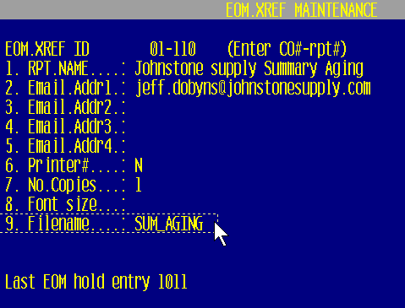
To access the reports off the Linux server, setup the following:
- Map a drive – Open up My Computer from your Desktop icon.
- Tools > Map Network Drive > Select ‘R:’ from the dropdown list.
- In the Folder field enter \\YOUR LINUX IP ADDRESS\reports
For Example - \\192.168.100.226\reports
- Reconnect at logon – Check this Box
- Select Finish

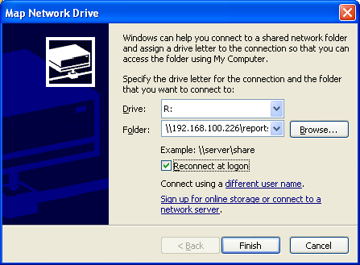

- Open the EOM folder to view the AP EOM reports
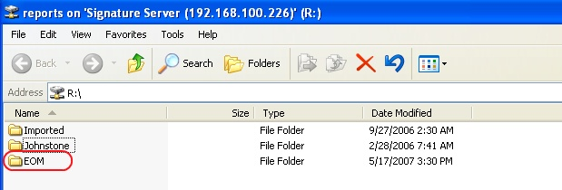
- Open the EOM folder to view the AP EOM reports
- Each report is listed as a PDF and a TXT file. Simply double click on a report name to view the report.

Menu 27 – Forecasting
Description: On-hand and On Order Qty of subs has been added to the forecast screen
Menu Path: Menu 27.5 (Maintain Forecast)
Why Use it: New fields added to the forecast maintenance screen to lessen the need for screen hopping from one menu to another by having more of the pertinent information all on one maintenance screen.
How to use it: Train your eyes to the Sub PN section and the Sub On Order Qty is displayed in the VOQ column.
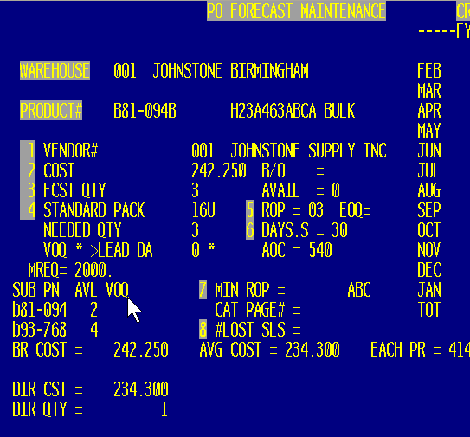

Description: On Hand display for ALL DC’s and your store group
Menu Path: Menu 27.5 (Maintain Forecast)
Why Use it: Easy reference for all DC inventory for cataloged items as well as inventory totals for stores within your group.
How to use it: Menu 27.5, train your eyes to locate the DC inventory in the top-left and your store inventory in the top-right.

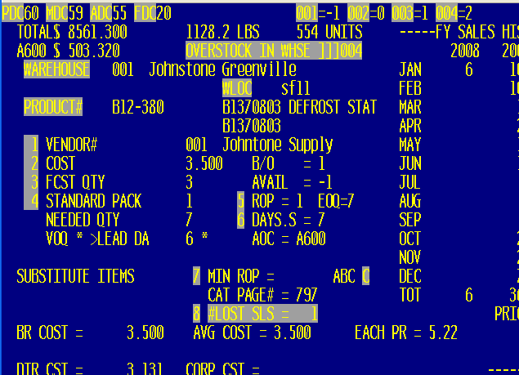

Description: Option to fax converted Purchase Order
Menu Path: Menu 27.6 (Convert Forecast to Purchase Order)
Why Use it: Step saver to convert forecast and fax all in one step.
How to use it: Run Menu 27.6 to convert your non-Corp. forecast, after the forecast is converted to a PO and the PO is created you will be prompted to ‘F’ to fax the PO. Enter the prompt to print vendor part#’s on the PO, enter to include costs, and select or input the vendor fax#.

See below for screen shot.

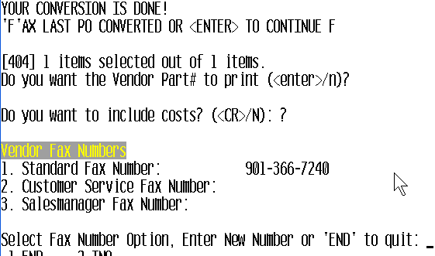

Menu 35 – Parameters
Description: Parameter to control whether credit memos are faxed or emailed nightly
Menu Path: Menu 35.12, Screen 2, Field 14. FAX/EMAIL CREDIT MEMOS DURING EOD
Why Use it: Control delivery of credits on customer accounts by disallowing EOD Fax or Email of credits.
How to use it: Go to Menu 35.12, Screen 2 and then set Field 14 to ‘Y’ to transmit credit memos. By default the system is set to ‘N’. If the parameter is blank or if set to ‘N’ the system will NOT transmit credit memos.
Description: Signature Capture modifications for signature requirements on Dropships, Delivery and UPS shipments
Menu Path: Menu 1.2 (Order Entry/Invoicing), Menu 35.12, Screen 2 Field 15 (Ship Methods to Bypass Signature)
Why Use it: Many typical scenarios just don’t offer themselves to the collections of signatures in all cases. Dropships, delivery and UPS shipments fall into this category. Instead of continuing to spend the time to bypass the signature by entering through or entering a dummy signature on the pad, simply setup the scenarios that you don’t want to require a signature to help speed up and streamline processing.
How to use it: For dropship tickets, the system looks at the dropship indicator (DS) on the ticket. For all other scenarios, go to Menu 35.12, Screen 2 Field 15 (SHIP METHODS TO BYPASS SIGNATURE) and, enter the various ship methods on the different lines.

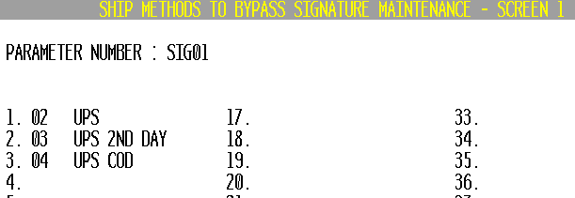

Description: System-wide price mark-up
Menu Path: Menu 35.3, Field 8 (System Wide Price Markup)
Why Use it: Set Field 8 to a percentage (ex: 1.00) to mark up ALL prices by that percentage. After the each price is calculated from the list price multiplier and/or the Menu 5.15 pricing matrix then the markup is applied. If the price that is used comes from a lot price or a fixed contract in Menu 5.3, those prices are NOT marked up.
***Note: That this mark-up does NOT affect actual pricing in the system.

Description: Clear lot pricing on 50 lot products
Menu Path: Menu 35.3, Field 5 (Clear 50 & 100 lots on B92 – B97, L96 - L98, & N98)
Why Use it: Remove the extremely low lot pricing on selected prefixes.
How to use it: Set parameter to ‘Y’ in Menu 35.3, Field 5 - Clear 50 and 100 lots on B92 – B97, L96 – L98 and N98.

Description: Parameter driven printer select for HTML formatted PO’s
Menu Path: Menu 35.5, Field 12 (Print Purchase Orders using Laser Form) & Menu 35.15 (Linux Laser Printer Definition Maintenance)
Why Use it: So you can select which printers the HTML formatted PO’s print to.
How to use it: Currently, stores already using HTML formatted purchase orders are printing them out without being able to select a printer. The HTML PO’s are printing to the port’s default print setup in Menu 35.13.
***DSST requires putting in a support job so we can guide you through this process of setting up additional network printers to select from.
DSST will setup the printer select table in the new menu 35.15 for you and then set the parameter in Menu 35.5 field 12 set to ‘Y’ to start using HTML formatted PO’s.
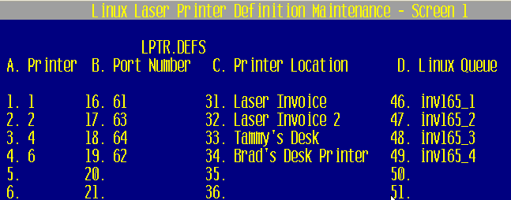

Description: Modification to price override event notification
Menu Path: Menu 35.19.4 (Price Override)
Why Use it: Price overrides that come as a result of Menu 5.15 Matrix pricing are excluded from the price override event notification.

