Job#: 124279
Job Desc: Add display of email address and maintenance of contact date in more AR screens
Menu Path: M-4.1.9
Why Use it: Ease of access to customer email information (from M-12.2.2.2, field 17) so when in the credit manager’s inquiry screen you can confirm the email address on file for customer before attempting to email them invoice copies.
How to use it: The email address is displayed at the bottom-left of the customer header information before the transition to customer invoice detail.

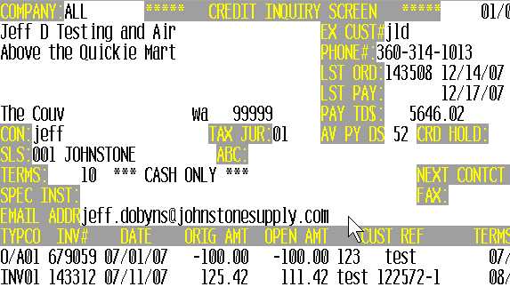

Job#: 125618/124127
Job Desc: Transition of notes editor away from DQ editor by incorporate new memo component for maintaining and displaying AR Memos
Menu Path: M-4.1.9/33.1, M-35.6 screen 3, field 2/3.
Why Use it: Parameter controlled piece of the puzzle before being able to eliminate the DQ editor.
How to use it:

- Set the parameters in M-35.6, screen 3 field 2 and 3. Use New non-DQ Editor for Credit Memo Notes (4.1.9) and telemarketing notes (33.1) to ‘Y’ .
- Once the parameter is set go into M-4.1.9/33.1, select ‘M’ for memos and the new program displays the existing memos and inserts your cursor to the last point of entry. You are in ‘INSERT’ mode. When done entering the memos, press ‘ESC’ (escape) and then ‘0’ to accept and save the entry. See memo screen below:

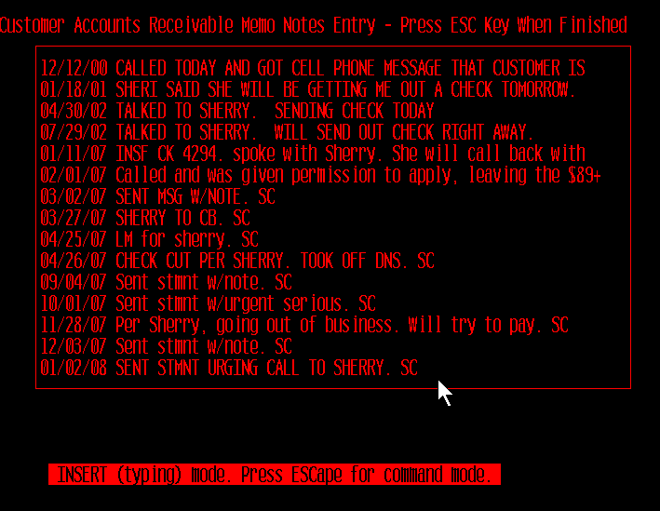

Job#: 124667
Job Desc: Parameter to control whether credit memos are faxed or emailed nightly.
Menu Path: M-35.12, screen 2, field 14. FAX/EMAIL CREDIT MEMOS DURING EOD
Why Use it: Control delivery of credits on customer accounts by disallowing EOD Fax or Email of credits.
How to use it: Go to M-35.12, screen 2 and then set field 14 to ‘Y’ to transmit credit memos. By default the system is set to ‘N’….If the parameter is blank or if set to ‘N’ system will NOT transmit credit memos.

Job#: 124435
Job Desc: Archive AR EOM reports to the linux server.
Menu Path: M-17.1a, 17.5 and M-17.6
Why Use it: Enhancement to the EOM Xref system for automatic archival of AR eom reports to the linux server.
How to use it: This is setup and will automatically start for those with a Linux server. The AR EOM reports are setup to be automatically archived to the Linux server. The file name of the report is stored in Field 9. The file name is what will appear on the Linux server in the EOM folder.

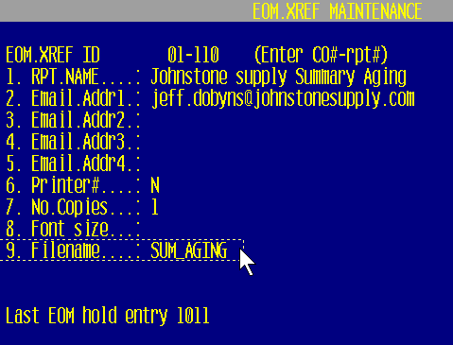

To access the reports off the Linux server, setup the following:
- Map a drive – Open up My Computer from your Desktop icon.
- Tools > Map Network Drive > Select ‘R:’ from the dropdown list.
- In the Folder field enter \\YOUR LINUX IP ADDRESS\reports
For Example - \\192.168.100.226\reports
- Reconnect at logon – Check this Box
- Select Finish

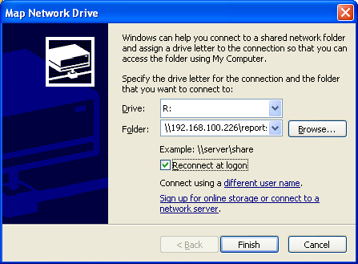

- Open the EOM folder to view the AP EOM reports
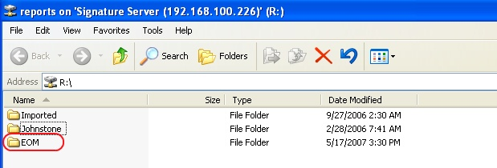
- Openthe EOM folder to view the AP EOMreports
- Each report is listed as a PDF and a TXT file. Simply double click on a report name to view the report.

Job#: 116811
Job Desc: Enhancements to the forecasting screen. Added onhand and on order qty of subs
Menu Path: M-27.5
Why Use it: Couple fields added to the forecast maintenance screen to lessen the need for screen hopping from one menu to another by having more of the pertinent info all on one maintenance screen.
How to use it: Train your eyes to the Sub PN section and the sub on order qty is displayed in the VOQ column.
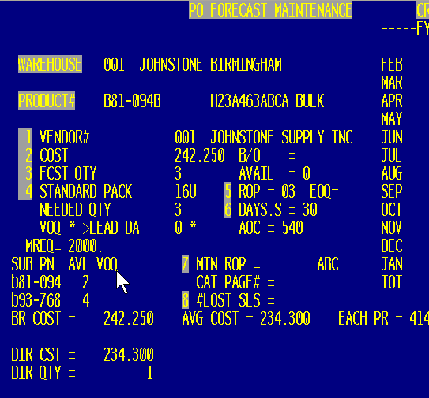

Job#: 124133
Job Desc: Complete On Hand display for ALL DC’s and your store group.
Menu Path: M-27.5
Why Use it: Easy reference for all DC inventory for cataloged items as well as the stores within your group.
How to use it: M-27.5, train your eyes to locate the DC inventory in the top-left and your store inventory in the top-right.

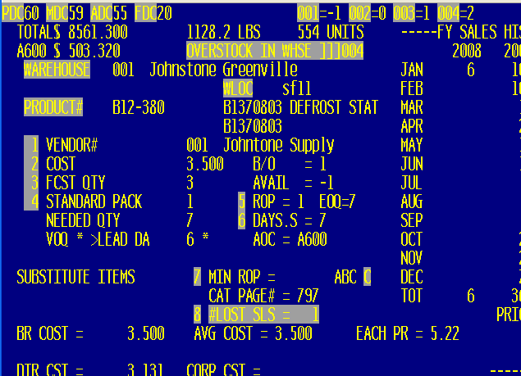

Job#: 114629
Job Desc: Signature Capture modifications for signature requirements on dropships, delivery and UPS shipments
Menu Path: M-1.2, M-35.12 screen 2 field 15.
Why Use it: Many typical scenarios just don’t offer themselves to the collections of signatures in all cases. Dropships, delivery and UPS shipments fall into this category. Instead of continuing to spend the time to bypass the signature by entering thru or entering a dummy signature on the pad simply setup the scenarios that you don’t want to require a signature to help speed up and streamline processing.
How to use it: For dropship tickets, the system look at the dropship indicator (DS) on the ticket…for all other scenarios, Go to M-35.12, screen 2 field 15. SHIP METHODS TO BYPASS SIGNATURE and when in that screen, enter the various ship methods on the different lines.

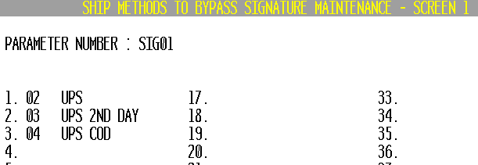

Job#: 123934
Job Desc: Add options to be able to fax and email quote from order entry total screen.
Menu Path: M-1.2
Why Use it: Step saver by adding the ability to create the quote, file it away and send it off to the customer from a single menu path.
How to use it: In M-1.2, in the total screen, when the Invoicing Options display (see screen shot below) select 5A to fax the quote or 5B to email the quote.
- If 5A is selected follow these quick steps
  - Enter # of days to display honoring quote.
  - Enter to confirm is prices should display on quote.
  - Enter fax# or enter to accept default fax# on customer file.
  - Enter Attention or enter for account default.
  - Enter special messages or enter to send the fax.
  - Then the system files the quote away and sends it to customer.

- If 5B is selected follow these quick steps:
  - Enter # of days to display for honoring the quote
  - Enter to confirm if prices should display on the quote.
  - Enter operator code
  - Confirm Email confirmation address
  - Confirm Email Recipient address –type in new address or enter to accept address on file
  - Then the system files the quote away and sends it to customer.

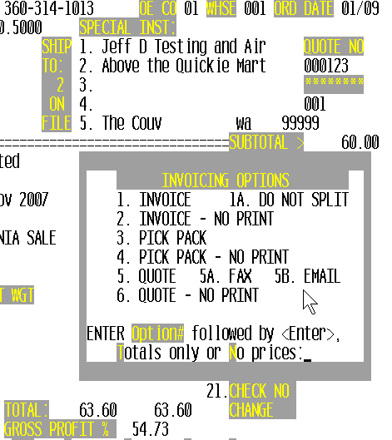

Job#: 125216
Job Desc: Additional digits for authorized buyer display in OE to accommodate customers with larger numbers of buyers.
Menu Path: M-1.2
Why Use it: As more customers add more and more buyers, this allows the authorized buyer screen display to continue to work.
How to use it: See sample screen shot below.

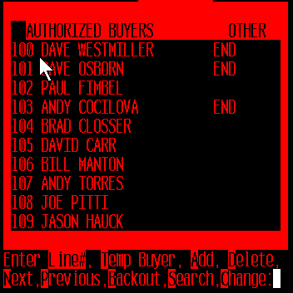

Job#: 124826
Job Desc: EDLP pricing coding and considerations for ‘Every Day Low Pricing’
Menu Path: M-1.2, M-5.3
Why Use it: Ease of use for setting up and assigning to all your customers certain items that need to get your Every Day Low Price.
How to use it: all you need to do is setup an EDLP program in M-5.3 Contract Prices and the coding is in place to give that EDLP to all your customers. Then in M-1.2 Order Entry when a customer pulls product up, pricing will display that its coming from the EDLP program. See 2nd screen shot below.

Screen Shot from M-5.3 (setting up the EDLP)
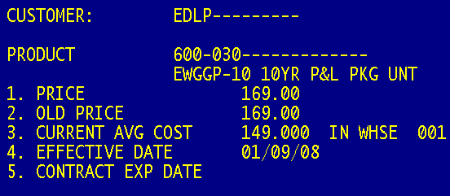

Screen Shot 2 from CPR (display of EDLP)

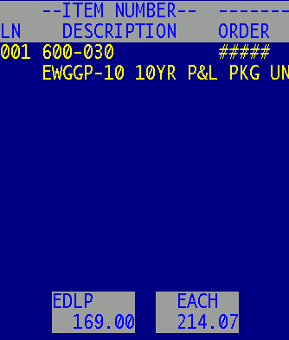

Job#: 125429
Job Desc: correct pricing issue for EDLP items when selling in a store branch transfer.
Menu Path: M-1.2
Why Use it: Correct issue with EDLP items on store transfers to use the average cost instead of the EDLP pricing.
How to use it:

Job#: 115917
Job Desc: Install ‘FT Only’ version of product pad as part of base package.
Menu Path: Bloomington, m-12.3.38 Product Pad (FT Only version)
Why Use it: there probably isn’t a better report for raw product data…and there probably isn’t a worse report for printing out lots more pages than needed. The FT version of the product pad provides the great info and builds it on an expandable platform for easy additions of more fields as well.
How to use it: There will be no printer select…Answer the prompts to M-12.3.38 and the report will FT into your Pick folder on your C:\ drive named FT.TXT. Once the report Ft’s open with notepad or import easily into Excel.

Sample of FT’d product pad.

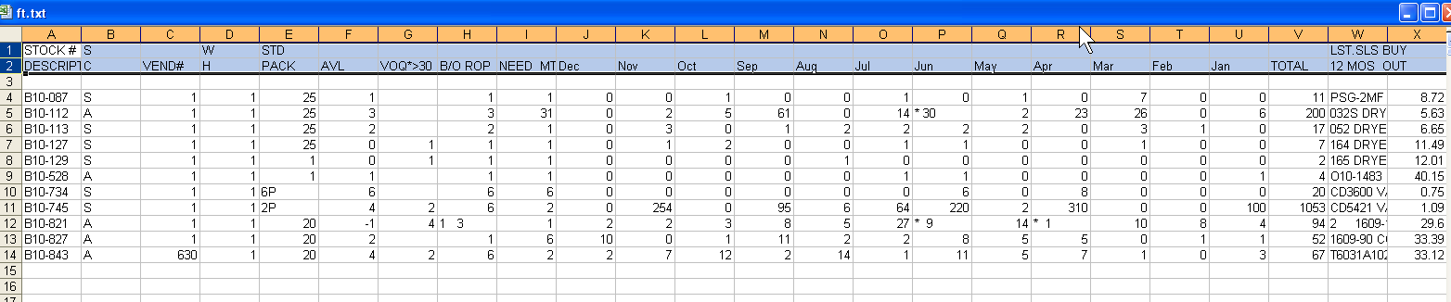

Job#: 124023
Job Desc: Parameter driven printer select for HTML formatted PO’s
Menu Path: M-35.5, field 12 set to ‘Y’ and M-35.15 to set printer defaults
Why Use it: So you can select which printers the HTML formatted PO’s print to.
How to use it: ***DSST requires putting in a support job so we can guide you through this process. DSST will setup the printer select table in the new menu 35.15 for you and then set the parameter in M-35.5 field 12 set to ‘Y’ to start using HTML formatted PO’s

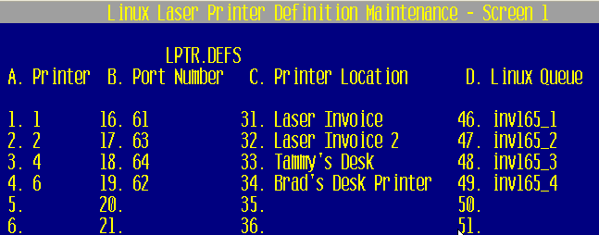

Job#: 126001
Job Desc: Auto upload (future) to corp during EOM run of financial information required by corporate.
Menu Path: M-11.4.30, M-12.1.1
Why Use it: Easy to use and find, centralized data needed for corporate reporting saving time tracking down by running a single report for this data instead of running various reports to generate this data.
How to use it:
Note: As of January 2008 this is still a manual process to create the single report to generate the data. Future plans are for an automation of this process where the report will generate and transmit to corp and you will receive a confirmation of completion of the process.

- Step 1 -set your FTE’s in M-12.1.1, field 20 for all stores within your store group.
- Step 2 –Run report from M-11.4.30 and begin by entering fiscal month to report (YYMM)

This report provides the following data. The data will be by each store#.
- Monthly Net Sales - Total sales less freight, tax and inter-store merchandise transfers.
- Gross Profit $ - Monthly Net Sales less monthly cost of goods sold. Monthly cost of goods sold is defined as the total cost of goods sold including freight-in and excluding vendor rebates and Cooperative Patronage.
- Monthly Net Purchases - Total purchases plus incoming inter-store merchandise transfers, less outgoing inter-store merchandise transfers, returns and freight.
- Inventory $ - Net Inventory $ value as of month-end (new).
- FTE''s - The number of full time equivalent employees employed on the last day of the month.

Sample Report:
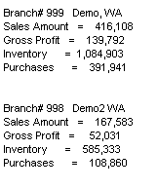

Job#: 125288
Job Desc: Add printer select to check register
Menu Path: M-13.2.7
Why Use it: Allow to select how and where to print.
How to use it: Select printer.

Job#: 124274
Job Desc: Add changes to customer master fields to audit.
Menu Path: m-12.7, M-12.2.2.2, screen 2, field 7., EOD Emails
Why Use it: Ability to track changes to the program field in customer master –helpful in the cases where programs have been put in place and things are not being changed without proper approval.
How to use it: When anyone makes a change to m-12.2.2.2, screen 2 field 7. Programs it writes an entry to the status log, which in turn makes the entry available in M-12.7 as well as the EOD emails (EOD.XREF 01-114)

Job#: 123873
Job Desc: Add comprehensive customer data information (CDI) report.
Menu Path: M-12.2.2.30
Why Use it: New report for customer information that combines into a single report (customer master address, mailer address, webstore login information, etc).
How to use it: M-12.2.2.30, FT ONLY, then select for either ‘ALL’ customers or those with no activity in the last 5 years.

Job#: 116912
Job Desc: Option to fax converted PO.
Menu Path: M-27.6
Why Use it: Step saver to convert forecast and fax all in one step.
How to use it: When running M-27.6 to convert your forecast after the forecast is converted to a PO and the PO created you will be prompted to ‘F’ to fax the po. Enter the prompt to print vendor part#’s on the PO, Enter to include costs, and select or input the vendor fax#.

See below for screen shot.

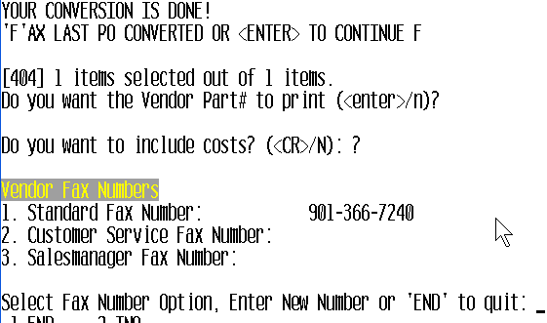

Job#: 125409
Job Desc: Send email confirmations for quotes and picks like we do for PO’s.
Menu Path: M-1.2, 1.34, 1.35
Why Use it: Consistency of processes across PO, Invoices, picks and quotes when emailing and faxing.
How to use it:

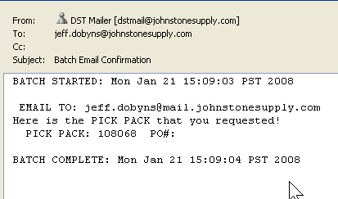

Job#: 123278
Job Desc: Added updated Johnstone logo to faxed po’s..
Menu Path: M-7.1, 7.30
Why Use it: Updated HTML PO fax form adding Johnstone Logo.
How to use it: See sample PO:
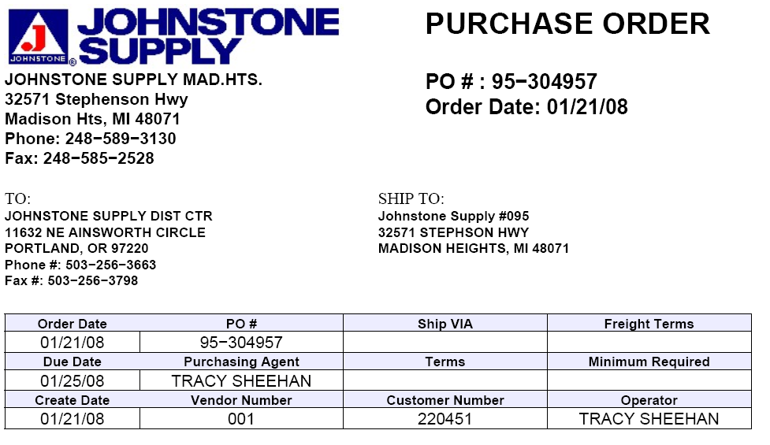

Job#: 124477
Job Desc: Modification to price override event notification.
Menu Path: M-35.19.4
Why Use it: Price overrides that come as a result of M-5.15 Matrix pricing are excluded from the price override event notification.
How to use it:

Job#: 117218
Job Desc: Add sales info to contract report .
Menu Path: M-5.23
Why Use it: Option to include sales in the last 12 months to help evaluate pricing programs to make decisions on keeping active or deleting.
How to use it: Run M-5.23 and at the prompt to ‘Include Sold Last 12 months (Y/N)’

Job#: 118389
Job Desc: Add pricing related reports to the pricing menu.
Menu Path: New to menu 5. M-5.22, M-5.23
Why Use it: Additional pricing reports
How to use it: added reports to m-5. Menu 5.22 is a new report. List of Customers with PPoint and Menu 5.27 is the old M-5.23 report - Customer Discounts (old 5.3/23)

Job#: 124671
Job Desc: System-wide price mark-up
Menu Path: M-35.3, option 8.
Why Use it: Set option 8 to a percentage (ex: 1.00) to mark up ALL prices by that percentage.
***Note: That this mark-up does NOT affect actual pricing in the system.
(without changing what's actually in the product master file)

Job#: 124702
Job Desc: Add option to product listing for reporting by category.
Menu Path: M-12.3.33
Why Use it: sometimes, when setting up pricing, sometimes you need to know what products are in a certain type, class category…this gives an easy option to obtain that list of products.
How to use it: After selecting printer in M-12.3.33 the first prompt is to SELECT BY 1)PRODUCT CLASS 2)PRODUCT TYPE 3)CATEGORY ? Input 1, 2, or 3 depending on what you want to run the listing by. Then input the class, type or category.

Job#: 125563
Job Desc: Bug fix to quote deletion selection.
Menu Path: M-28.0
Why Use it: Correction to quote deletion so the correct quotes are being selected.
How to use it: Previously, some additional quotes would be deleted that were much younger than the purge date. This corrected the selection criteria, fixing the purge.

Job#: 124552
Job Desc: Add sales report to show items sold and GP for a vendor.
Menu Path: M-11.4.40
Why Use it: Report to provide detailed information for vendor data from M-11.4.20 Vendor Sales Inquiry.
How to use it:
This new report is tied into the existing inquiry, M-11.4.20 where it provides summary information, this new report provides the detailed data broken down for a vendor and time frame.

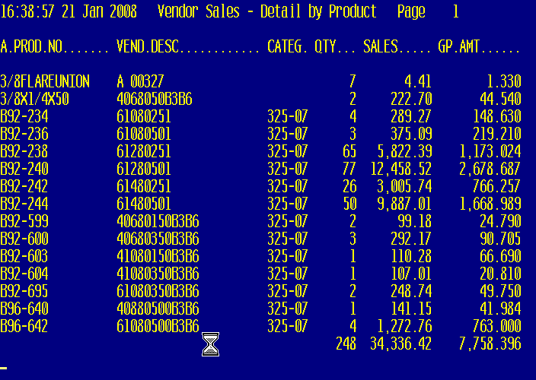

Job#: 122629
Job Desc: Additions to eod report.
Menu Path: M-16.1, M-16.5 EOD.XREF 01-190 Contract Prices with cost changes
Why Use it: Additional fields added to report, sell price, GP$ and GP%
How to use it:

Job#: 124458
Job Desc: change to prompt to reflect expected input.
Menu Path: M-14.1.14
Why Use it: Easier to know what is expected at the update prompt.
How to use it: M-14.1.14, prompt was changed from ‘Y’ to ‘Y***’ DO YOU WANT TO RUN THE AUTO-REVERSE JOURNAL ENTRY UPDATE ? (Y***/N)

Job#: 109280
Job Desc: Remove ability to delete system parameter
Menu Path: M-35.6
Why Use it: Safety prevention –remove the ability to ‘DELETE’ this record.
How to use it:

Job#: 125648
Job Desc: clear lot pricing on 50 lot products
Menu Path: M-35.3
Why Use it: Remove the extremely low lot pricing on selected prefixes.
How to use it: With this parameter set to ‘Y’ M-35.3, field 5 Clear 50 and 100 lots on B92 – B97, L96 – L98 and N98

Job#: 125468
Job Desc: Add option to serial report to compare serial numbers to onhand quantities
Menu Path: M-12.3.31
Why Use it: Helpful tool to track serial numbers on hand comparing to onhand quantity for a product.
How to use it: M-12.3.31 then answer prompt ‘SELECT ONLY ITEMS WHERE ON HAND DOES NOT MATCH NUMBER OF SER.NOS Y/N and report selects only items where the onhand does not match the number of serial#’s.

Job#: 125596
Job Desc: Add printer select to lost sales report.
Menu Path: M-27.7
Why Use it: Printer select needed to be able to FT report.
How to use it:

Job#: 117279
Job Desc: Enhanced audit information for warranty transactions
Menu Path: M-15.10, M-19.7b
Why Use it: The warranty receiving in inventory process (WAR transaction type) will now include the operator and sequence number when displayed in M-19.7B Inventory Transaction by Product
How to use it: M-15.10 will prompt for a valid operator number and M-19.7B will display this operator along with the warranty sequence number under the WAR transaction type.

Job# 126770
Job Desc: Clean up fax and email flags and customer data.
Menu Path: M-12.2.2.2, field 11, 29, 31, 34
Why Use it: To clean up data, which cleans up the email and faxing processes providing better chances for successful transmissions.
How to use it: See below for breakdown of how this job affects the various fields.
What will happen to your invoices if a valid fax number and email address is not listed in the appropriate field?
Situation:
A customer in (menu-12.2.2.2, screen 1), with a “F”, “FE” or “FS” in field 31- PRINT-FAX-EMAIL, does NOT have a valid fax number in field 11- FAX NUMBER or in field 29.
Resolution:
Field 31 will be changed from “FE” to “E” and “F” & “FS” to NULL (blank).

Situation:
A customer in (menu-12.2.2.2, screen 1), with a “F” or “FI” in field 34- STMT SEND FLAG, does NOT have a valid fax number in field 11- FAX NUMBER or field 29.

Resolution:
Field 34 will be changed from “F” & “FI” to NULL (blank).

Situation:
A customer in (menu-12.2.2.2, screen 1), with an “E” or “FE” in field 31- PRINT-FAX-EMAIL, does NOT have a valid email address in field 17- EMAIL ADDR.

Resolution:
Field 31 will be changed from “FE” to “F” and “E” to NULL (blank).

Situation:
A customer in (menu-12.2.2.2, screen 1), with an “E” or “EI” in field 34- STMT SEND FLAG, does NOT have a valid email address in field 17- EMAIL ADDR.

Resolution:
Field 34 will be changed from “E” & “EI” to NULL (blank).

