Database Business System
U2006.3 Upgrade Documentation
Release Date 1/10/07

Menu 1 – Order Entry

Menu 1.2 – Order Entry
When entering a credit on a drop-ship item in Order Entry - If Field 18, in the Order Entry Line Detail Maintenance screen has a ''DS'' Flag the system will read Field 7, Reason Code and then populate Field 8, Return Indicator with the appropriate value.

Menu 1.21 – Time Clock Entry
The date field is restricted to only allow the current date to be entered.

Menu 2 - Order Entry Reports

Menu 2.10 – Sum of Today’s Invoices
Menu 2.10 now provides users with additional information. Users need to set Menu 35.10 Field 12 to Y then Menu 2.10 will display totals for:

- Today's Finalized Invoices - All invoices finalized at this time
- Sum of today's Orders - All orders taken today, if finalized they will also appear in the Today’s Finalized Invoices totals
- Month to Date - All orders that have been finalized this month

Menu 35.10.13 will control whether or not Gross Profit figures appear in Menu 2.10. If a ‘Y’ is entered or if the field is left blank Gross Profit information will appear on the screen. Placing an ‘N’ in Field 13 will remove Gross Profit information from Menu 2.10.

Menu 4 - Accounts Receivable

Menu 4.2.1 - Daily Cash Receipts Journal
The bank number is now shown on the Daily Cash Receipts Journal.

Menu 5 - Price Maintenance/Price Books

Menu 5.2A.2 – Delete Contracts
This menu path now offers the ability to delete Menu 5.33 Programs and Customer Contracts.

Menu 5.33 – New Customer Pricing Matrix
When the "S"ell price option is selected, the system will prompt for the actual sell price that the user determines. This will then auto setup the matrix as follows. If there is a list price on this product, it will auto fill Field 2, DPOINT with a price pointer of "23" and auto fill Field 3, DISC% with the calculated discount percentage off the list price to get the desired sell price. If there is no list price on this product, it will auto fill Field 2, DPOINT with a price pointer of "0" and auto fill Field 3, DISC% with the calculated discount percentage off the each price to get the desired sell price.

Menu 7 - Purchasing

Menu 7.1 - Purchase Order Entry

**Note – This upgrade is on a request basis only. Please submit a job through http://dst.myjohnstone.com/Login.asp to request this upgrade.

Freight Terms now appear on the Purchase Order printout. The Freight Term is pulled from the Freight Policy listed on the C99.

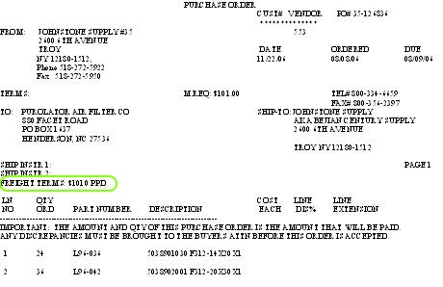

Menu 12 - File Maintenance

Menu 12.3.2.9 – Price Update Parameter Maintenance
Field 23 – Category - has been added to give users the ability to block Corp from updating the product category.

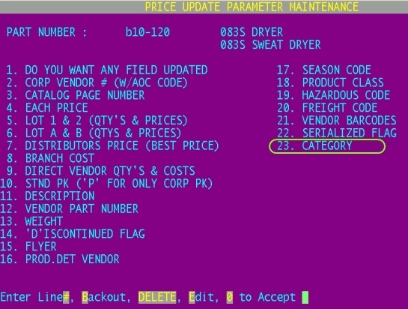

Menu 12.7 - File Maintenance History
Menu 12.7 File Maintenance History will now also reflect changes made to average cost in 13.20.2 Purchase Order Receipts Update.

Menu 13 - Accounts Payable

Menu 13.2.3 – Cash Disbursements (By Due Date)
The total number of checks will now print at the bottom of the Cash Disbursement report. This is a handy tool so that users know how many checks to put in the printer.

Menu 13.2.6/6A - AP Print Checks/Laser Checks
Users will no longer be able to date a check run with a date that doesn’t match the selected period. For instance if you date a check run (menu 13.2.6/6a) for 12/01/06 but enter period 200611, you’ll see the following error message:

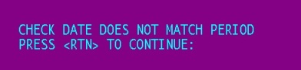

Menu 13.2.8 - Bank Activity Report
Cash transactions can now be viewed for closed period; however, the total is cumulative based on a starting balance of zero and is not based on a GL account balance (see screen shot below.) This will allow for historical data to display. However, if the report is run for an open GL period, the starting balance is based on the starting balance of cash for the period.

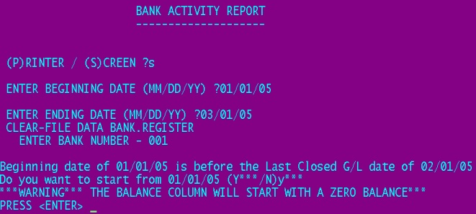

Menu 13.20.2 - Purchase Order Receipts Update
- Stores can now control the account posted to in Menu 13.20.2 to A/P when there is a price variance. If there is no quantity on hand then the variance will be posted to the account in Field #19 in Menu 12.1.7, General Ledger Control Maintenance. If this field is left blank, then Cost of Goods will be the default account posted to.
- Changes made to average cost in Menu 13.20.2 because of variances between a vendor invoice and a purchase order can now be viewed at menu 13.20.34
- An additional prompt has been added to Menu 13.20.2. Use the “F” option to add a freight amount right before the final update.
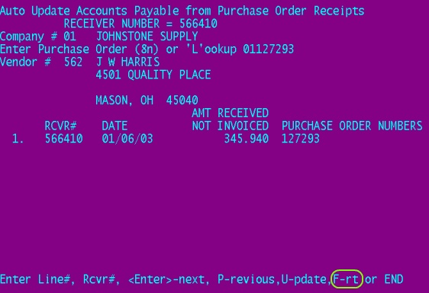
- When using 13.20.2 to voucher merchandise, after the final update to the voucher screen, users now have the ability to change the vendor address.

Menu 13.20.18 - Voucher Deletion
Vouchers can no longer be deleted in 13.20.18 if the batch the voucher was created in is still open.

Menu 14 - General Ledger

Menu 14.1.5 - Recurring Entry Maintenance
Cross Posting in Reconciling Journal Entries
If the parameter for cross posting in the GL is set to Y in menu 35.6,screen #2, Field #1, then you can now create reoccurring journal entries which cross post in menu 14.1.5.

Menu 14.2.9 - Final Detail General Ledger Report
Users can now back out of menu 14.2.9.

Menu 14.3.8 – New Financial File Calculation & Report
Real Time General Ledger

An accurate Income Statement & Balance Sheet can be run at any time during the month. The Trial Balance must first be run from menu 14.2.4 and the accounts payable period must be current. Menu 14.3.8 will generate the real time statements.

Menu 15 - Warranty

Menu 15.11 - Update Warranty File with Vendor Credits
The GL number for the warranty system will now be the default in 15.11. The GL used is from 12.1.7, field # 15. Users can still override that account number; although, it is highly discouraged.

Menu 19 - Inquiries

Menu 19.6 – Stock Status
Serial numbers can be viewed on items in stock status. After entering in the item, type SER to view the serial numbers that have been received and are available for sale.

Menu 19.6 - Stock Status
'CENTRAL XXX’ will display above the pricing bucket, for example input B14-884, 'CENTRAL PDC' will be listed above the pricing buckets.
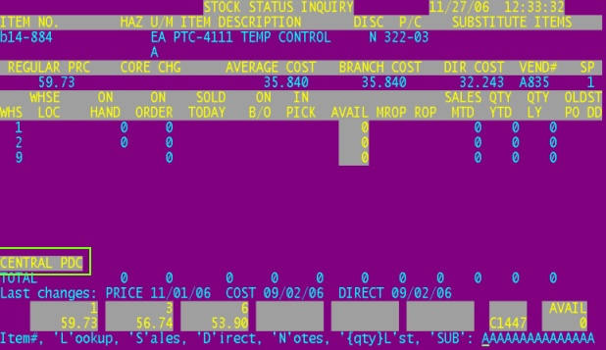

Stock status (m-19.6) select 'W' for web, 'CENTRAL XXX' will flash in the memo line. As an example, when in stock status input B14-884, select 'W' for Web, in the memo line under substitute 'CENTRAL PDC' will be flashing.

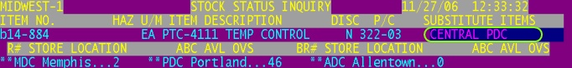

Order entry (m-1.2) 'CENTRAL XXX' will display next to the order quantity. Input B14-884 during order entry and next to the prompt for order quantity, 'CENTRAL PDC' will display.

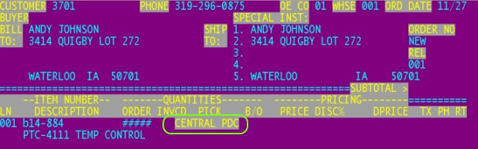

Menu 27 – PO Forecasting

Menu 27.1.24 – ROP/EOQ Parameters
All fields in this menu can now be changed except for fields 8 and 9. In previous versions this was a read only screen and edits could not be made. Plus an additional option has been added to Field 7, Seasonal. Users now have the option to select 50%/2 mos/1 yr.

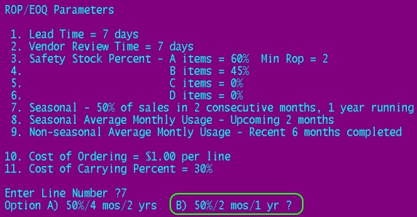

Menu 27.5 – Maintain Forecast
When forecasting for vendors, other than Corp, on the line below the VOQ and line above the SUBSTITUTE ITEMS, the following information will display:

FGT= {From Vendor Buying Information Inquiry - Menu 19.14.10, Field 10 FRT TERMS}
MREQ= {From Vendor Master Maintenance, Field 32. MIN REQ}

When forecasting for Corp, a (flashing) CENTRAL message will also display directly below the AOC vendor number, identifying a product as centralized.

Menu 28 – Purge and Fix Programs

Menu 28.10 – Purge Discontinued Catalog Items
This menu path purges items that are flagged as discontinued (Menu 12.3.2.2 Field 22), have a back order quantity of zero, have zero on hand, zero on purchase order for all stores and zero in pick. A report will print out of the purged items. This report is similar to non-stock monthly purge.

Menu 34 - Bar Coding

Menu 34.1 – Purchase Order Receiving
When scanning in items in Menu 34.1 all locations appear on the screen. The additional location(s) will appear in small font above the main location.

Menu 35 - Parameter

Menu 35.5 – Purchase Order Parameter Maintenance
A password has been added to Menu 7.1 to protect who can edit a roll-down on a Purchase Order. The password is setup in Menu 35.5 Field 10.
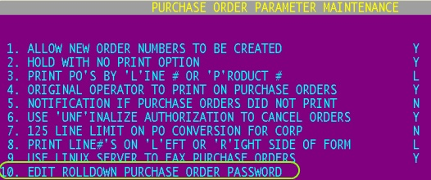

Menu 35.7 - A/P & G/L Parameter Maintenance
- The journal entry required at the end of every month to record GL impact for store transfers can now be automated using menu 35.7, Field # 17 Auto Journal Entries of Inventory Transfers. The GL account pulls by company from Menu 12.1.7.
- The journal entries required at the end of every month to record GL impact for stock adjustments can now be automated using menu 35.7, field # 21 Auto Journal Entries of Stock Adjustments. The GL account pulls from Menu 12.3.7 for each stock adjustment. If the account is blank in Menu 12.3.7 the system will look to the Cost of Goods account in Menu 12.1.7.

Menu 35.12 – Signature Capture Company Parameters
Menu 35.12, Field 7 Print Each Price on Laser Invoice – Placing a ‘W’ in this field will print the warehouse location on the invoice.

Menu 35.19.4 – Price Overrides
Price Override for customer numbers starting with SO (store transfers) will no longer send an event notification.

Menu 35.19.10 – Unfinalized Invoices
Notifies individuals via email if an invoice is unfinalized.
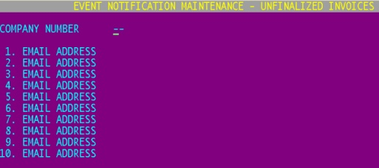

End of Day
AR adjustments will automatically be updated during EOD processes. Rule of thumb: Menu 4.2.2, Daily Adjustments Journal should be run immediately following AR Adjustments so that a report is generated and the adjustments are immediately updated.

End of Month

End of Month Report
The EOM AR Write-Off report has been fixed so the correct write-off code appears next to the adjustment.

Last Updated 1/05/07

