Database Business System
U2006.2 Upgrade Documentation
Summer 2006
Printable Version
Menu 1 - Order Entry
Menu 1.31 – Re-print Signature Capture Invoices
The option to reprint Signature Capture Invoices with or without pricing has been added.
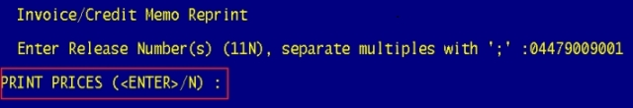

Menu 3 - Accounting Registers
Menu 3.25 – Monthly Inventory Transaction Register
This new report displays Inventory Transfers for past periods. Menu 12.2.2.3, Field 17 must be flagged in order for items to appear on this report.
Menu 3.22 – Monthly Tax Report
This new report displays the tax amount on invoices over a specified period of time.
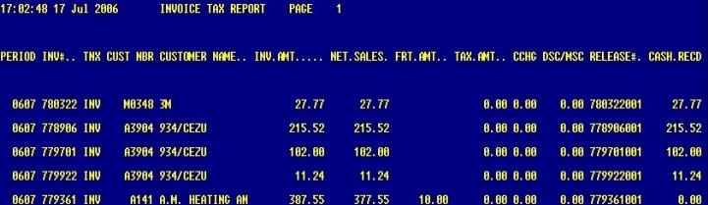

Menu 4 - Accounts Receivable
Menu 4.3.6.1 – Build/Print/Fax/Email Statements on Demand
When building statements mid-month users can now print a statement without being required to change the customer master flag in Menu 12.2.2.2, Field 31.
Enter the Customer number, and select Option 2 - Print Statements, 3 - Fax Statements or 4 - Email Statements.
Note: This option is not recommended for regular use, only for running one statement mid-month.
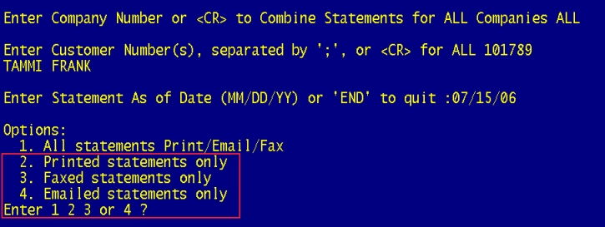
Menu 5 - Price Maintenance
Menu 5.17 – Price Book for a Customer
In menu 5.17, after selecting ‘Y’ to the following question: New Price Book to Include Menu 5.33 Pricing (Y/<enter>)? Y

The following prompts were added:
PRICE BOOK FOR A CUSTOMER
Enter Company Number 01
Enter Customer Number CASHT
Enter Product Class or <enter> for ALL ALL
Enter Product Type or <enter> for ALL ALL
Enter Vendor Number or <enter> for ALL ALL

COST OPTIONS:
1. Branch cost
2. Average Cost
3. Direct Cost
4. No cost
Enter cost option
Selecting ‘Y’ will include Menu 5.33 pricing and will automatically do all Contract, Program and 5.33 pricing that applies to that customer, so the ‘N’ option is used to get the old Discount Pricing.

The following price options are only available when answering ‘N’ to New Price Book to Include Menu 5.33 pricing
(Y/<enter>)? N
PRICE OPTIONS:
1. CONTRACT PRICES ONLY
2. PROGRAM PRICES ONLY
3. DISCOUNT PRICES ONLY
4. PROGRAM & CONTRACT PRICES
5. PROGRAM, CONTRACT & DISCOUNT PRICES
6. ALL PRICES
ENTER PRICE OPTION

Menu 5.25 – New Contract Price Listing
Menu 5.25 has been added to the system to allow users to print Menu 5.33 contracts. Menu 5.25 will show all
items on a contract and the current contract pricing on those items.
(Menu 5.25 Report Example)
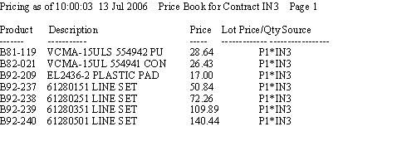
Menu 5.30 – Copy 5.33 Matrix Contract
This program allows users to copy one Menu 5.33 contract to another. Enter in the Contract to copy from and then the name of the new contract.

Menu 7 - Purchasing

Menu 7.30 Fax PO thru Linux
This program will fax a PO thru Linux instead of thru Desqtop (DQ)
You will first be prompted to enter the PO number(s)

Enter PO number(S): (8N) separated by (;), or END:04467431

Then it will display the vendor name from the PO(s) that you entered and ask you to confirm that it is correct

HART & COOLEY, INC.
IS THIS THE CORRECT VENDOR (<CR>/N) ?

Next, it will display any vendor fax numbers that are on file for you to choose from or allow you to enter a different number
Vendor Fax Numbers
1. Standard Fax Number: 800-223-8461
2. Customer Service Fax Number: 800-223-8461
3. Salesmanager Fax Number:
Select Fax Number Option, Enter New Number or 'END' to quit: 3580975

Then you will be prompted for your operator code

Enter Operator Code

Next, an email address will be displayed based on the operator code that was entered*, this is the address that the confirmation of successfully or failed fax will go to. You may enter a different address at the ? if the one displayed is not correct.

Enter Email for fax confirmation or <ENTER> for Tammi.Frank@johnstonesupply.com
?
* The system will first look to the email address setup for the Operator in Menu 12.1.4. If no email address is setup for the operator in 12.1.4 the system will display an email address based on the operator name from the operator code entered, it is highly recommended that the operator name be setup exactly as the email address. For example; my email address is 'tammi.frank@...' my Operator Code name should be 'Tammi Frank', not 'Tamara Frank' or 'T Frank' or 'Frank, Tammi' etc...)

You will then be asked whether you want to send a cover sheet or not.

Do you wish to send a cover sheet? (Y/N): Y

If you select 'N'o, the fax will then be sent.
If you select 'Y'es, you will be prompted for the TO (or ATTN) name, and to enter any comments. After entering the comments, the fax is sent.

FAX COVER PARAMTERS
Enter the TO: name : Tammi
Enter COMMENTS: Test

The following will appear on the screen, but you will have to use your scroll bar to scroll the AccuTerm screen back up to see it.

request id is 76721 (group id 76721) for host localhost (1 file)

There will be an audit in Menu 7.23 that the PO was faxed.
Tammi Frank 09:12:18 24 May 2006 - 261 'FAX'
Tammi Frank Fax transmission to Vendor Name.. Fax #
5551212
Click here for an example of a new faxed PO and cover sheet.

Menu 12 - File Maintenance
Menu 12.2.2.2 - Customer Master Maintenance
New Statement Send Flag
This new flag (Field 34 – STMT SEND FLAG) will allow you to control some of your statement send options separately from the invoice options. This flag will work in conjunction with field 31 – PRINT-FAX-EMAIL.
If the new STMT Send Flag is not set (is blank) then all invoice and statement send options will be controlled by the PRINT-FAX-EMAIL field (31). The new STMT Send Flag options are explained below:

E = Email Statements
This option will send the statement by email regardless of the setting in field 31. The invoices will be sent according to the setting in field 31. For example, if you have an ‘F’ in field 31, and ‘E’ in field 34, your invoices will be faxed and the statement will be emailed.
P = Print Statements
This option will print the statement regardless of the setting in field 31. The invoices will be sent according to the setting in field 31. For example, if you have an ‘F’ in field 31, and ‘P’ in field 34, your invoices will be faxed and the statement will be printed.
F = Fax Statements
This option will fax the statement regardless of the setting in field 31. The invoices will be sent according to the setting in field 31. For example, if you have an ‘E' in field 31, and ‘F' in field 34, your invoices will be emailed and the statement will be faxed.
EI =Email Statements/Invoices Monthly
When using this option, the statement will be emailed along with all of the invoices for the month. Field 31 should be set to ‘N’ to keep the invoices from being printed, faxed or emailed daily (or weekly – depending on your parameter setting). See Important note below about the EOM process for this option.
PI =Print Statements/Invoices Monthly
When using this option, the statement will be printed along with all of the invoices for the month. Field 31 should be set to ‘N’ to keep the invoices from being printed, faxed or emailed daily (or weekly – depending on your parameter setting). See Important note below about the EOM process for this option.
FI =Fax Statements/Invoices Monthly
When using this option, the statement will be faxed along with all of the invoices for the month. Field 31 should be set to ‘N’ to keep the invoices from being printed, faxed or emailed daily (or weekly – depending on your parameter setting). See Important note below about the EOM process for this option.

Important: In order for invoices to be sent to customers that have an EI, PI or FI flag the following must be done.
- Run Menu 4.3.6.15 after EOM is run - this feature will send invoices marked EI, PI or FI. If Menu 4.3.6.15 is not run then invoices will not be sent for customers having these flags.

In this example, the invoices and statements will be printed at month-end only:
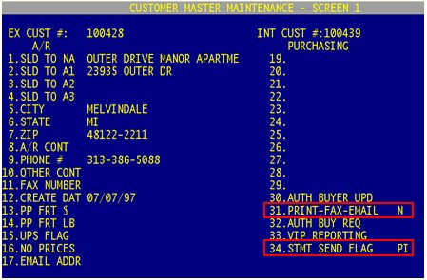
If you are unsure of how to set your fax flag options to get the desired results, click here for a quick reference cheat sheet.

Menu 12.3.2.2 – Product Master Maintenance
When the Each Price is changed in Menu 12.3.2.2, Field 14 the price will be immediately updated throughout
the system. For example, Stock Status (Menu 19.6) will show the price change as soon as the price in
Menu 12.3.2.2 field 14 has been changed and accepted.

List Price users, in the event that you would like to change the List Price, you can enter the new ‘trade’ Each Price in Menu 12.3.2.2, Field 14 and the List Price will immediately change. List price is calculated by multiplying the 'trade' price by 2.2223.

In the past, if a change was made to Each Price, the updates were not made throughout the system until after Day End was run or until Menu 32.1 was manually run.

Menu 12.1.13 – Order Entry/Credit Memo Message Maintenance
Menu 12.1.13 now has the option of allowing users to add expanded descriptions on part numbers. The expanded descriptions will appear after the part number is entered in Order Entry.

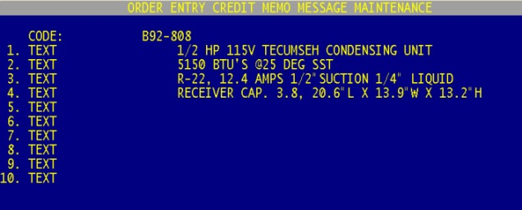

In menu 12.1.13, enter the part number (including the dash) in the CODE field. There is up to 10 TEXT lines
per part number. After the part number is entered in Menu 1.2, the system will auto add the TEXT lines as message lines.

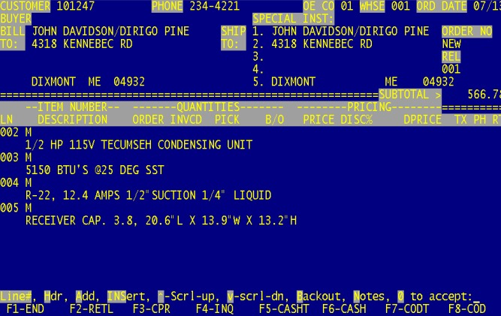

Menu 13 - Accounts Payable

Menu 13.20.7 - PO Receiving Not Yet Vouchered
A prompt has been added allowing users to run the report for an individual company. The prompt appears after the print select option.

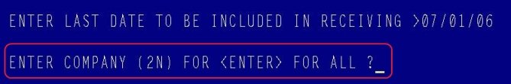

Menu 16 - EOD Processing

End-of-Day Report – Customers with No Multipliers

End of Day will now generate a report that lists customers with no List Price Multiplier in Menu 12.2.2.2, Screen 2, Field 37. Changes to the report can be made in Menu 16.5 EOD.XREF 01-155.

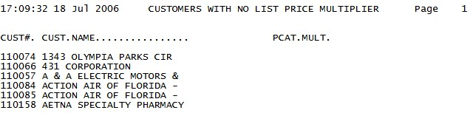

Menu 19 – Inquiries

Menu 19.6 – Stock Status
When viewing product History in Menu 19.6, a prompt has been added that allows users to enter the 11-digit release number and be taken directly to Menu 19.5 to view invoice detail.

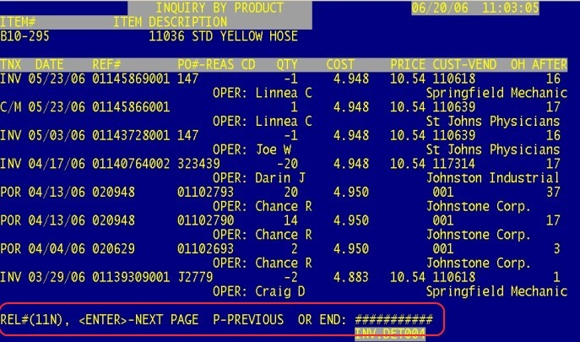

Stock Status - Sharepoint Option
The Corp Sharepoint Stock Screen can now be reached through Stock Status (Menu 19.6). First enter in the part number, type DC, the Sharepoint Stock Screen then appears. Another way to reach the Sharepoint Stock Screen is to type in SP after entering the product number in Stock Status. Option #20 from SP also goes to the Corp Sharepoint site.
Menu 19.8 - Serial Number Inquiry
Beginning and Ending Date prompts have been added to Menu 19.8 when running the inquiry by Customer or by Product.
Menu 19.13 – Open Purchase Order By Item
A prompt is now available in menu 19.13 to allow a Due Date to be changed on an item for multiple PO’s. The new due dates will immediately appear in Menu 19.6.
Step #1 - ENTER LINE# TO MAINTAIN, C-HANGE DUE DATE, OR <ENTER>
Step #2 - ENTER NEW DUE DATE (MM/DD/YY)
Step #3 - ENTER Y*** TO CHANGE DUE.DT ON OPEN PO'S FOR B92-599 TO 07/24/06
Step #4 - ENTER LINE NUMBER OR <ENTER> FOR ALL

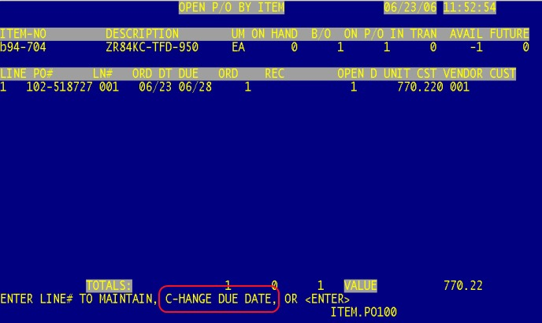

Menu 19.14.15 – View Serial Numbers
This menu path has been added to provide a View only inquiry of Serial Numbers on file for a product. Product Serial numbers can be added or changed through Menu 12.3.2.6.
*The View Maintenance Screen 19.14 can also be viewed by pressing 'V' <enter> at any menu.

Menu 27 - PO Forecasting

Menu 27.5 - Maintain Forecast
Forecast Maintenance now displays the MIN ROP instead of the Season Code. The MIN ROP pulls from Menu 12.3.2.3, Field 6. The MIN ROP will allow the ROP to move up as needed by an increase in Sales, but will not allow the ROP to go below the minimum specified.

Note: The Season Code can be found in Menu 12.3.2.2, Field 5.

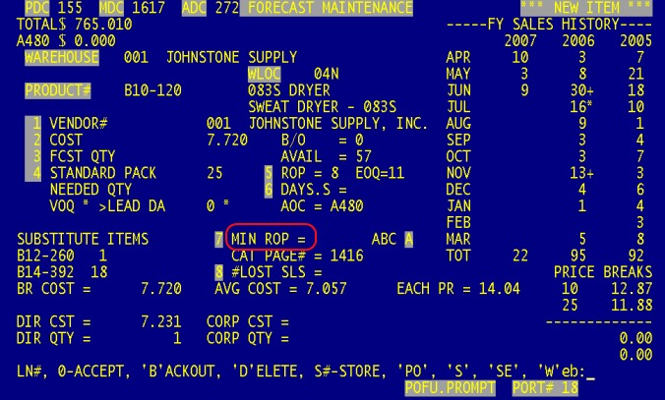

Menu 27.5 & 27.4 - Maintain Forecasts & Report Forecast
Corp has a project named Aurora which gives stores a discount if a Standard Pack is purchased by certain vendors. Database has added 2 features that allows users to know that an item is part of the Aurora Standard Pack program.

1. In Menu 27.5 when a forecast quantity is more than 50% of the Corp Aurora Standard Pack this message will appear, “Consider ordering the Aurora Standard Pack from Corp”.
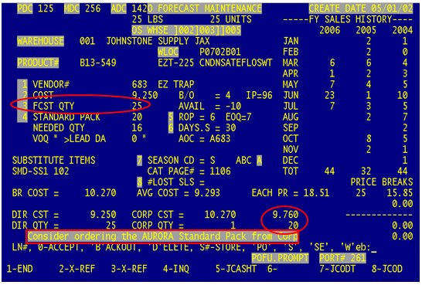

- The PACK column in Menu 27.4 has been changed to show the Aurora Standard Pack, followed by the letter “A”.

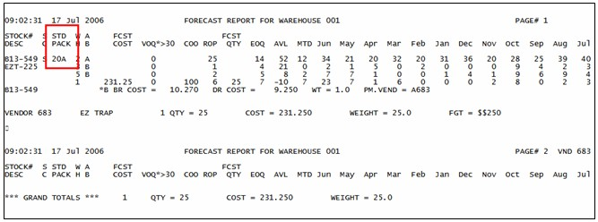

Menu 34 - Bar Coding
Menu 34.25 - Compare Bar Code Receiver with Corp Packing List
The Corp invoice number now appears on any line that has a variance. Adding this feature to Menu 34.25 eliminates the need for users to run Menu 13.20.11 to retrieve the Corp invoice number.
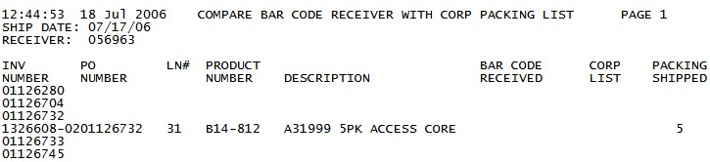
Menu 35 - Parameters

Menu 35.20.4 - JS Webstore - Account Maintenance
A parameter has been added to Menu 35.20.4 to enable users to turn off the on-line discount on a Customer by Customer basis. The discount is not relating to any special pricing the customer may have, but to the special on-line discount that can be setup in Menu 35.20.2, Field 3 for customers ordering online. Go into Menu 35.20.4, pull up the customer and in Field 8 put in "N" to turn off the on-line discount by customer.

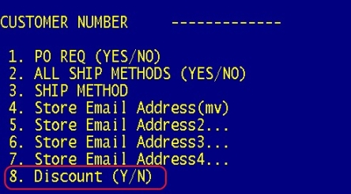

Menu 35.19.9 - Customer Purchase Orders
This program allows you to setup a customer with a pattern for their PO numbers. If an order is finalized with an incorrect pattern PO, then an email will be sent to up to 9 email addresses.

Begin by selecting the customer (Lookup will work here) Enter the email address(es) that the notification should be sent to (can be customer’s email addresses and/or employee email addresses)

In field 10, the pattern, enter the pattern for the purchase order. An example of a pattern would be 8N-4A-2N, this means 10 numbers, dash, 4 letters, dash, 2 numbers – such as 12345678-ABCD-12.

There will be no validation at the time the order is entered – the only time an email is generated is if the order is finalized with a PO that does not match the pattern.

(Menu 35.19.9 Setup Screen)
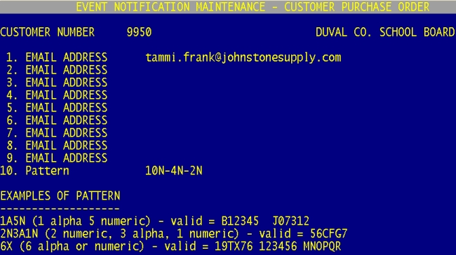

(Example of Email that is sent)
Subject: CUSTOMER PURCHASE ORDER

OPERATOR STORE SUPPORT
ORIG OPER STORE SUPPORT
CUSTOMER 888888 STEVE MOELLER
RELEASE# 04481520001 **PICK/PACK**
AMOUNT 10.59
CUST PO# TEST

Menu 35.12, Screen 2, Field 7 - Signature Capture Company Parameters
Web Address to Print On New Forms - Enter the web address as you would like it to appear on the new laser invoice form, (i.e., www.johnstoneoc.com) Leave blank to print the default of www.johnstonesupply.com.

Menu 35.12 – Signature Capture Company Parameters
To receive only one copy of all invoices printed in Menu 1.2 setup Menu 35.12, Screen 2, Field 8 (Print One Copy in all Cases). Entering a ‘Y’ in Field 8 tells the system to print one copy of everything ignoring all other parameters (Menu 35.12, Screen 1, Fields 8, 16, and 17). If a ‘N’ is entered then the copies received is controlled by the other parameters.
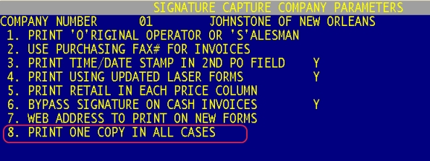

Menu 35.12, Field 9 - Always Print "INVOICE" on Laser Forms
Enter a 'Y' in field 9 to have the word INVOICE print on the laser forms. If an 'N' is entered the word 'INVOICE' will not print on the laser forms. A 'Y' in this field will over-ride settings in Menu 35.12.19.

Menu 35.12, Field 10 - Prompt for Number of Copies in Order Entry
Enter a 'Y' in field 10 to have a prompt appear in Order Entry (Menu 1.2) that will ask how many copies of the Signature Capture invoice need to print. If an 'N' is entered the system will not ask for the number of copies to print in Order Entry.

Note: This feature is only available if you have a Linux server

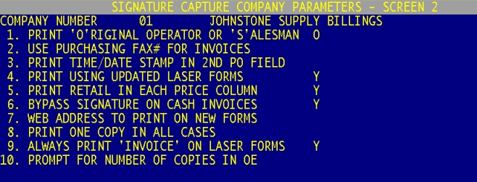

Menu 35.10 – EOD Update Parameter Maintenance
Menu 35.10, Field 11 has bee added - Program/Contracts Expiration Days – Enter the number of days from
today for which you want to include contracts that will be expiring within that number of days. For example, 30 days will show what expired 30 days before today and also what will expire within 30 days from today.
EOD Xref-ID 01-156.

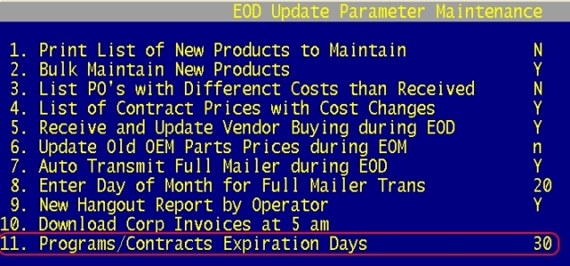

Menu 35.5 – Purchase Order Parameter Maintenance
Menu 35.5, Field 9 – Use Linux Fax Server to Fax Purchase Orders - If this parameter is set to Y, Menu 7.1 option to 3 - Hold, Fax or 4 - Hold, Print, Fax will use the new Linux PO and fax-server to send the PO. Menu 7.7 Fax Purchase Orders will also use the Linux PO and fax-server.
Note: Must have a Linux fax-server installed
Note: If this parameter is set to N, PO faxes will be sent through DQ – DesqTop.
