Database Business System Software
U2006.1 Release Documentation
Spring 2006
Printer Friendly Version
Menu 1 - Order Entry & Invoicing
Menu 1.1.1A & 19.1A – Price Quote Lookup
New functionality has been added to Menu 1.1.1a & 19.1a that gives users the opportunity to see what quotes are outstanding for customers on a particular vendor. This will allow users to see if there are any quotes, for a particular vendor’s products. Users can select ‘ALL’ customers, select products based upon product master vendor, and select multiple products at the same time.
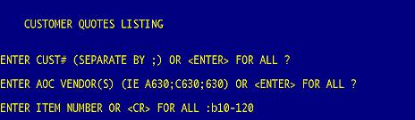
Menu 1.2 - Hazardous Ship Code Descriptions
Hazardous ship codes will now appear on the product description in Order Entry Line Input. Previously only the description showed. Only happens when you have an automatic message line being added, based on Menu 12.3.8 field 2 set to Y for the ship codes that you want to print.
Freight code is stored in Menu 12.3.2.12 field 4.
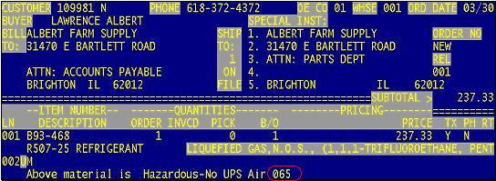

Menu 1.2 – Customer Pricing Matrix Code Display Change
Previously, on the Order Entry (OE) screen on the lower left had side there was a small bucket with a code in it such as C1, C2, P1, or P2. This code is explains where the bucket pricing came from.
The following is for reference for the codes:
C1 – Customer, Product P1 – Program, Product
C2 – Customer, Category P2 – Program, Category
C3 – Customer, Class P3 – Program, Class
C4 – Customer, Type P4 – Program, Type
C5 – Customer, Vendor P5 – Program, Vendor

Now, this code will also include the name of the program such as P3*CLEAR5
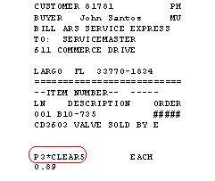

Menu 1.2 - Johnson Control PO validation logic
Johnson Controls has 2 national customer account numbers (JCO & JCS). More logic has been added to Order Entry to make sure a valid purchase order has been entered as follows:
JCO
Before this upgrade, the logic only checked that there are 4 characters before the first dash. New logic checks for the following acceptable purchase order patterns (B=branch number):
XBBB-XXXX XXX (example 5073-2988 100)
82-BBBX-XXXX (example 82-0731-1234)
XBBB-XXXX-19 (example 0073-6130-19)
JCS
Before this upgrade, the logic only checked that there were 3 characters before the first dash. New logic checks for the following acceptable purchase order patterns (B=branch number):
BBB-XXXXXX (example 073-1010920)
BBB-133 XXXX (example 073-133 1812)
Menu 1.2 – Order Entry (Reversing order quantity on deposit invoices)
When changing the quantity to a credit (negative) amount on the backorder releases of a deposit ticket the error “Cannot change to negative quantities on an order that has a deposit” will display in Field 3 of the Order Entry Line Detail Maintenance screen.

Menu 4 - Accounts Receivable

Menu 4.3.6.10 – Statement E-mail Log Update & Report
Menu 4.3.6.10 provides a log update and report on statement that are emailed. The log can be run for specific customers or all customers. Parameters are also available to run the log based on a specific date range.
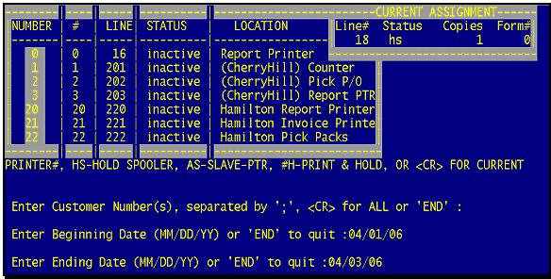

Customer Statement Email Log Report
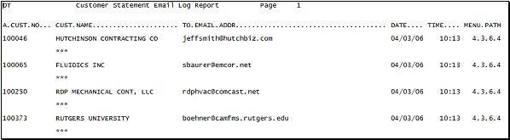

Menu 5 - Price Maintenance

Menu 5.24 – New Pricing Matrix Listing
The following Selection Options have been added to Menu 5.24
- Select for Specific Products
- Select for Specific Product Types
- Select for Specific Product Categories
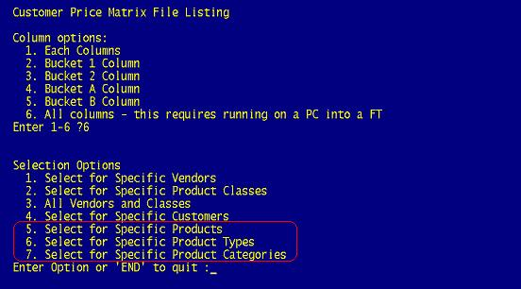

Menu 5.29 – Product Class Multiplier Maintenance
Menu 5.29 is available as a tool to help keep product prices competitive. If a multiplier is created for a product class in Menu 5.29, it will override the multiplier listed on the customer record in Menu 12.2.2, Field 37.

Note: No price changes will take affect in Stock Status (Menu 19.6) if a multiplier is added to a Product Class in Menu 5.29. Stock Status will continue to display the regular prices based on the original setup. For this reason it's best not to use Stock Status for quoting prices.

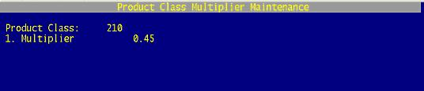

Menu 6 - Inventory Evaluation
Menu 6.9 Hits Report - Activity Profiling
This report will have the following prompts after selecting the printer:
- Enter Warehouse (3N) or <ENTER> for all?
- Enter Minimum number of Hits (ie 10)?
Based on the selection criteria for warehouse and number of hits, the report will include part numbers with at least the number of hits specified and show the Warehouse, Part Number, Description, Quantity Sold, Vendor Number, Vendor Name and the number of hits. The time-frame for this report is the total for this fiscal year + last fiscal year. It could be as little as 12-months and as much as 23-months.

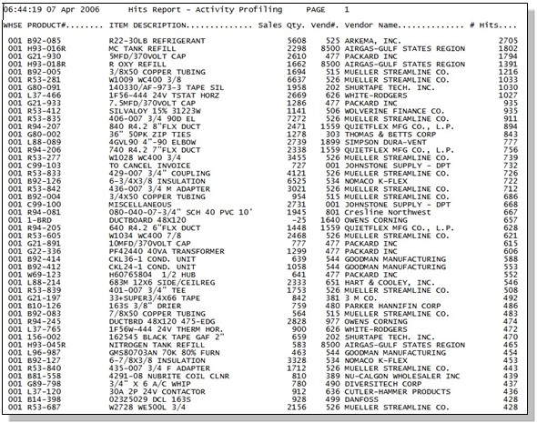

Menu 6.30, 6.31, and 6.32 - Database ABC Ranking Setup & Analysis

Database has added 3 new Menu Paths to accommodate the use of the ABC ranking methodology. These menus will Maintain, Calculate on Demand, and Compare Old vs. New ABC Ranking.

Note: Carefully read the following documentation so you understand how the ABC Ranking works and how it will affect your Forecasting once turned on.

For definitions on ABC ranking please first read the "New ABC Ranking Definitions"

Menu 6.30 - ABC Ranking Maintenance

Weight of Sales, Hits or GMROI is controlled on lines 5, 10, and 15. These lines can be changed and maintained. However, lines 5, 10, and 15 must total 100%.

The additional breakdown (lines 2-4, 6-9, and 11-14) is the cumulative total the system is calculating. For example – line one Sales A – the system looks for the top 60 % of sales then stops – these are A items for Sales – then the system looks for the next 20% which is a cumulative total of 80% - stops – those are B items for Sales. The system looks for the next 10% (cumulative total of 90%) – stops – those products are C items for Sales.

The option to maintain all lines is available. However, we are recommending to not change lines 2-4, 6-9, and 11-14 during the pilot testing. By not touching these numbers, the review and feedback gathered during the pilot test will be easier to compile.

To exit the screen type B to back out, DELETE to delete, E to Edit, or 0 (Zero) to accept.

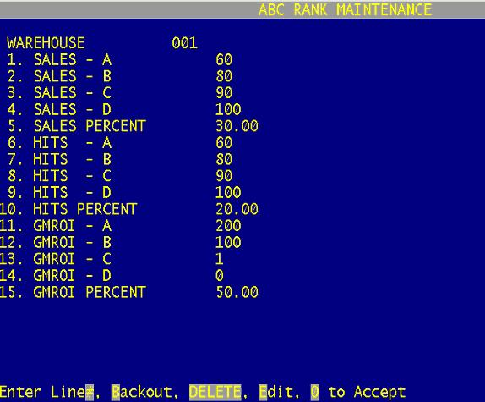

Menu 6.31 - ABC Ranking Calculation

Menu 6.31 is used to re-calc the ABC Ranking on demand. Run this menu after changing parameters in Menu 6.30 or after closing month.

To exit Menu 6.31 type END at the Warehouse prompt.

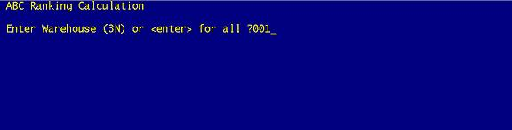

Menu 6.32 - ABC Ranking Report

The ABC Ranking Report is for spot checking and analyzing items to see if they agree with the Sales, Hits, & GMROI ranking. It’s also used to compare Old ABC (OABC) to new ABC (ABC) ranking.

The report can be FT (file transferred) into Excel to alter the sort order.

ABC Ranking Report Column Headings
Warehouse #, Part #, Item Description, On Hand, ROP, EOQ, Average Cost, Qty Sold 12 Month, Old ABC, Sales $$, Sales ABC Rank, Hits, Hits ABC Rank, GP $$, Inventory $$, GMROI, GMROI ABC Rank, Final ABC Rank

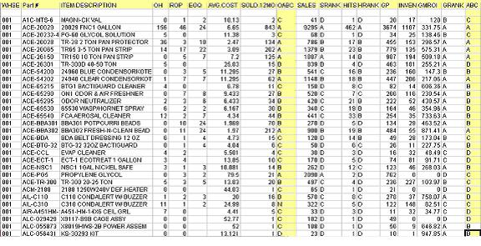

Menu 27.1.21, Field 13 – Use New ABC in ROP/EOQ Calculations

Setting field 13 to ‘Y’ will prompt the system to use the new ABC calculation during the next ROP/EOQ weekend update. Setting the parameter to ‘Y’ will also automatically prompt the system to run Menu 6.31.

To manually update the ROP/EOQ calculation run Menu 27.1.26.

This parameter gives users the option to turn the new ABC calculation On/Off. To not use the new ABC calculation in ROP/EOQ leave Menu 27.1.21, Field 13 blank or set to ‘N’.

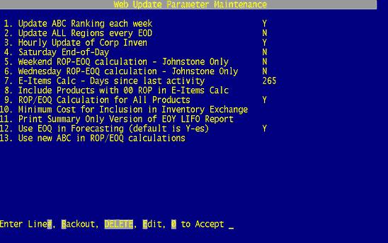

Menu 7 - Purchasing

Menu 7.1 - PO Entry - Dropship Auto Message Line
When a PO is coded with DS in field 5 of the header in PO Entry, an automatic message will be added to the body of the PO. The message will say:
"Please include a no price packing list only"
If the PO is coded as DS before any line items have been added, the message will be at the top. If the DS isn't coded until line items have been added, the message will appear after the line items.

Menu 9 - Physical Inventory Procedures
Menu 9.20.30 Top 50 Variance Report (+/-)
This new report shows the top variances up and down in a variance report format. It is called the Top 50 report, but the number of items displayed is user defined.
The report shows, based on value change, the top items up and down. It can be run at any time after the variance has been updated (Menu 9.20.8)

- You will first be prompted for a printer number.
- Next, you will be prompted for the warehouse to run for
- Then the number of items to show on the report. - If you enter 100, you will get the top 50 items up and the top 50 items down for a total of 100 items. If you enter 200, you will get the top 100 items up and the top 100 items down for a total of 200 items.
Menu 12 - File Maintenance

Menu 12.2.11 - Terms Maintenance
Database users now have the ability to freeze customers from purchasing items. A flag has been added to Menu 12.2.11, field 10. If set to 'Y' then when the customer number is typed in Order Entry (Menu 1.2) a message will appear.

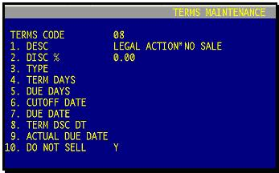

Order Entry message: "NO SALE ALLOWED ON THIS ACCOUNT - PRESS <ENTER>"
Pressing <enter> returns to the customer number prompt.
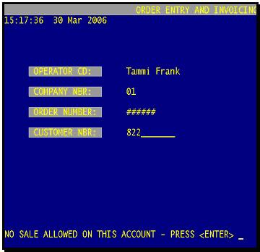

Menu 12.2.40 - Customer ABC Report
The Customer ABC Report has been modified where it now places City, State, and Zip into individual column to make sorting easier when the report is file transferred. A Phone Number column has also been added to the report.

Menu 12.3.33 – Product List – By P/C or P/T
This new report allows users to print a list of Product Class or Product Type. Parameters have been added to give the report flexibility (i.e. it’s possible to print a list of all products classified with a certain product type).

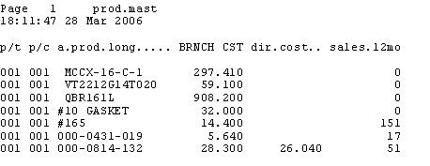

Menu 13 - Accounts Payable

Menu 13.4 - Month-End Job Stream
When running 13.4, users will instead be prompted to logoff and type MONTH-END at the big J. Option # 2 will start the AP close for the entered period. Reports generated during the AP Month-end close will now be stored in the spooler as a result.

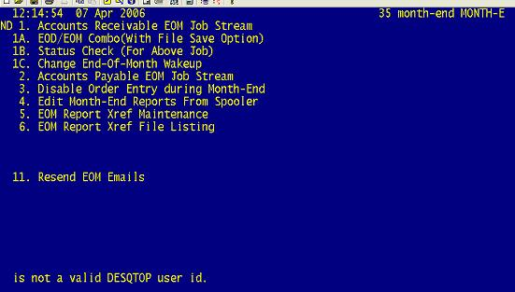

Menu 13.5 - Vendor Payables Inquiry
Menu 13.5 can now be used to find AP information using the Purchase order. After entering the vendor number, users can now enter ‘PO” and using the six digit PO number, find voucher and invoice information.

Menu 13.20.2 - Purchase Order Receipts Update to A/P
In menu 13.20.2, users can enter a purchase order to find a receiver number. A list of receivers associated with the entered PO will be displayed. Alternately, the user can return past this prompt, see below, and simply enter the Vendor number and proceed as usual. At the next prompt, when asked for the receiver number, the user can use one of the provided receivers displayed or use the paper receiver, depending on processes in place.

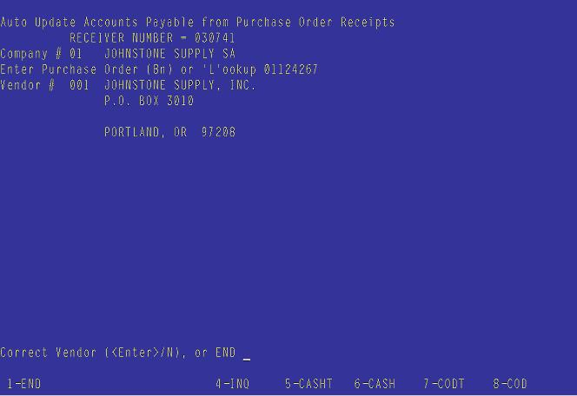

Menu 13.20.2 - Changing Product Price
In menu 13.20.2, when the user changes a product’s price, they will now see the following prompt at the bottom of the screen:

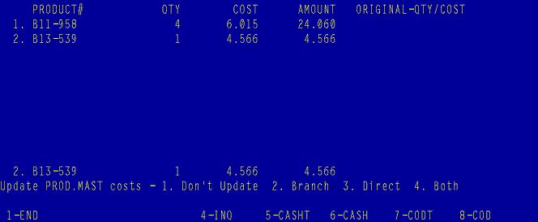

User will have the opportunity to update the Product Master’s Branch Cost, Direct Costs, Both costs or Neither depending on the option they select. Changes to the Product Master are instantaneous. However, if a change is made to a catalog item, unless the price/cost transmission is suppressed in menu 12.3.2.9, the change could be overridden with the next transmission.
This prompt will display anytime the cost has been changed in menu-13.20.2.
1. Don’t update – only the cost relating to this vendor invoice & receiver will be changed
2. Branch – update this new cost to PROD.MAST (12.3.2.2), field 16. BR CRP CST
3. Direct – update this new cost to PROD.MAST (12.3.2.2), field 18. DIR CST
4. Both – update both branch & direct costs
Also, these cost changes will update the audit file on menu-12.7 File History Maintenance.

Menu 15 - Warranty Menu

Menu 15.1 – Unclaimed Warranties Report
Currently Warranty items that are not complete get stuck on the report. Programming has been added that cleans up this report so items that appear to be stuck in the system or are not complete, will no logger appear on the Unclaimed Warranties Report.

Menu 16 - End Of Day

EOD Process Reports
During the EOD process reports titled “EOD Tape Verify Heading” and “EOD Tape Verify Message” print to the printer. With the release of U2006.1 these report are now part of paperless EOD. If you would like to receive copies of these reports go into Menu 16.5 and setup the EOD.XREF ID 01-165 for EOD Tape Verify Heading and 01-166 for EOD Tape Verify Message.

End of Day Updates
During the EOD run, List price will be updated based on the Each price for Discontinued Johnstone items.

EOD Invoice Email Confirmations
The EOD process will now send one email confirmation, for all invoices emailed, to the designated person at the store. The email will list confirmations on all invoices sent.
EOD Open Purchase Orders with Customer Backorders Date
A new EOD report has been added. Open Purchase Orders with Customer Backorders Date (xref 01-179, 02-179, etc…)

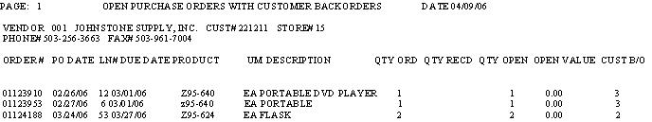

Menu 19 - Inquiries

Menu 19.6 – Stock Status
Lost Sales can now be recorded in Stock Status. The {qty}L option has been added. To record a lost sale type in the quantity lost followed by an L (1L).

Note: the ‘LS’st feature is still available for selection by typing in ‘?’

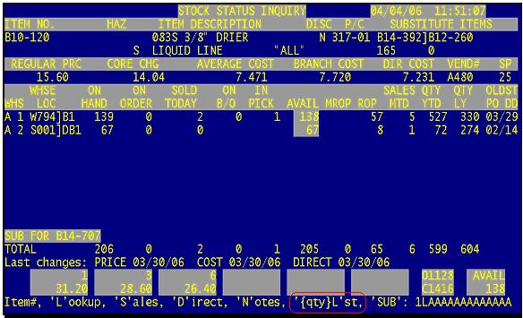

Type LS to see the Lost Sales
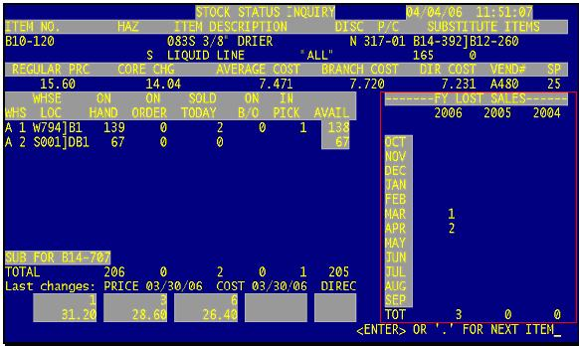

Menu 19.6 - Stock Status
In Stock Status, type ‘SP’ to bring up the Sharepoint options. The DC Inventory Stock Status feature has been added in Field 20. Selecting this option will take users to the Corp DC Inventory Stock Check screen.

Menu 19.7B – Inventory Transaction by Product
Stock Status (Menu 19.6) now allows users to search transactions by Adjustments (ADJ), Purchase Order Receipts (POV), and Invoices (INV). To see the new options enter a product in Stock Status, Select ‘H’ (Inquiry 19.7B – Inventory Transaction by Product), enter in the Warehouse and then select the Customer.

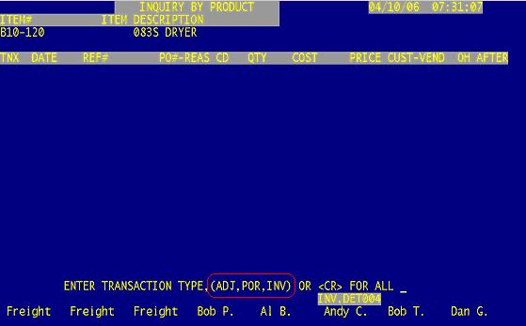

Menu 25 - Printer Options

Select a Printer
For any report, listing, or anything in the system that prompts for a printer, users now have the option to EM-ail, FAX, and D-isplay reports.

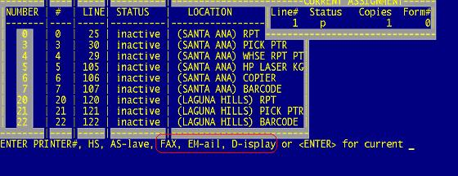
Note: When using the D-isplay option, remember that Ctrl ‘x’ will take you to the end of the report.

Menu 25.3 - Reset a Printer
What this does: Originally this program was designed as the most drastic attempt to clear up a serial printer. Trouble was, if you had a jet direct/network printer installed this would clear up the printer, delete it and never be able to restart it again. This program has been upgrade to allow for the clear and reset of the jet direct/network printers.

1) This program first advises you to run through and check the most common printer issues.

Check the following:

1. Turn printer off/on
2. Is the printer on-line?
3. Is the baud rate correct?

Enter printer number?

2) Next, after inputting the printer# we PING the printer to confirm the printer in question is actually on the network. If it doesn’t find it on the network (100% packet loss), it will not proceed.

Note: The program will not PING serial printers. It will only PING the printer, if it can tell if it is a network printer. Otherwise it will delete/start the printer as it did before.

First let's make sure the Printer you want to reset is on the network
PING omjd01: (192.168.9.8): 6 data bytes
14 bytes from 192.168.9.8: icmp_seq=0 ttl=64
14 bytes from 192.168.9.8: icmp_seq=1 ttl=64
14 bytes from 192.168.9.8: icmp_seq=2 ttl=64
14 bytes from 192.168.9.8: icmp_seq=3 ttl=64
14 bytes from 192.168.9.8: icmp_seq=4 ttl=64
14 bytes from 192.168.9.8: icmp_seq=5 ttl=64

----omjd01 PING Statistics----
6 packets transmitted, 6 packets received, 0% packet loss

Did you get a successful packet transmission - Y***?

3) Answer Y*** if you get a message at the end like this: PING Statistics - 6 packets transmitted, 6 packets received, 0% packet loss
4) Next, the program will delete the printer and make 2 attempts to clear the jet direct/network print queue (cancel all print jobs in the queue for this printer.)
5) Next, the port is logged off and the jet direct/network printer is restarted.
6) Printer and print/queue is ready to go

Menu 27 - PO Forecasting Menu

Menu 27.1.2 – Flag Exceptional Sales
Users no longer need to know the fiscal year to run this menu path. Parameters have been changed to enter Column A (This Year), enter Column B (Last Year) or Column C (2 yrs Ago). Then the parameters will prompt for 1 thru 12 (1 = First Fiscal Month, 2 Second Fiscal Month, all the way through 12 = Last Fiscal Month).

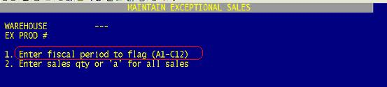

Menu 27.1.21, Field 13 – Use New ABC in ROP/EOQ Calculations
Note: See Menu 6 above for further details on ABC
Setting field 13 to ‘Y’ will prompt the system to use the new ABC calculation during the next ROP/EOQ weekend update. Setting the parameter to ‘Y’ will also automatically prompt the system to run Menu 6.31.
To manually update the ROP/EOQ calculation run Menu 27.1.26.
This parameter gives users the option to turn the new ABC calculation On/Off. To not use the new ABC calculation in ROP/EOQ leave Menu 27.1.21, Field 13 blank or set to ‘N’.

Menu 34 - Bar Code Receiving

Menu 34.1 – Purchase Order Receiving
If something is scanned or typed in Menu 34.1 beginning with a ‘ . ‘ and followed by a number greater than 1000 the system will prompt with the following: Enter ‘Q’uantity or ‘P’art number. If a Part bar code was scanned, select ‘P’, if a Quantity was entered, select ‘Q’.

Menu 35 - Parameters

Menu 35.14 Field 11 – Print/Fax/Email Statements During EOM
Enter a ‘Y’ in field 11 to have Statements Print/Fax/Email during the EOM process. In order for statements to Print/Fax/Email during the EOM Menu 35.14, Field 9 must also be set to a ‘Y’.

Menu 35.14, Field 11 will default to a blank field which equals ‘N’. If the field is set to ‘N’ statements will not print/fax/email during EOM.

Note: If parameters in Menu 35.14, Field 4 and/or 5 are set to ‘N’ statements will not fax/email, they will print.

Menu 35.19.6 – PO 855 Acknowledgement
Users now have the opportunity to enter up to 8 email addresses to receive PO acknowledgements. In the past, the system offered 2 email addresses.

