Truck Stock Version 1.0

Introduction
Phase 1 Goal: Customers with handheld units provided by the store are able to scan product bar codes (EX: truck shelves) and build an order on the handheld or connected to a wireless network and submit (sync) the order via XML (using Easyco). Order then arrives into the PICK system as a live order.

Phase 1:
Basic Screen flow
*Single list only at this time 9/15/06
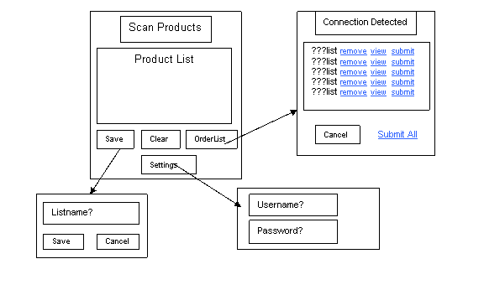

Phase 1:
Data Flow for submitting orders if connection detected
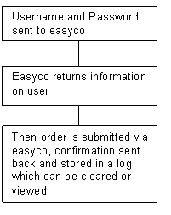

Truck stock platform
There are few requirements to run the truck stock application on a handheld device. They are as follows:
- Pocket PC 2003
- Microsoft ActiveSync (on the PC –Same program used for Sig Cap)
- Internet Connection on the handheld
- .NET framework
- Truck Stock Application Ver. 1.0
- Easyco/PICLAN-IP middleware on PICK system

Installation
Contact Database Support to have Truck Stock installed.

Functionality

Truck stock application opens up to the order building screen. From this screen you are able to build the order, change your settings or quit out of the application.

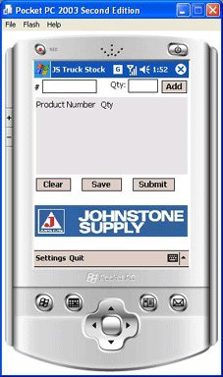

Customer Setup:
Customer setup takes 2 steps. You will need to activate their account and create a login on your local system and setup the handheld.
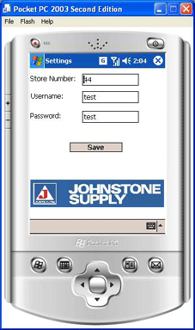
- Customer needs to be setup in m-35.20.4 and 5 (same as setting up an online customer)
- On the entry screen select the Settings option and enter the store#, username and password (same as online username and password as setup in m-35.20.4 & 5)
- Save the settings

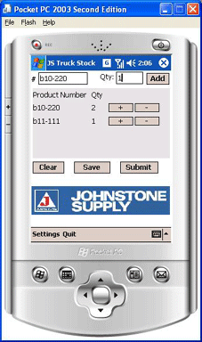
Order Creation:
Begin by scanning the product bar codes or by manually entering in the product numbers and the quantities.

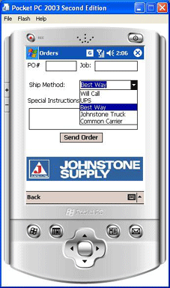
Order Info Screen -Prepare order for submittal
Orders often need purchase order#’s, Job info, ship method and Special Instructions. There is a screen that lets the user input the information as needed. At any time, from the order screen you can get to the order info screen by clicking submit (you can always come back and continue with the order before sending the order to the store).

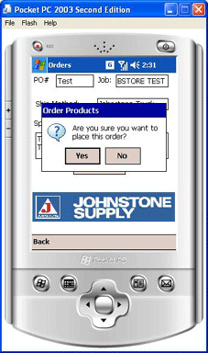
Confirming the order
After entering in the valid information (PO#, Job info, ship method or special instructions) click SEND ORDER. Will be prompted to confirm the order submittal.

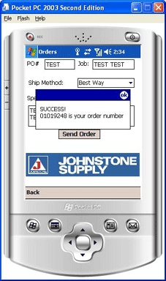
Submitting the order
After sending the order you will receive confirmation that the order was created into the system with the display of the 8 digit order#. You and your customer will also receive and email order confirmation of the submitted order.

