Credit Card Processing

Processing a Standard Credit Card

This process describes the procedures for processing a standard credit card transaction on a 3101, 8810 or 8500 Signature Pad. In this example the card will be authorized during the swipe process.

Step 1
- Enter in a customer invoice in Menu 1.2. On the Totals screen select one of the credit card options in field 21. In the example below, AMX is the selected payment method.

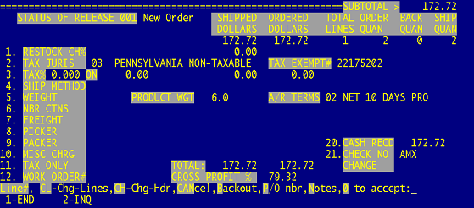

Step 2
- Select option 1 or 2 to Invoice

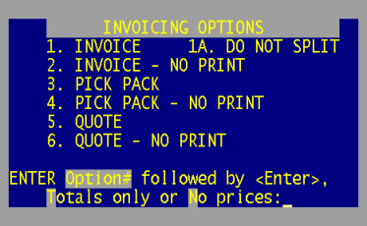

Step 3
- The Payment Processing window opens after the invoice selection is made. The Status bar at the bottom of the screen will state when the customer should swipe their card.

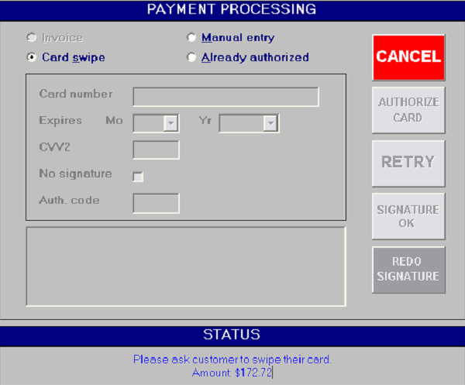

Step 4
- After the card is swiped the Status screen will show that the Authorizing process has started and prompt you to wait until authorization is complete.

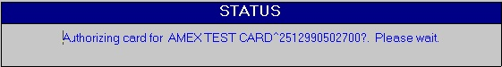

Note: If the card is declined the Status screen will show a Card Declined message and a reason for the decline.



Step 5
- If card is approved the Status screen will prompt you to ask the customer to sign the pad.



Step 6
- The signature will appear on the Payment Processing screen after the customer signs the pad and hits the OK option on the pad. You then have the option to ask the customer to REDO the signature if it’s not legible or approve the Signature by selecting the Signature OK option.

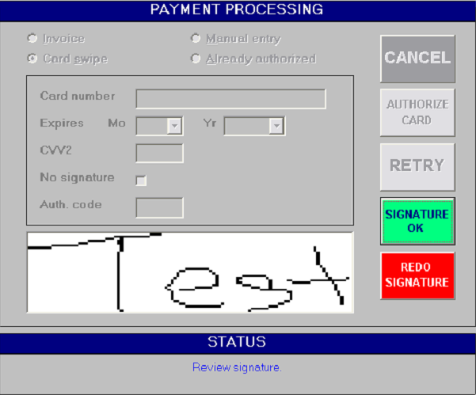

- After selecting the Signature OK option the Payment Processing screen will close and will return to the Order Entry process to finalize the order. The invoice will print a time and date stamp, the authorization number and the last 4-digits of the credit card number.

