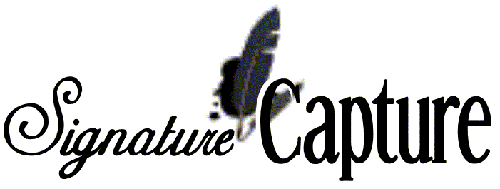
Signature Capture vs. Three Part Invoices Cost Comparison

Signature Capture - what we are doing NOW
- Toner Cartridges - $140 per cartridge changed every other month (lasts for 2 months) for two invoice printers = $140
- Plain Paper - $24.80 per 5000 sheet case, using two cases per month based on 5000 invoices plus weekly reprinting = $49.60
- Monthly cost = $189.60
- Based on having been setup to print two copies of everything. Doesn’t include going to printing of statements on laser forms or e-mailing or faxing of invoices.

Three Part - what we used to do.
- Ribbon - $11 per ribbon changed twice a month on two invoice printers = $44
- Three Part Paper - $56.50 per 1100 count carton using 4.5 cartons per month based on 5000 invoices = $254.25
- Monthly cost = $298.25

So right now in the New Orleans store we are saving $109 per month, not including other savings like:
  - The added cost of reprints to fax
  - Finding original invoices with signatures to fax
  - Labor to put the 3rd copy in numerical order.
  - And we have not started realizing the savings from faxing and emailing the invoices instead of mailing.
  - ETC.

