
Signature Capture PC Software Installation Documentation
Windows XP Professional installation instructions for the
HHP3101 signature capture pad as of 7.27.04
First, you will need to map a network drive to the signature capture server. To do this
- Close all programs currently running on your computer.
- Click START > RUN
- Type in - net use i: \\yourIPAddress\signature (Contact DST to obtain your IP address if you do not have it.)
- Click OK
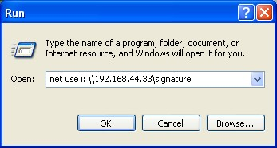
You will briefly see a black window come up and go away and this step will be complete.
Next, install the Signature Capture Software on each PC with a signature pad attached. To do this
- Close all programs currently running on your computer.
- Click START>RUN
- Type in one of the following depending on which version of Windows you are running:
Windows XP or 2000: i:\sigcap\X.XX\install.bat
Windows 98: i:\sigcap\X.XX\install98.bat
NOTE: X.XX represents the current version of signature capture. Contact DST to find out what the latest version of signature capture is, currently it is 2.22.
- Click OK
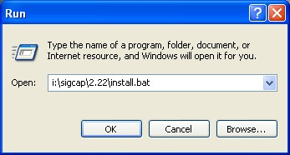
You will see the following window on your screen:
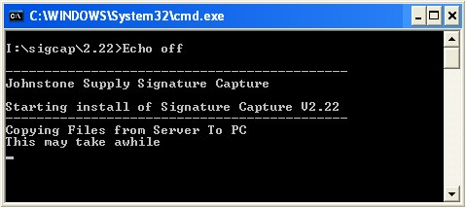
Just be patient while the necessary files are being copied to the PC. Once this is done you will get the File Download dialog box, click OPEN.
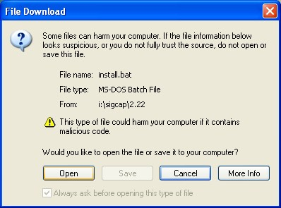
Next, you will get the welcome screen that reminds you to close all running programs. Once you have confirmed that your programs are closed, click OK
The next window will look like this:
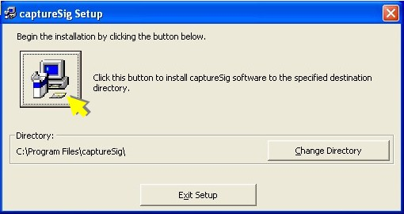
Click the box that the arrow above is point at to begin the installation.
You will next be prompted for two different program groups, accept what is already highlighted and click Continue. The first will be Signature Capture and the second will be Startup.
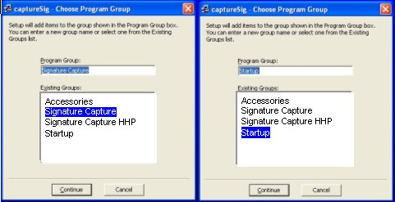
You should next see the installation progress and then finally Signature Capture Install Successful, click OK.
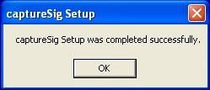
Once your software is installed on the PC, you need to tell it where to store the signatures. To do this
Click START > PROGRAMS > SIGNATURE CAPTURE > SIGNATURE CAPTURE to start the Signature Capture software running and to open the signature caputre window on the pc.
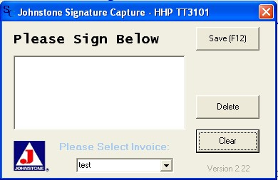
Click the Johnstone J Logo  to get into the Application Settings.
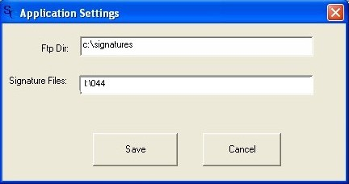
The Ftp Directory field remains C:\Signatures
In the Signature Files field type I:\ your store number, for example I:\044
Click SAVE, then click Delete on the signature capture window to close it out.

