How to set up an Eltron/Zebra Label Printer on a PC/Laptop.

This document explains how to set up a label printer on a PC/Laptop to print labels with Accuterm.

Setting up the Hardware

- Plug in the power to the printer, turn it on and load the labels.
- Take a Serial Cable (DB-9 Male to DB-9 female) plug one end to the label printer and one end to the Serial port of the PC/Laptop. NOTE: if you have only one Serial port on your PC/Laptop, as a rule, it is configured as COM 1. If you have two ports you need to note which port you plugged into, usually it is either COM 1 or COM 2. This is important for steps that are discussed later.

Setting up the printer in Microsoft Windows Platforms.

- The first step is to turn on your PC/Laptop if not done so already
- Once the PC/Laptop is booted up you need to click the start button and follow the path below for your windows platform.

Windows XP Windows 95, 98
& 2000
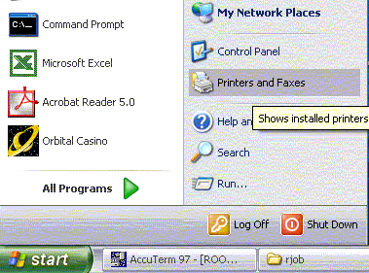
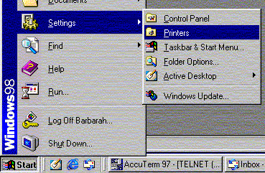

- Double Click on the Add Printer icon. The different options for the Windows Platforms are shown below:

Windows XP Windows 95, 98
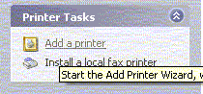
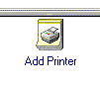
& 2000

- When you Double Click on the icon an Add Printer Wizard will come up. Click next, click the button that says Local printer then Click next again. The window for the different Windows Platforms are shown below:

Windows XP Windows 95, 98
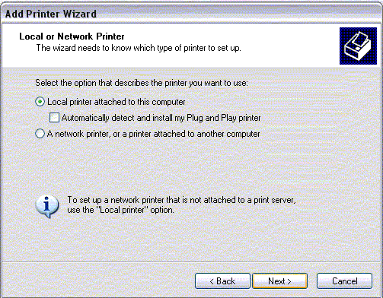
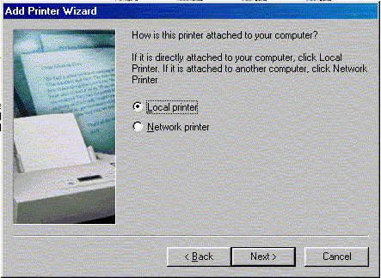
& 2000

- Windows XP & 2000 users, the next screen prompts you to select the port the printer is attached to. To do this click on the port the printer is attached to (COM1, COM2 or USB) then click next. (This is where the steps on setting up your hardware come in.) Windows 95 & 98 users, it will prompt you to select the printer to install. Click on the Manufacture AGFA on the left side of the window then click the printer named AGFA-ACCUSET 1000 on the right side of the window then click next. NOTE: on the setup of the Label printer you don’t have to select the make or model of your printer just a generic printer. The DBS will take care of the rest. The step for the different Windows Platforms are shown below:

Windows XP Windows 2000 Windows95, 98
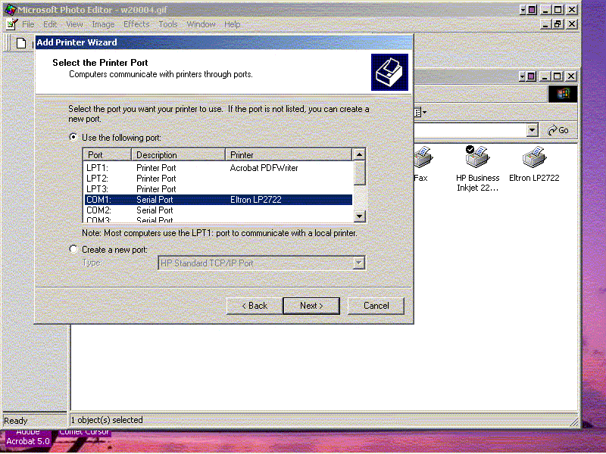
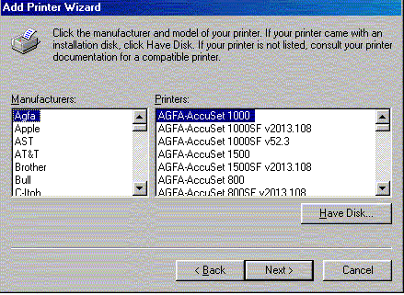
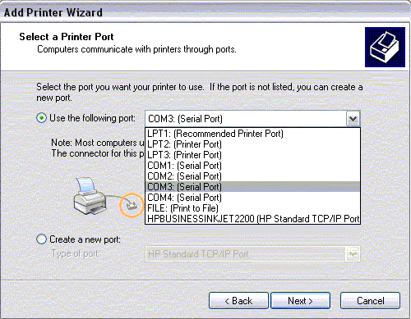

- Windows XP & 2000 users, the next step is to select the printer and on the Windows 95 & 98 Platforms this is where you select the port that the printer is attached to. Follow the step 5 to finish this step. The Windows for the different platforms are shown below.

Windows XP Windows 2000 Windows95, 98
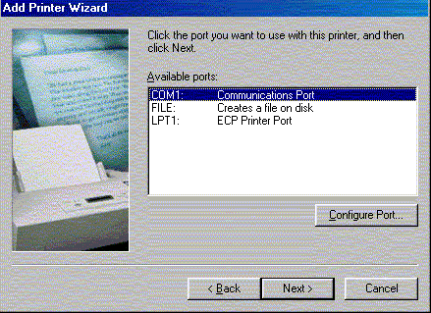
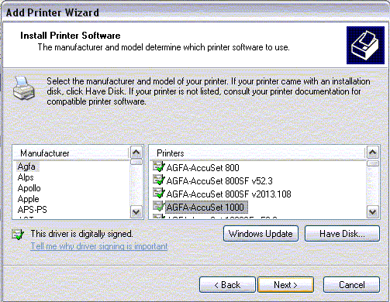
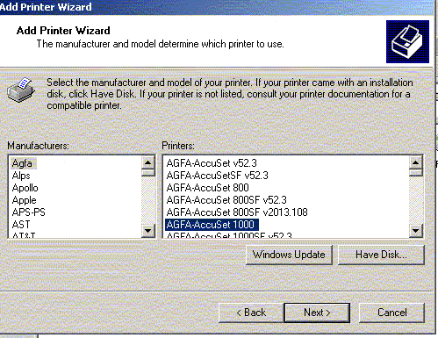

- The next step is to Name the printer you just installed. In the field where is says AGFA-ACCUSET 1000 highlight it and rename it Label Printer. This makes it easier to set up in later steps. Underneath this field click the button that says NO you do not want to be your windows default printer then click next. The windows for the different platforms are shown below.

Windows XP Windows 95, 98
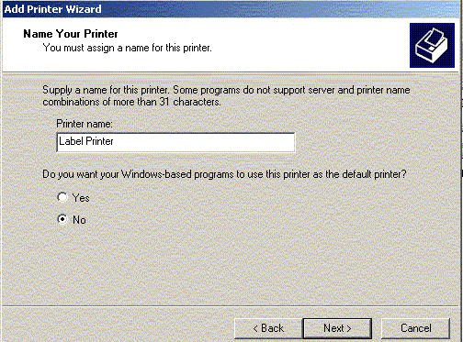
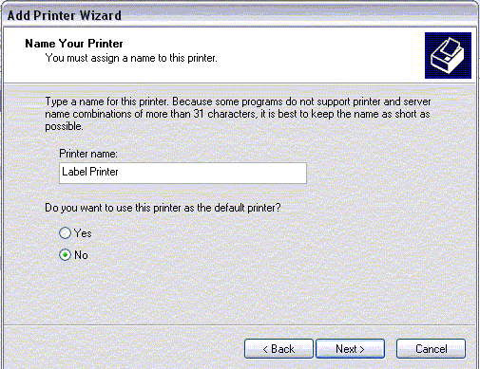
& 2000

- The Next step asks you if you want to share this printer. Click the button that says “NO I do not want to share this printer” then click next. Another window will come up and ask you if you want to print a test page, click the no button then click next. This last window displays the information on the printer you just set up. Click finish and close the printer window. The windows for the different platforms are shown below.

Windows XP Windows 2000 Windows95,
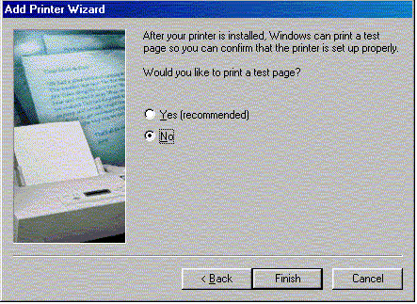
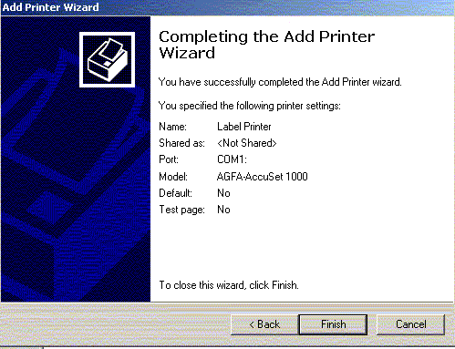
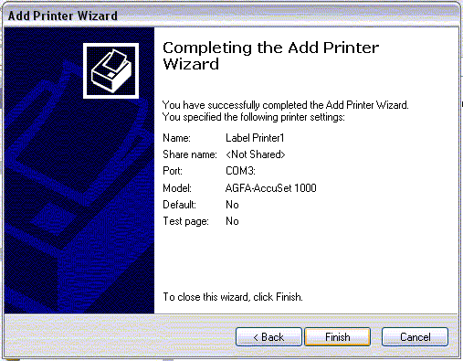

Setting up the label printer in Accuterm

- The first thing you need to do is open Accuterm, then start your session.
- After you start your session and have the Big J on your screen you need to go to the tool bar and click TOOLS>SETTINGS. The window is shown below.
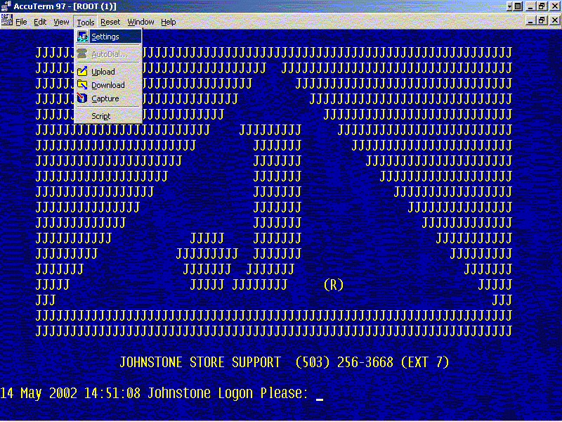

- The AccuTerm settings window will open up. Click the Printer tab at the top of the window. On this screen you need to click the dropdown next to name and select the printer named “Label Printer”. Next click the button that says “use specific printer” and click apply at the bottom of the page then click OK. This window is shown below.
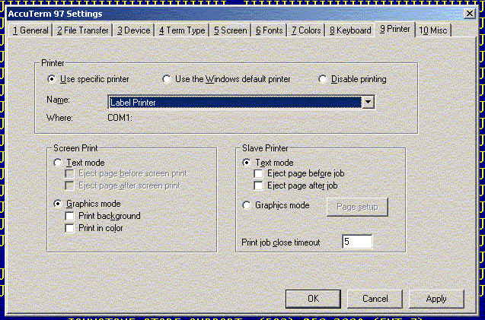

DON’T FORGET TO CLICK ‘FILE>SAVE’ TO SAVE YOUR CHANGES!!!

