Setting Up Warehouse Locations

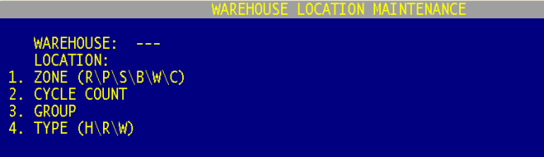

It’s important to setup your warehouse locations in a manner that is logical and provides quick access to high moving items. In Menu 9.20.20 Database is giving you the flexibility needed to setup warehouse location that will meet the needs of any size warehouse.

- Note: If you do not have locations, enter a warehouse location of “none” in Menu 9.20.20. This will allow you to scan the product in 9.20.4 with the location of “none.”

- Enter the Warehouse Number
- Enter the Location Number – This number can be up to 8-digits (see the following page for examples)
- Enter Zone – R (Rack); P (Parts); S (Showroom); B (Bulk); W (Will Call); C (Counter)
- Cycle Count - If this location includes items that you would like to
cycle count, then place a Y in this field. Cycle Counting is usually done
on high moving items that are easy to count or high cost items.
- Group – Not used at this time.
- Type – Where is the primary location for this item. H = Home (Main Location; R = Random (Bulk Storage) and W = Will Call.

Upload Warehouse Location to Menu 9.20.20
Database provides stores the option to upload warehouse locations from a spreadsheet into the Database system. Menu 9.20.23 Upload loc.txt from a Spreadsheet will automatically take everything on a spreadsheet and up-load it into the system. This process eliminates the need for users to go into Menu 9.20.20 and enter each warehouse location individually.

- Note: The format for the warehouse location excel spreadsheet should be as follows:
Column A LOCATION
Column B ZONE (R\P\S\B\W\C)
Column C CYCLE COUNT (Y/N)
Column D TYPE (H\R\W)

Printing Warehouse Location Labels
To print the entire setup of labels, File Transfer the WARE.LOC listing from Menu 9.20.21 into Excel. Then follow the Create Bar Code Labels for your Warehouse Locations instructions (see page 3). The instructions show how to print all labels at one time instead of printing them individually through Menu 34.8

