Hand-Held S3 Menu

Logging on to the S3 menu will give users the following options.

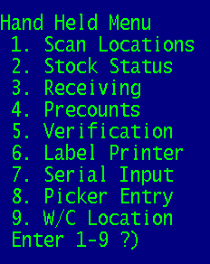

The S3 Menu can be accessed on the Hand-Held and also in PICK. In PICK type S3 and the TCL prompt (colon).

S3 Menu 1 Scan Locations

Menu 1 is used to match a location up to a part number. This is often used when setting up a new location/item or when prepping for inventory.

1. To scan new locations, select Menu 1.
- Enter the Warehouse
- Enter the location you are scanning (press <enter> after the location is entered) See figure A
SCAN PRODUCT LOCATIONS

ENTER WAREHOUSE 001

ENTER LOCATION 1A1
ENTER 1 2 3 OR 4
ENTER PRODUCT
Figure A.

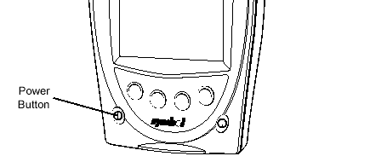

- Enter/scan the part number(s) in this location then press <enter>.

Next, select which location you would like to replace with the new one; location 1, location 2, location 3 or location 4.

SCAN PRODUCT LOCATIONS

ENTER WAREHOUSE 001 WLOC1 = wc
WLOC2 = SG4
ENTER LOCATION 1A1 WLOC3 = 2SRG1
ENTER 1 2 3 OR 4 1_ WLOC4 = sg1
ENTER PRODUCT B10-120
B10-120 083S DRYER WHSE 001 LOC 1A1

Note: This screen will not display all at once on the hand held screen, you will need to scroll over to the right to see the 4 locations.

Finally, you will be prompted to enter ‘L’ to print a label or just press <enter>.
SCAN PRODUCT LOCATIONS

ENTER WAREHOUSE 001

ENTER LOCATION 1A1
ENTER 1 2 3 OR 4 1
ENTER PRODUCT B10-120
ENTER L-ABEL PRINT OR <ENTER> C 1A1

Additional Features:

- <ENTER> = will do the same selection as previous - so if they selected "1" on the last product, <ENTER> will also go into location "1".

- 9 = will go into the next available open location, so if they have locations 1 & 2 filled, then selecting 9 will go into the 3rd location

S3 Menu 2 Stock Status

This option allows users to see the Stock Status screen (Menu 19.6) from the hand-held.

- Enter the Warehouse number.
- If the warehouse that appears is correct then press <enter>, if the warehouse number is wrong then enter the 3-digit warehouse number.
- Scan or Enter the part number.

The Stock Status screen looks like the following image.

1-W 2-IP/BO 3-POR 4-L
1-W 2-IP/BO 3-POR 4-L
WHSE-001*************
LOC OH PO IP BO
B1 142
A1 ******************
B10-120
083S 3/8" DRIER
*********************
SCAN ITEM
- Selecting 1 will scroll you through all of your different warehouses.
- Selecting 2 will show the In pick/Backorders and will display the customer & qty IP or BO.
- Selecting 3 will show the last 3 purchase order receipts, and displays the date & qty of the last 3 receipts. If the last three receipts were longer than 60-days ago, it will only show the last one, no matter how long ago it was.
- Selecting 4 will print a label * The system label printer default is assigned in Menu 34.9 and can be controlled by individual port in Menu 12.10 or Handheld, option #6 Label Printer.

Press <enter> after any of these functions, to get back to the stock status screen.

S3 Menu 3 Receiving

This Menu allows users to bar code receive products. It’s the same functionality that is available in Menu 34.1. The only difference is that receiving is done by hand-held vs. the bar code scanner.

- To receive items, select menu 3.
- Select an open receiver number by entering the line number, or press <enter> to begin a new receiver just like what is done in Menu 34.1.
BAR CODE RECEIVING

Company#: 01
01176412
Press <enter>
-- ----- ---
1 213949 01176412
2 213995 01175654

Ln# or <enter> 1

Processing...

Note: When you select a receiver or create a new receiver, it will say processing… at the bottom of the screen, then it will show the PO number of the receiver you selected and tell you to press <enter> above.

After you press <enter> you will be asked if you want to be prompted for a serial number, this display may run off the screen and you may have to scroll over to see it. Answer the prompt and press <enter>.

The rest of the receiving screens work just like a regular terminal.

How can multiple devices (Hand-Helds, laptops, PCs, dumb terminals) be used to receive in a large order at the same time?

Immediately AFTER creating your receiver in menu-34.1 or 34.20 and BEFORE
scanning items into that receiver, use Menu 34.21 to Create a 2nd Copy of
the Receiver. After the 2nd copy is created, which will be a different
receiver number, one person can receive using a bar code scanner in Menu
34.1 and another person can receive in inventory using the Hand-held S3
Menu, or both people can enter with Hand-Helds.

Run Menu 34.22 when receiving is complete. This menu will combine the 2
receivers back into one receiver for printing, verifying and updating in
Menu-34.2.

S3 Menu 4 Precounts
BAR CODE RECEIVING

Company#: 01
01176412
Press <enter> PROMPT FOR SERIAL# (Y/N)
-- ----- ---
1 213949 01176412
2 214051 01176495

Ln# or <enter> 1

Processing...

Option 4 is used to scan in inventory pre-counts.

- To enter pre-counts, select menu 4
- Enter the warehouse that is being pre-counted, press <enter>
- Enter the warehouse location that is being scanned press <enter>
- Scan or Enter the part number
- If you manually enter the part number, then you’ll need to manually enter the quantity number. To enter a quantity of 10, you must hit .10 (dot ten) <enter>
- To decrease a quantity, for example by qty 1, enter, . –1 (dot minus one) <enter>. (This process is the same no matter if the product was manually entered or scanned in through the hand-held).
WHSE: 001
ENTER WLOC 1A1
--------------------
WHSE:001 WLOC:1A1
PRODUCT B10-120
B10-120
083S DRYER 20
--------------------
WHSE:001 WLOC:1A1
PRODUCT .-1
B10-120
083S DRYER 18
--------------------
- The quantity that is displayed at the right after you enter the quantity is the current quantity. Database recommends ignoring this number. The reason why is that another person could have already scanned this item in a different location. The quantity that you see to the right displays the quantity at all locations that have been scanned.

S3 Menu 5 Verification

This menu path verifies that the product that is pulled for shipping matches what the customer has ordered.

- Enter the Picker number
- Scan or Enter in the Release number. If bar code labels print on your pick tickets then scan the bar code for the release number.
- Verify that the customer is correct.
- Scan in the item. The system will tell you if an item is scanned that is not on the order. The item can be added to the order by answering Y.
- Select ‘0’ to Accept.

Verification is also available through Menu 1.2. Enter ‘V’ in the Operator field.

S3 Menu 6 Label Printer

This menu assigns a network label printer to the hand-held port. See Menu 12.10 for an example. In the following example Port 1 is set to the HS (Hold Spool), you can enter any network printer in this option. Menu 6 in the S3 option functions the same as Menu 12.10.

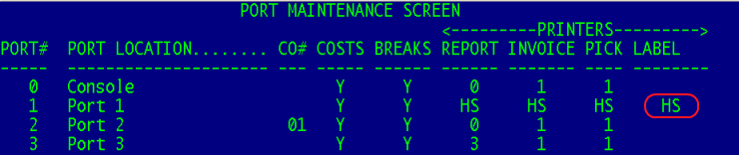

S3 Menu 7 Serial Input

Menu 7 allows serial numbers to be entered from the hand-held.

- Scan or Enter the release number.
- The system will then search for the first serialized number on the order that is in-pick.
- System will prompt for the serial number (if a serial number is already listed then the user can accept the serial number or change it)

S3 Menu 8 Picker Entry

Assigns a picker to the pick ticket. This feature is most often used when a person picks up the pick ticket off the printer. Menu 7 is used to save the picker time from going having to go into Order Entry to enter the picker ID.

- Scan/Enter release number.
- Enter Picker ID

Picker ID’s are setup in Menu 12.3.9. Most often the Picker ID matches the operator code.

S3 Menu 9 W/C Locations

This option is used to input the Gate location of customers will call items. To setup the Gate options use Menu 12.1.13. Below, code l1 is setup to display the text that appears in field 1. In the S3 Menu, the user types in l1 and the text message assigned to this code will display on the invoice.

