Setting up the Symbol P370 with 123 Scan

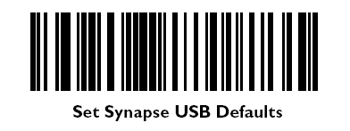
DIRECTIONS:

- Connect the scanner to the PC and let Windows find the drivers*
- Pair the scanner with the base by scanning the bar code on the scanner charger base that says PAIR.
- Scan all bar codes on both pages in order.
- Unplug the power from the scanner base and plug it back in.

*Windows 98, 2000 and XP should automatically find the drivers, if a window doesn’t come up saying that new hardware was detected, try the rest of the directions and see if it works before calling DST.


Reset Defaults

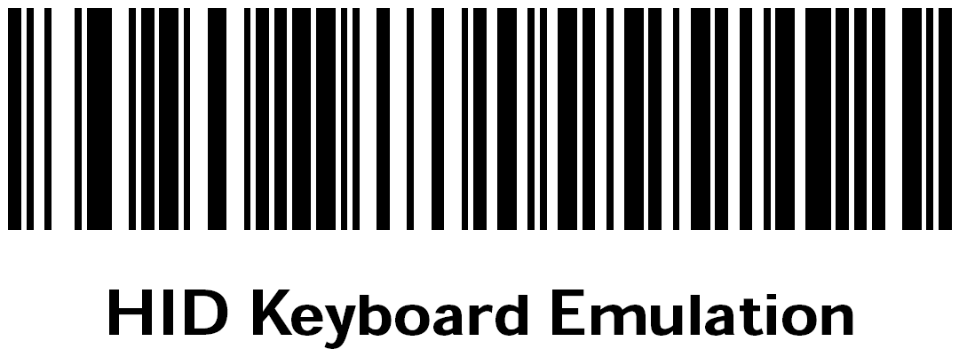

ADF Rules (9)
