New ABC Ranking Definitions

Analysis Method Definition: The 3 methods that are used for ABC analysis are Sales, Hits and GMROI (Gross Margin Return On Investment) methods.

 | Sales | GMROI | Hits
A | Top 60% of sales | GMROI > 200% | Top 60% of hits
B | Next 20% of sales | GMROI > 100% and <= 200% | Next 20% of hits
C | Next 10% of sales | GMROI > 0% and <= 100% | Next 10% of hits
D | Next 10% of sales | GMROI <= 0% | Next 10% of hits

Sales Method
The sales method focuses on the sales volume and hence is customer-centric. This is the typical method used in a majority of situations. The ranking methodology follows the standard Pareto rule and typically has three or more cut-off levels for the ABC ranks.

GMROI Method (Last 12 MO GP $$/AVG Ending Inventory $$ last 12 months)
The Gross Margin Return on Investment (GMROI) method focuses on profitability of items. The GMROI formula is calculated as the Gross Margin divided by the average inventory, both in dollars. This formula is similar to the Return on Asset financial measure except that here inventory is the only asset.

Hits Method
The Hits method focuses on the logistical or physical movement of inventory. The term Hits is defined as the velocity with which an item is picked from inventory irrespective of the quantity. It captures the frequency of item movement from the shelf and is very useful for designing warehouse layouts and minimizing transportation expenses caused through excessive branch transfers or expediting from suppliers. This method is similar to the sales method with respect to the ranking methodology.

    - Parameter Setting: Sales – 30%, GMROI – 50%, Hits – 20%
    - Ranking Weight: A – 40%, B – 30%, C – 20%, D – 10%
Sales - A, GMROI - B, Hits – C = (0.3*0.4*10) + (0.5*0.3*10) + (0.2*0.2*10) = 3.1
    - Ranking Range: A – Top 25%, B – Next 25%, C – Next 25%, D – Remaining
A = 3.3 to 4.0 B = 2.5 to 3.2 C = 1.8 to 2.4 D = 1.0 to 1.7

Database ABC Ranking Setup & Analysis

Database has added 3 new Menu Paths to accommodate the use of the ABC ranking methodology. These menus will Maintain, Calculate on Demand, and Compare Old vs. New ABC Ranking.

Menu 6.30 - ABC Ranking Maintenance

Weight of Sales, Hits or GMROI is controlled on lines 5, 10, and 15. These lines can be changed and maintained. However, lines 5, 10, and 15 must total 100%.

The additional breakdown (lines 2-4, 6-9, and 11-14) is the cumulative total the system is calculating. For example – line one Sales A – the system looks for the top 60 % of sales then stops – these are A items for Sales – then the system looks for the next 20% which is a cumulative total of 80% - stops – those are B items for Sales. The system looks for the next 10% (cumulative total of 90%) – stops – those products are C items for Sales.

The option to maintain all lines is available. However, we are recommending to not change lines 2-4, 6-9, and 11-14 during the pilot testing. By not touching these numbers, the review and feedback gathered during the pilot test will be easier to compile.

To exit the screen type B to back out, DELETE to delete, E to Edit, or 0 (Zero) to accept.

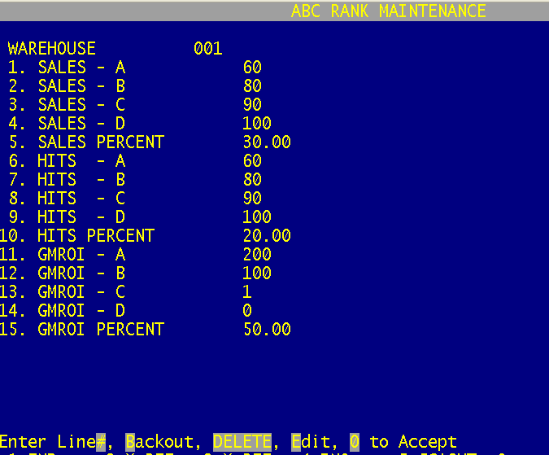

Menu 6.31 - ABC Ranking Calculation

Menu 6.31 is used to re-calc the ABC Ranking on demand. Run this menu after changing parameters in Menu 6.30 or after closing month.

To exit Menu 6.31 type END at the Warehouse prompt.



Menu 6.32 - ABC Ranking Report

The ABC Ranking Report is for spot checking and analyzing items to see if they agree with the Sales, Hits, & GMROI ranking. It’s also used to compare Old ABC (OABC) to new ABC (ABC) ranking.

The report can be FT (file transferred) into Excel to alter the sort order.

ABC Ranking Report Column Headings
Warehouse #, Part #, Item Description, On Hand, ROP, EOQ, Average Cost, Qty Sold 12 Month, Old ABC, Sales $$, Sales ABC Rank, Hits, Hits ABC Rank, GP $$, Inventory $$, GMROI, GMROI ABC Rank, Final ABC Rank

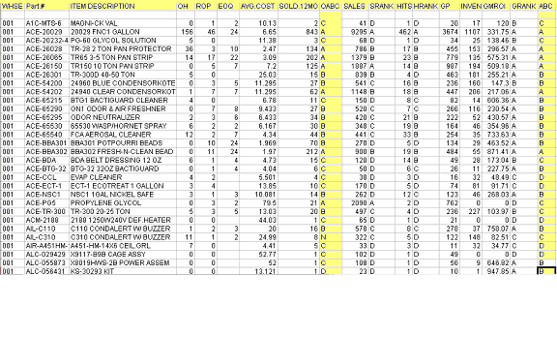

Menu 27.1.21, Field 13 – Use New ABC in ROP/EOQ Calculations

Setting field 13 to ‘Y’ will prompt the system to use the new ABC calculation during the next ROP/EOQ weekend update. Setting the parameter to ‘Y’ will also automatically prompt the system to run Menu 6.31.

To manually update the ROP/EOQ calculation run Menu 27.1.26.

This parameter gives users the option to turn the new ABC calculation On/Off. To not use the new ABC calculation in ROP/EOQ leave Menu 27.1.21, Field 13 blank or set to ‘N’.

