Credit Card Processing

Manual Credit Card Entry & Authorized Credit Card Entry

Manual Credit Card Entry

This process describes the procedures for manually processing a credit card transaction on a 3101, 8810 or 8500 Signature Pad.

Step 1
- Enter in a customer invoice in Menu 1.2. On the Totals screen select one of the credit card options in field 21. In the example below, AMX is the selected payment method.

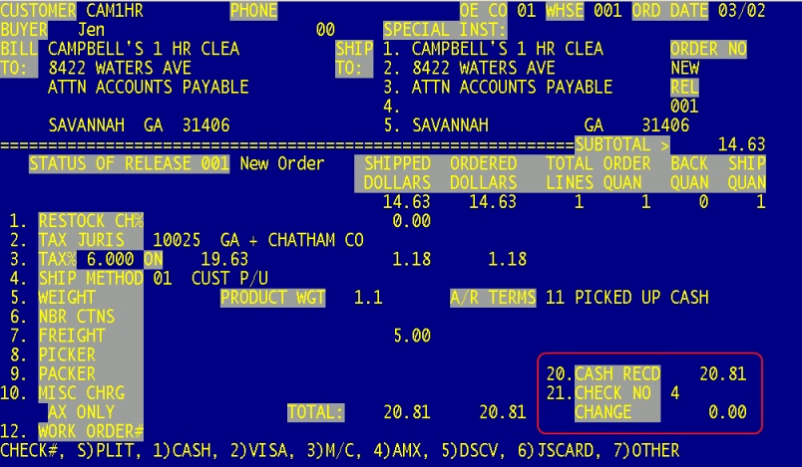

Step 2
- Select option 1 or 2 to Invoice.

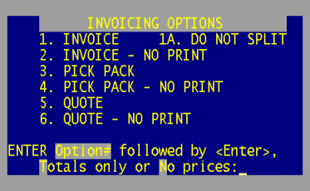

Step 3
- The Payment Processing window opens after the invoice option is selected.

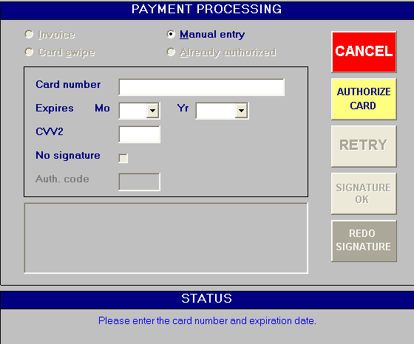

Step 4
- Select the Manual Entry option. Enter the Card number, expiration information and the CVV2 number
- Select Authorize Card

Note: A Manual Entry can be processed with or without a signature. If the customer is not present to sign, check the No Signature box.

Note: The credit card information stored for the customer in Order Entry Field 11 will not pre-fill in the card number field on the Payment Processing screen. If your customer wants to use a credit card that is on file within Database then you’ll need to copy the number from field 11 and paste/type in the card number on the Payment Processing screen.

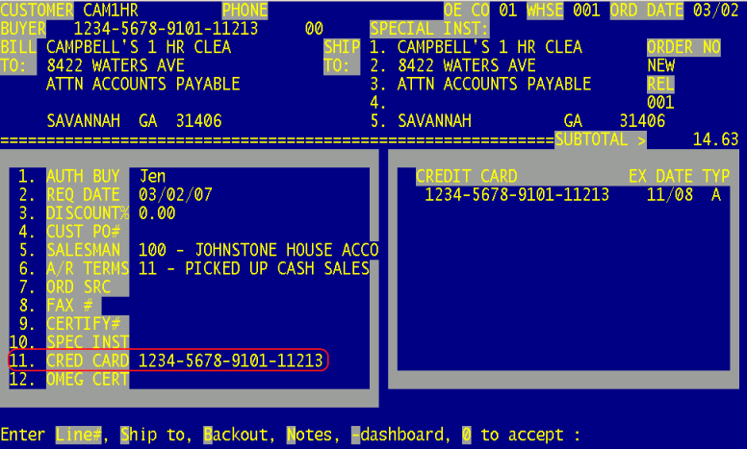

Note: If the card is declined the Status screen will show a Card Declined message and a reason for the decline.



Step 5

- If the card is not declined ask the customer to sign the pad when the Status screen says Card Approved.



Step 6
- The signature will appear on the Payment Processing screen after the customer signs the pad and hits the OK option on the pad. You then have the option to ask the customer to REDO the signature if it’s not legible, or approve the Signature by selecting the Signature OK option.

- After selecting the Signature OK option the Payment Processing screen will close and will return to the Order Entry process to finalize the order. The invoice will print a time and date stamp plus the authorization number.

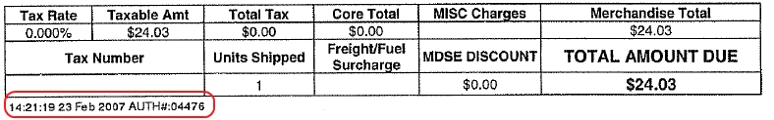

Already Authorized Credit Card Payment

The Already Authorized option is used if the Internet is down, which means authorization cannot occur through the signature pads. Instead use your old terminal swipe machine or call your credit card processor for authorization.

Once you have received the authorization number you’ll need to:
- Enter the Credit Card number
- Enter the Authorization Code
- Select the Get Signature option

Once the pad is signed the invoice will be processed with in Database as normal.

