Before you begin scanning the bar codes, plug the scanner base into a power outlet and let the scanner charge completely.

Once the scanner is charged, pair the scanner with the base by scanning the bar code on the base.

Scan: Set All Defaults
Scan: HID Keyboard Emulation Barcode
Scan: The rest of the barcodes beginning with the left column,
then the right column.

Make sure the keyboard works then try to scan something in stock status. If it does nothing, unplug the scanner base and plug back in.
LS4000 Series Scanner

USB Setup Sheet



(Wait for three beeps before continuing – about 10 seconds)



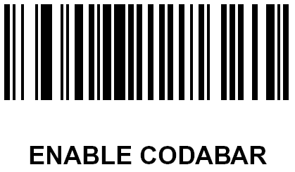

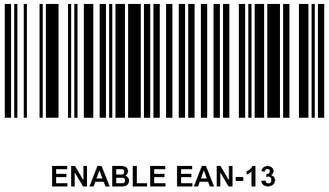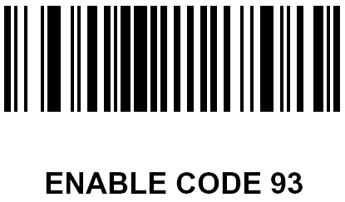
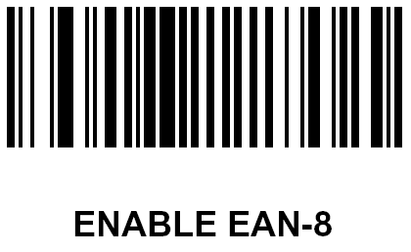

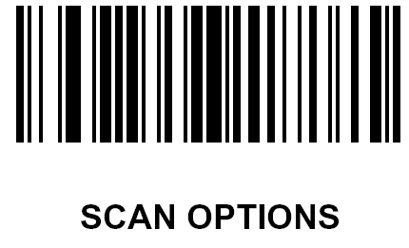

 Scan this code last

