Setup sheet for the LS4000 SERIES RS232 scanners



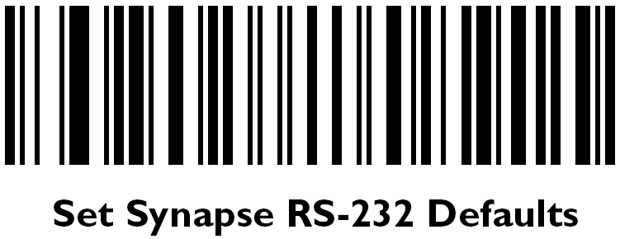





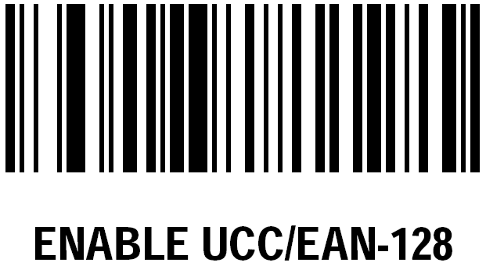

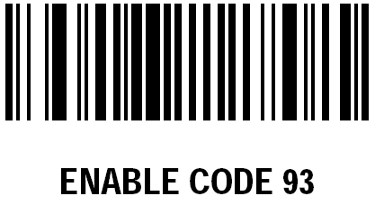



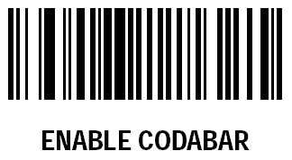
Before you begin scanning the bar codes, plug the scanner base into a power outlet and let the scanner charge completely.

Once the scanner is charged, pair the scanner with the base by scanning the bar code on the base.
Scan: Set All Defaults
Scan: Set Synapse RS232 Defaults
Scan: Baud Rate 19,200
Scan: Female Host Connector/Male Local Connector
Scan: TXD Pin 2 Host/TXD Pin 3 Local
Scan: Baud Rate 19,200
Scan: Bar codes numbers 7-16
Scan: Scan Options
Scan: <Data><Suffix>
Scan: Enter
Scan: Scan Suffix
Scan: 1
Scan: 0
Scan: 1
Scan: 3
Scan: Single Line Only
Make sure the keyboard works then try to scan something in stock status. If it does nothing, unplug the scanner base and plug back in.
1

2

3

4

5

6

7

8

9

10
11

12

13

14

15


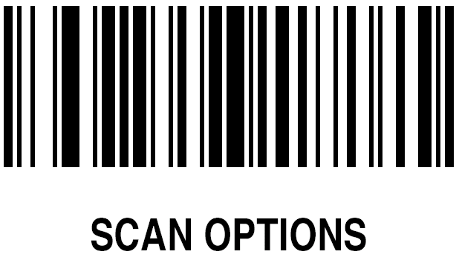






16

17

18

19

20

21

22

23

24



