Graffiti Keyboard For Symbol Hand-helds

To temporarily pop up the keyboard, click on the arrow above the Keyboard Icon on the lower right of the Screen. Select Letter Recognizer.
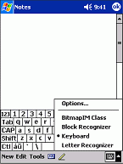

To default to the Graffiti Keyboard: go to Start - Settings - Input - Input method – Select Letter Recognizer. Click on Word Completion – uncheck box that says suggest words when entering text) click OK.
