
Delivery Procedure With Handheld

The signature capture process using the symbol PPT 2846 is quite simple.
When you finalize an invoice using a laser printer, a barcode is going to print underneath the Johnstone logo (see figure A). The procedure will go as follows:

- The delivery driver will take the invoice to the customer
- The delivery driver will scan the barcode with the handheld device. The invoice number and amount will show up on the handheld.
- The customer will sign the handheld and tap the save button.
- The driver will give the customer the invoice he scanned and go on to the next delivery.

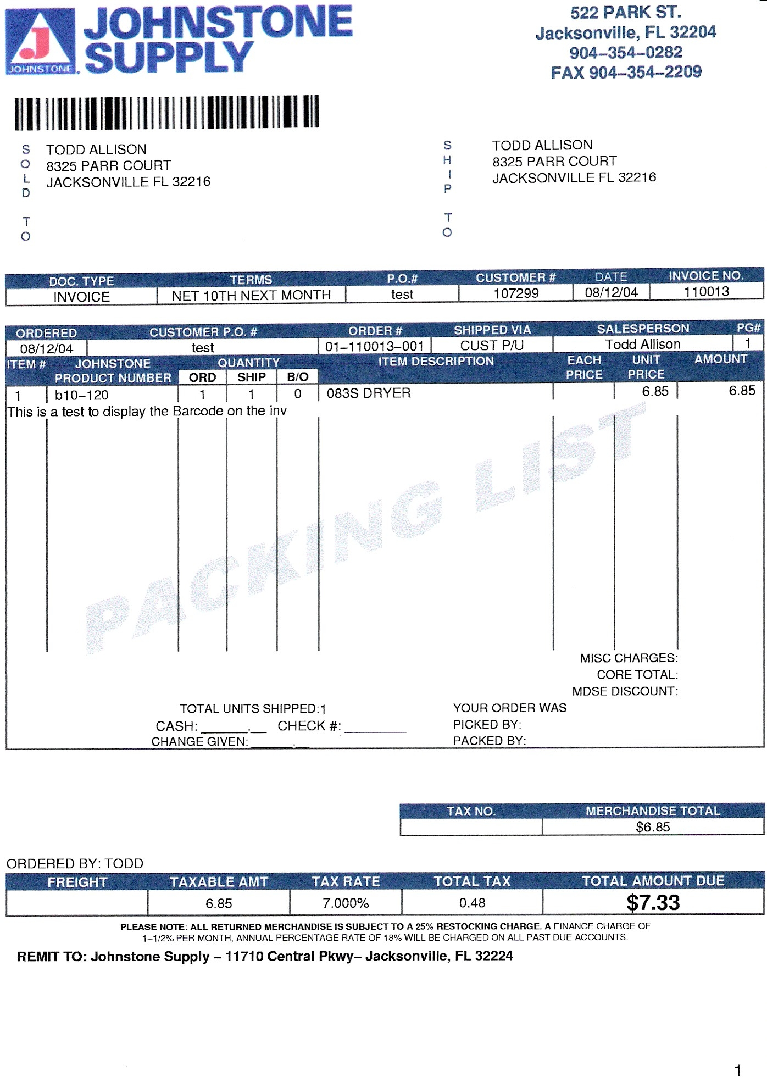
Figure A:

Equipment Setup and Port Maintenance

Handheld:
- Refer to Handheld setup Documentation on setting up handheld device.

Laser Printers:
- If you use a Dot Matrix style printer for your delivery invoices, you will need to replace it with a laser printer.
- Refer to the Signature Capture Hardware installation guide posted on http://dst.sitemax.com/signaturecapture.asp for instructions to set up your laser printer.
- If you use your invoice printer at the counter for deliveries, your port can be setup to print a barcode for the handheld.

Port Maintenance:
To configure your port to print a barcode, go to menu 35.13 field 6 (see figure B.)
NOTE: you can have a signature pad attached to a port and still have it print a barcode for the driver solution, It is not recommend to have the synchronization cradle attached to a PC that has a signature pad attached. MS ActiveSync and the signature capture software for the signature pad will conflict with each other.

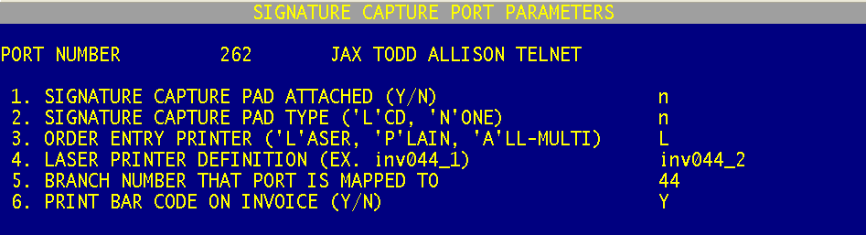
Figure B:

Using the Handheld (Symbol PPT 2846)

You can start the program two different ways; a) by tapping the start icon, then tapping the programs icon from the drop down menu. and then tapping the signature capture icon on this menu. Or b) Pushing the button of a clip board with a check mark in the middle (see figure C.)
R

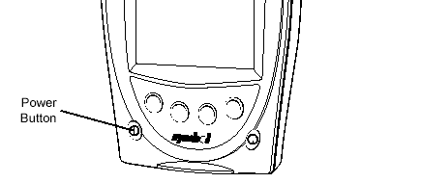
Figure C:

The Signature Capture program is design to stay open after each invoice. It will allow you to open other programs; however after a few seconds the Signature Capture program will automatically become the active program again. This is to prevent games from being played on the handheld and to keep the unit for work purposes only.

Now the program is ready to start capturing signatures.
The driver will scan the Barcode on the invoice (see Figure A.) by pressing any of the yellow buttons at the top of the handheld (see figure D.)
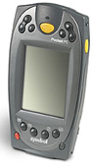
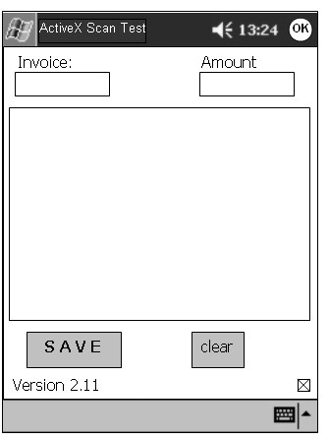
When the barcode is scanned, the invoice # and amount will display on the screen. (see figure E.)The customer will then sign the area that says signature and tap the save button. When the customer taps the save button, the signature is saved on the handheld. The signature program then goes back into the standby mode, waiting for the next invoice to be scanned.
Figure D.
123456
$123.45

Figure E.
Upload Handheld Signatures

- Place the handheld into the single slot cradle (see figure A). This should start the synchronization progress. You will see the status of synchronization, it is indicated by both color and animations, letting you know instantly what's actually happening (see figure B). If the window below, (Figure C), opens up, you may need to use your mouse to click on the program in the task bar this will bring the program up.

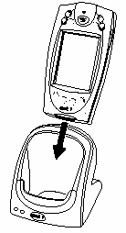
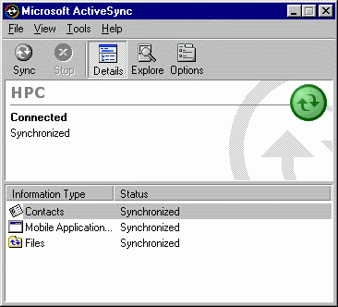
Figure A
Figure C
Figure B

- Once Microsoft ActiveSync is connected and synchronized (see Figure B.) in AccuTerm, run menu 1.35 Upload Handheld Signatures.

NOTE: If you have any errors on Figure B retry step 1. If errors still persist, Please call the IT Department at 904-493-1106.

- Upload Handheld Signatures (M. 1.35) is going to ask you to Enter company number, after you enter the company number, press enter. On the screen you will see a message about converting files, then it will display the invoice numbers (see figure D). When it is done, it will return back to the menu. When this process is complete, you can remove the handheld from the cradle and return it to the charger.
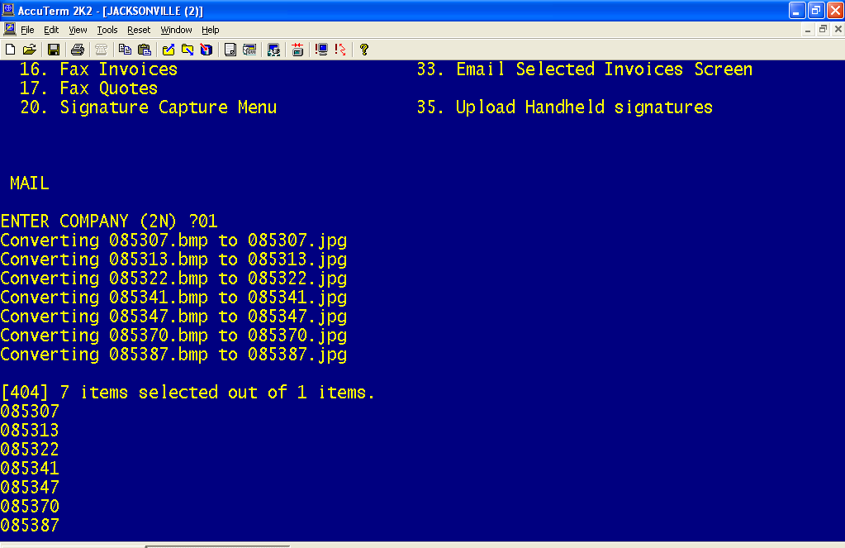
Figure D

