Credit Card Processing

Cancel Credit Card Transaction & Pay with Cash

This training document describes the procedures of when a customer decides to pay with cash instead of a credit card, after the credit card payment processing window is activated.

Step 1
- Enter a customer invoice in Menu 1.2. On the Totals screen select one of the credit card options in field 21. In the example below, AMX is the selected payment method.

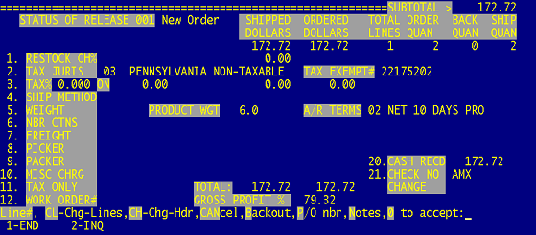

Step 2
- Select option 1 or 2 to Invoice

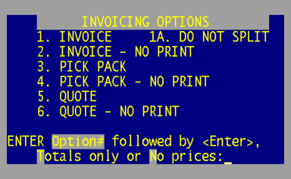

Step 3
- The Payment Processing window opens after the order is invoiced. The Status bar at the bottom of the screen will state when the customer should swipe their card.

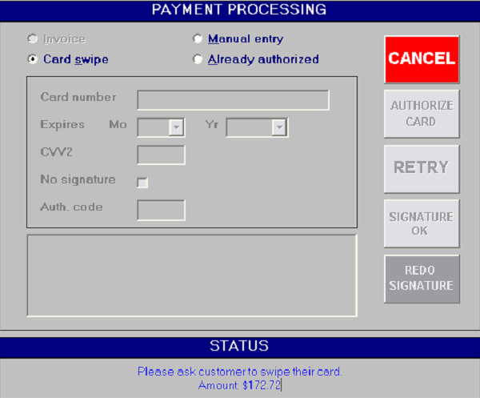

Step 4
- The customer decides, before they swipe their card that they do now want to pay with a credit card. They want to pay with cash instead.
  - Select the CANCEL button to return to the Order Entry screen.

Step 5
- Select a different payment option. In this example option 1 is selected for CASH.

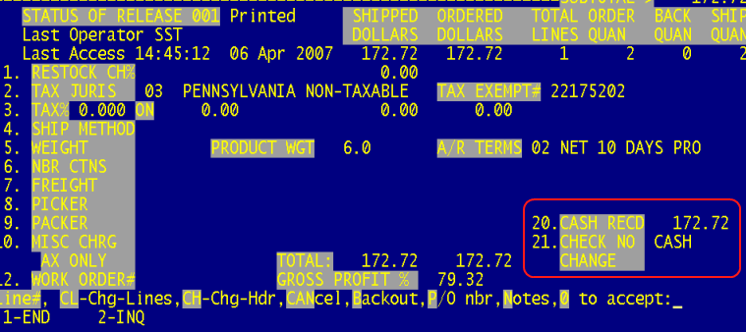

Step 6
- Select 1 or 2 to Invoice

Step 7
- The payment is processed as an Invoice. The screen will prompt you to ask the customer for a signature.

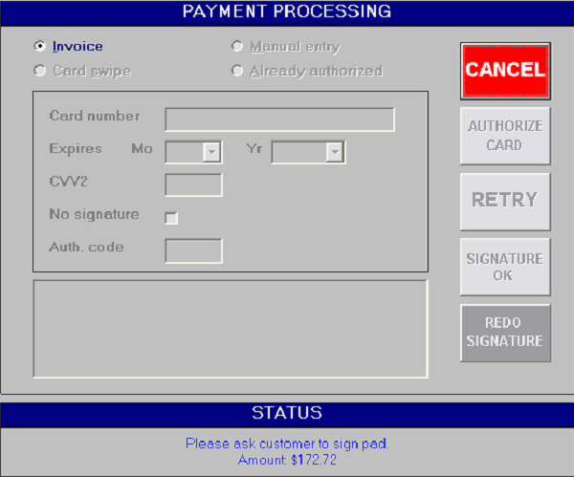

Step 8
- The signature will appear on the Payment Processing screen after the customer signs the pad and selects the OK option on the pad. You then have the option to ask the customer to REDO the signature if it’s not legible or approve the Signature by selecting the Signature OK option.

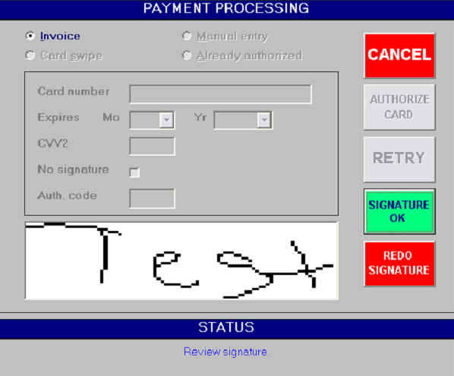

- After selecting the Signature OK option the Payment Processing screen will close and will return to the Order Entry process to finalize the order. A time and date stamp will print on the invoice.

