Customer Managed Inventory
(CMI)

“CMI is an important tool to build a relationship with the customer. It helps reduce the channel costs involved in ordering from Johnstone and is functional from almost any device that has access to the Internet. The customer does not need expensive proprietary devices that the competition uses, which is an important selling point.
A customer told me that this product would only help strengthen the relationship with Johnstone as he looks to keep less inventory and rely on next-day service. I am very excited about the future of CMI and expanding its applications in the future”.

Craig Wallace
Johnstone Supply Easton

What is CMI?
CMI allows you to place the “golden handcuffs” on your customers making Johnstone Supply the vendor of choice. CMI is an inventory replenishment solution that Johnstone gives to their customers, empowering them to place orders and manage their inventory.

Customer Benefits
- Reduces the customers inventory cost in their part room and trucks.
- Reduce the need for redundant parts. The use of universal parts can help eliminate many different line items on a truck and in the parts room. This not only helps reduce inventory, create ease of ordering but also helps the contractor complete the service call. There is less time running around town trying to track down multiple parts. Instead this will help increase their customer service and create more service calls per day.
- Inventory stock is kept current. Reduces the risk of the customer being stuck with huge quantities of product or obsolete parts.
- Empowers the customer to replenish their own trucks and parts room. This can help reduce or even eliminate purchasing departments for the contractor. Less time spent ordering parts and no time spent figuring out how much to order.
- Increased accuracy in ordering parts. Automatic email confirmation so the purchase order can match the invoice.
- Customers can job cost quicker. Prices are shown so they know exactly how much the materials cost. In turn this can increase receivable turns.

Johnstone Supply Benefits
- The “golden handcuffs” builds a system and partnership that strengthens the ties between Johnstone and the customer.
- Increase Sales by making ordering easier for the customer.
- Reduce order errors by Johnstone. The customer places the order so there is no opportunity for error.
- Increase sales without increasing counter sales staff.
- In the long run it will help reduce Johnstone inventory. Johnstone’s will not have to overstock product “just in case” the customer decides to place a huge order. Better sales information from the customer will in turn help make better purchasing decisions and forecasts.
- Increase customer service and efficiency.
Platform & Hardware Recommendations

Customer Managed Inventory (CMI) is designed to work with the following devices.

Laptop (XP Home or Pro) with bar code scanner – Using a laptop plus bar code scanner is a more cost effective solution then using a mobile device. If the laptop is being used within a store then it can easily tap into the stores Internet. If the laptop is being used within a truck then a wireless card will need to be purchased.

All Windows Mobile devices. Tested devices are the Verizon Treo 700 and the Samsung ACH9300. A version of Opera Mini must be loaded as a platform to run on. http://www.opera.com/products/mobile/products/ A scanner does need to be purchased when using a mobile device.

Requirements
- In order to use CMI you must have the Piclan easyco connection in place. If you currently allow your customers to place real-time orders online then you already have this connection. Piclan gives your customers the ability to place an order and have that order directly enter into Order Entry (Menu 1.2) as a pick ticket.
- The setup cost for Piclan is $800.00 plus a monthly fee of $35.00 charged by Piclan that would appear on your Data Services monthly statement.

CMI
- Prep – customer setup in 35.20.4 & 5

Preparing a customer to be able to use CMI is a quick 2-step process for setup. Customers must first be setup in M-35.20.4 to activate their account for online ordering. The second step is to assign them a login and password in M-35.20.5. Once these two steps are complete, the user is ready to login to CMI immediately.

Screen shot of step 1 Menu 35.20.4

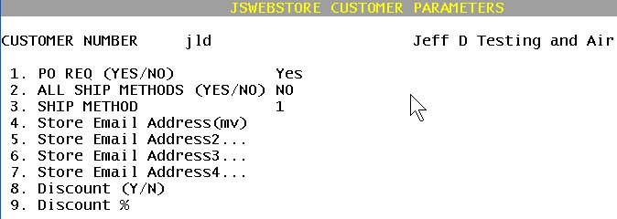
Screen Shot of Step 2 Menu 35.20.5

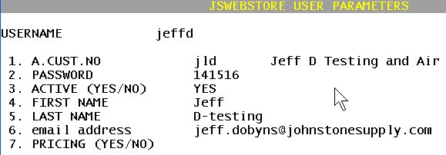

- Where – URL; Desktop vs. mobile -Whether you are on a Desktop or on a handheld mobile device, you get to the CMI application at the same location. http://cmi.johnstoneds.com/login.aspx
Sample Screen Shot of Desktop Size Screen
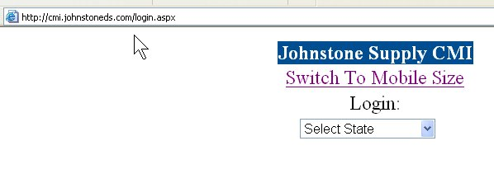
Sample Screen Shot of Mobile Size Screen
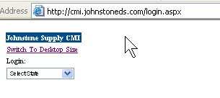

- How
  - Login – At the login screen select your state then select your city, then enter username and password at the login screen.
Select your State
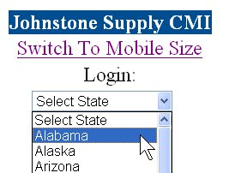

Select your City

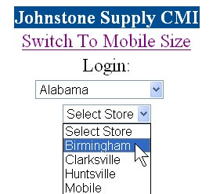

Enter Username and Password

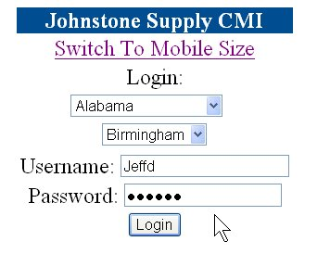

  - Build Order –once logged in, you are at the order building screen.

Screen Shot order Building screen

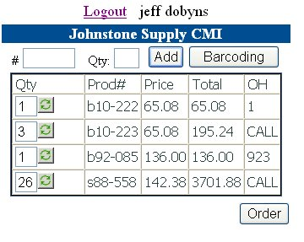
Screen definition
Click here to go to the alternate ordering method –scanning in multiple items at a time/uploading from spreadsheet.

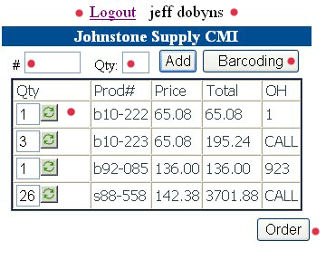
This button takes you to the order total screen to enter special inst, PO# and/or Job#
Type or scan in the product# and a quantity to enter multiples of a single item. Or just click Add.
Once a product is on the order, you can change the quantity and click the refresh button to update. **Also use this to delete an item by entering a quantity of 0 and hitting refresh.

Building Orders one item at a time
- Build an Order -Once logged in, the default order screen is the one above. Simply scan an item or type in the product#. Click add <hitting ENTER is the same as clicking add> to build your order a single item at a time. You can also put in a product# with a corresponding quantity to build your order that way. The advantage to this is if ordering multiple quantities of the same item, you will only have to enter/scan it once instead of entering it each time for each quantity (single entry vs. multiple).
- Delete Item from Order –if an item added to the order needs to be deleted for whatever reason, simply go to the line, put quantity of 0 (zero) into the field and then refresh/update the order. This will remove the item from the order.
- Submit the Order –Once done entering your order, simply hit the ORDER button to take you to the order confirmation screen. See screen shot below.

***Note: You can start an order, logoff and then come back later and login and pick up where you left off previously.

Building Orders using the Bar Code/Upload from Spreadsheet Options
Bar Code Option
- Scan the items into the entry box. ***Note: scanner setup needs to default to a carriage return after each scan. (individual scanner settings differ). When done scanning, click ADD PARTS to add these scans to the order and check pricing and availability.

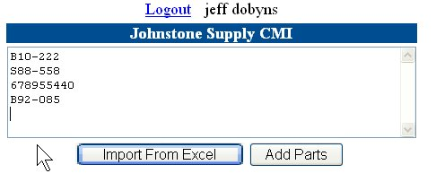

Import from Excel Option ***Note –used only in Desktop mode –not mobile version
- Click the import from Excel button
  - Click the BROWSE button to locate the spreadsheet on your local system.
    - ***Note The sheet can be setup pretty much in any order you need as during the upload process you are able to assign the prod# and quantity columns to the uploaded sheet. (see sample sheet below)
  - Once located, double-click to select the Excel file
  - Click the upload button to pull it in.
  - Select the prod# column and the quantity column on the sheet.
  - ****See Sample Screen shots to follow;

Sample Excel Sheet

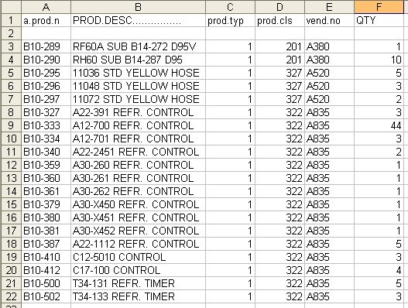

Sample Upload Screen
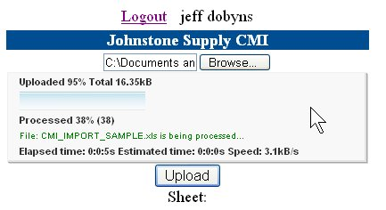
Once Sheet is uploaded, assign prod# column and quantity column then click add parts.
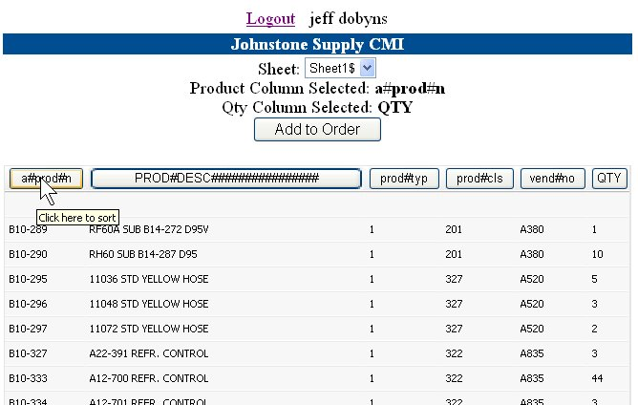

Place Order

- Checkout –when done building your order (either one at a time or via bar code or excel) click the ‘ORDER’ button to go to the Checkout Screen. Fill in PO#, Job Name, Ship Method and any special instructions/notes. When those have been filled in click Submit to send the order into your system.

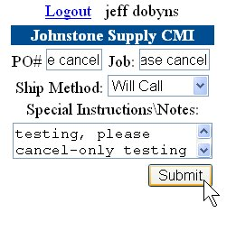
- Order Confirmation –After clicking submit, the order is entered real-time into your system and displays system order # and you are immediately emailed an acknowledgement. Click RETURN to build another order.

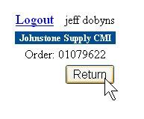
- Acknowledgements –in addition to the on-screen display of the order# you are immediately emailed an acknowledgement of the order submitted. A copy is sent to the customer and to the store administrator. This email is setup in M-35.20.5.

Sample Email CMI Order Acknowledgment;
