Accounting Upgrade Documentation

Upgrade #1

In menu 13.20.2, when the user changes a product’s price, they will now see the following prompt at the bottom of the screen:

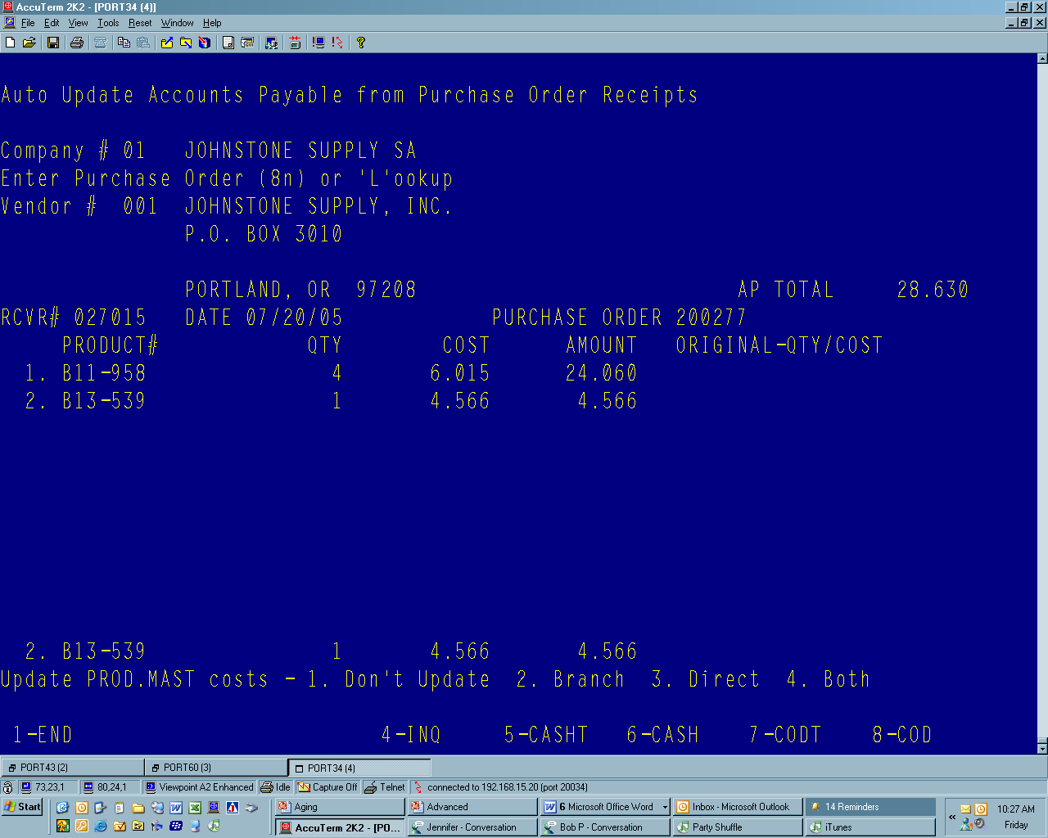

User will have the opportunity to update the Product Master’s Branch Cost, Direct Costs, both costs or neither depending on the option they select. Changes to the Product Master are instantaneous. However, if a change is made to a catalog item, unless the price/cost transmission is suppressed in menu 12.3.2.9, the change could be overridden with the next transmission.

Upgrade #2

After deleting a merchandise voucher in menu 13.20.18, the user will be asked whether to reopen the receiver attached to the voucher. This will mean that the receiver will again be available in 13.20.2.

Upgrade #3

Menu 13.5 can now be used to find AP information using the Purchase order. After entering the vendor number, users can now enter ‘PO” and using the six digit PO number, find voucher and invoice information

Upgrade #4

When running 13.4, users will instead be prompted to logoff and type MONTH-END at the big J. Option # 2 will start the AP close for the entered period. Reports generated during the AP Month-end close will now be stored in the spooler as a result.
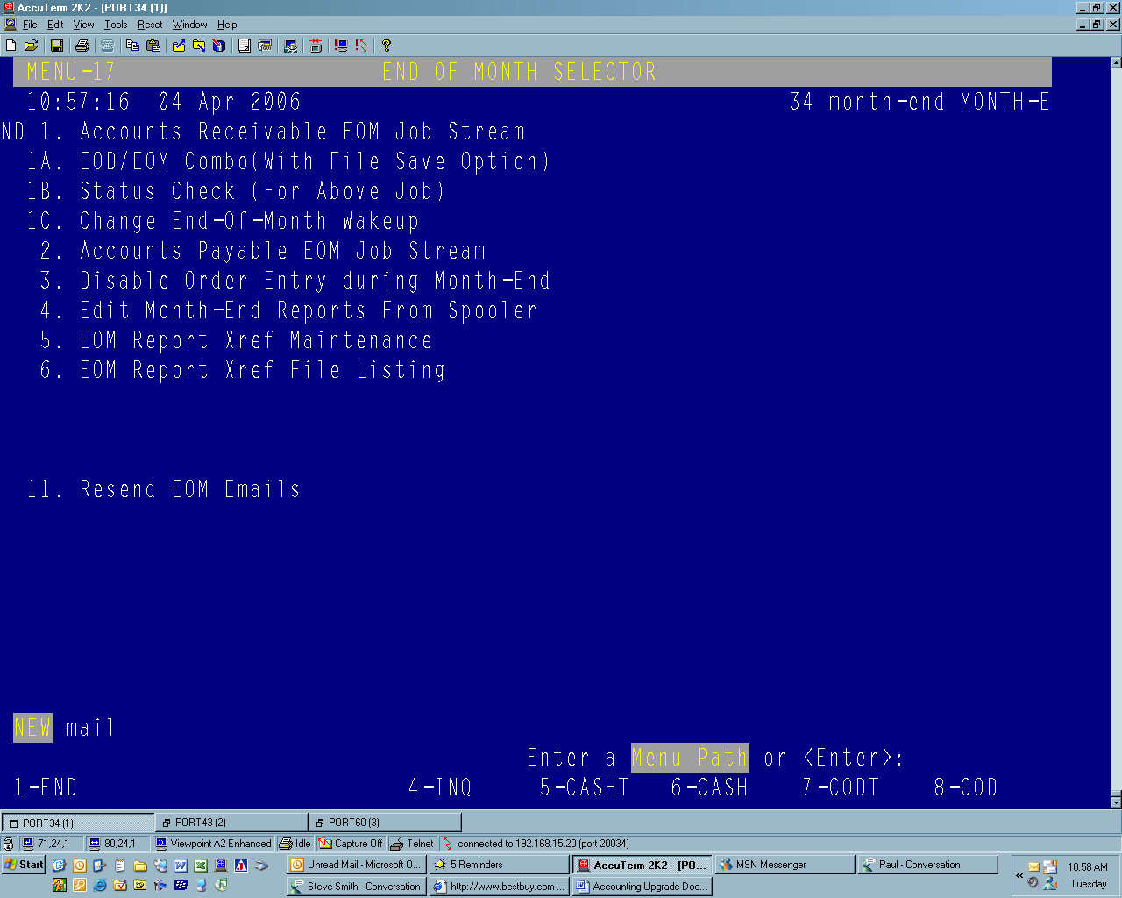

Upgrade #5

In menu 13.20.2, users can enter a purchase order to find a receiver number. A list of receivers associated with the entered PO will be displayed. Alternately, the user can return past this prompt, see below, and simply enter the Vendor number and proceed as usual. At the next prompt, when asked for the receiver number, the user can use one of the provided receivers displayed or use the paper receiver, depending on processes in place.

