Accounts Payable & Inventory

Accounts Payable and Inventory

- When inventory comes into the warehouse is it received in.
- At this point it will be reflected in the inventory counts (detail), but not the G/L (summary.).
- Inventory doesn’t hit the G/L summary until it has been vouchered and set for payment. The receivers created when inventory is scanned in are very important in facilitating this process. The receivers must be cleared through menu 13.20.2 when paying for merchandise.

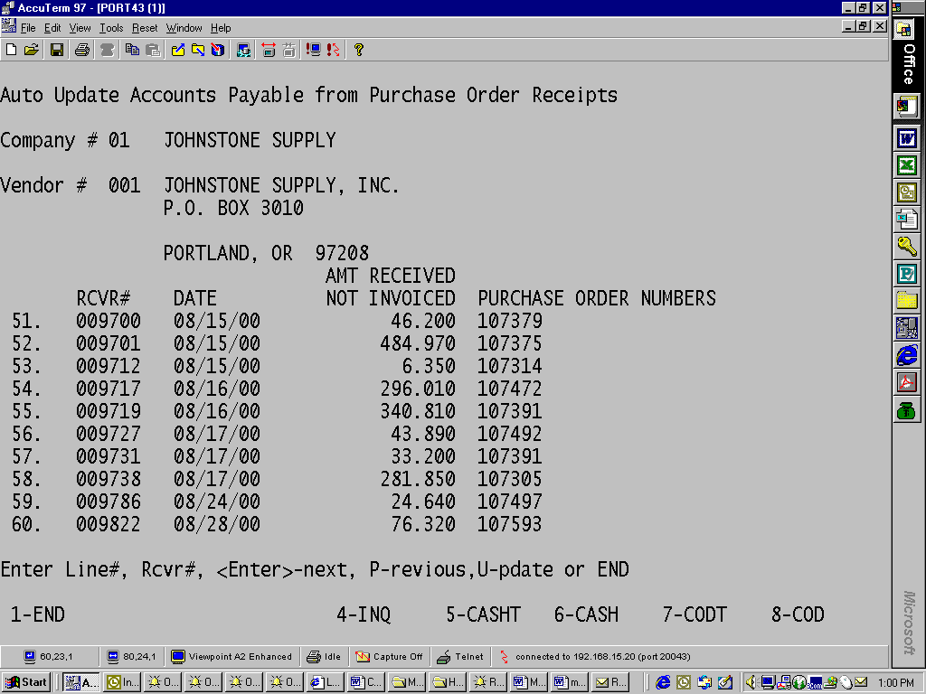

- Also, we have had special programming done so that the average cost changes are taken to a COG account if there is quantity on hand. This is important on the accounting side.

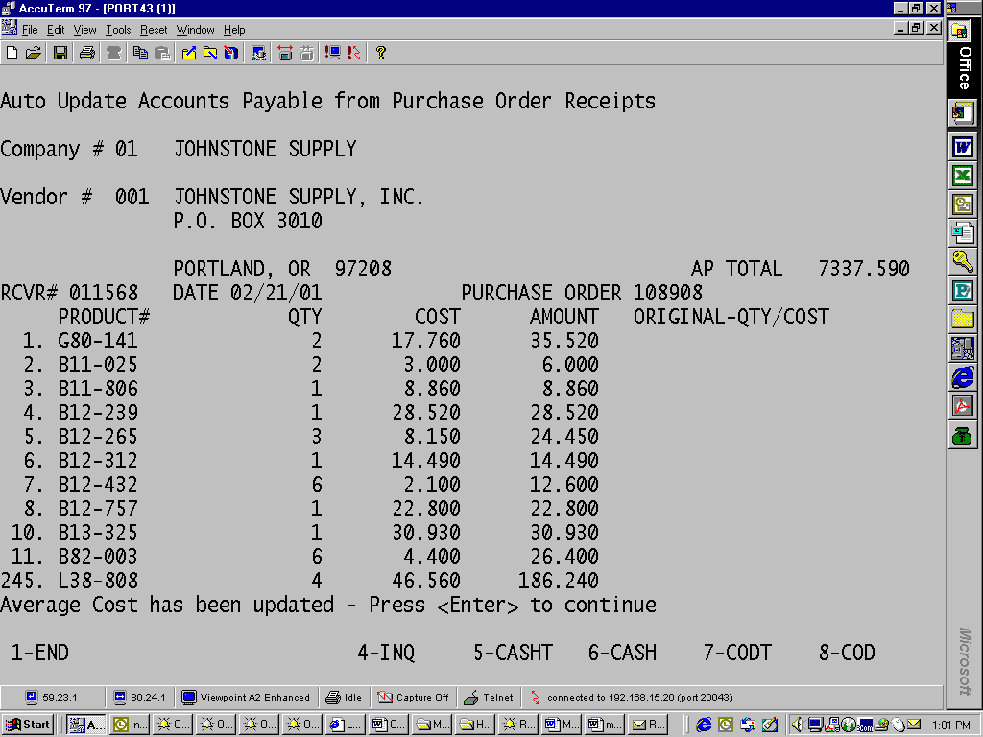

- If there isn’t quantity on hand, then the discrepancy is coded to 4105 and is a line item on the last screen in 13.20.2. (see T-cell diagram)
- At the end of the month, 13.20.7 is run right after Accounts Payable is closed. It is preferable to close A/P on the first day of the following month.
- This report generates a lit of all the receivers that haven’t been vouchered again in 13.20.2. Originally, receivers older than 90 days weren’t included on the report so we had to have custom programming done to remove this limitation.
- At the end of the month, the total on the bottom of the report is used in a journal entry to force the unvouchered receivers to hit the GL summary. All the receivers that have not been vouchered are accounted for in a reversing journal entry that credits inventory (1212) and debits the accrual account (2120.)
- It is very important that these are reversing journal entries since the individual receivers may be vouchered in the next month and finally hit inventory.
- If a receiver is over 90 days old and still on the report, it would be a good idea to research it and find out why it hasn’t been paid. I wouldn’t call the vendor since we don’t want to do their accounting for them, but it would be a good idea to do a little investigating.
- Stock adjustments also need to be accounted for. Run 8.4A to get a list of the stock adjustments made during the month and debit or credit the inventory GL account and the corresponding expense account. The stock adjustments have taken the item out of the detail and the journal entry takes it out of the summary to bring you in balance. Auto-warranty receiving stock adjustments show up on this report (when inventory is received in to close out a claim) but a journal entry is NOT needed for this category
- Once the journal entries have been made, the amount in your GL inventory account should balance to the inventory detail report that came off with your month end. If the difference is greater than $100, then I try to research it and figure out why. I deem anything less than $100 immaterial.

